|  |  |  |  |  |  |  |
| --- | --- | --- | --- | --- | --- | --- |
| ***SOFTWARE USER MANUAL***  ***(brat version 4.0.0-beta)***   |  |  |  | | --- | --- | --- | | **version** | **:** | 1.1 | | **date** | **:** | 30/06/2016 | |

This page intentionally left blank

Document Information

|  |  |
| --- | --- |
| **Contract Data** | |
| **Contract Number:** | 4000113810/15/I-LG |
| **Contract Issuer:** | ESA |
|

|  |  |  |  |
| --- | --- | --- | --- |
|  | **Name** | **Function** | **Signature** |
| **Prepared by** | BRAT development team | - | - |
| **Reviewed by** | Ana Friaças | PA Manager |  |
| **Approved by** | Miguel Terra-Homem | Project Manager |  |

Document Change Log

| **Issue** | **Author** | **Section** | **Change Description** | **Date** |
| --- | --- | --- | --- | --- |
| 1.0 | BRAT Dev team | All | SUM version aligned with the new BRAT GUI. | 02/05/2016 |
| 1.1 | BRAT Dev team | All | SUM version aligned with the new BRAT GUI. | 30/06/2016 |
|  |  |  |  |  |
|  |  |  |  |  |

Table of Contents

1. INTRODUCTION 10

1.1. Project history and background 10

1.2. Global overview 10

1.3. Toolbox contents 11

2. DATA READ AND PROCESSED 13

2.1. Background 13

2.2. Level 1B/2 data products 13

2.3. Higher level products 14

3. HOW TO INSTALL AND UNINSTALL BRAT 16

3.1. Supported platforms 16

3.2. The BRAT distribution CD 16

3.3. MS Windows 16

3.3.1. Installing the binary distribution 16

3.3.2. Installing from source 17

3.3.3. Uninstalling 17

3.4. Linux 17

3.4.1. Installing the binary distribution 17

3.4.2. Installing from source 18

3.4.3. Uninstalling 19

3.5. Mac OS X 19

3.5.1. Installing the binary distribution 19

3.5.2. Installing from source 20

3.5.3. Uninstalling 20

4. BRAT GRAPHICAL USER INTERFACE (GUI) 21

4.1. Overview 21

4.2. Starting with BRAT GUI 21

4.2.1. Create a workspace 21

4.2.2. Create a dataset 22

4.2.3. Create an operation 24

4.2.3.1. Select source data 24

4.2.3.2. Define expressions 25

4.2.3.3. Output 27

4.2.3.4. Export 28

4.2.4. Create a view 28

4.3. BRAT GUI tabs description 30

4.3.1. Workspace menu 30

4.3.2. Datasets tab 31

4.3.2.1. Creation of a dataset 32

4.3.2.2. Management of the data files list 32

4.3.2.3. Selection of data files 32

4.3.2.4. Data file information 33

4.3.3. Operations tab 34

4.3.3.1. Manage Operations 34

4.3.3.2. Define source data 35

4.3.3.3. Define expressions 36

4.3.3.4. Expression information and parameters 37

4.3.4. Logs tab 50

5. ALIASES 51

5.1. Using aliases 51

5.2. Structure 51

5.3. Modifying an alias 52

5.4. Creating an alias 52

5.4.1. For a field for which no alias exists 52

5.4.2. For a field for which an alias has already been defined 52

6. VISUALISATION INTERFACE 54

6.1. ‘Plot2D’ 54

6.2. ‘Map Plot’ 56

6.2.1. Plot3D 58

6.2.2. Color table editor 60

6.3. Vector Plots 60

7. BRAT SCHEDULER INTERFACE 61

8. USING BRAT IN ‘COMMAND LINES’ MODE WITH PARAMETERS FILE 62

8.1. Creating an output netCDF file 62

8.2. Visualising an output netCDF file through BRAT 64

8.3. Using the parameter files to process many datasets 65

9. BRATHL APPLICATION PROGRAMMING INTERFACES (APIS) 67

9.1. Data reading function 67

9.2. Cycle/date conversion functions 68

9.3. Date conversion/computation function 69

9.4. Named structures 70

10. ANNEX A: list of datasets read by BRAT 72

10.1. Cryosat product overview 72

10.2. Cryosat Ocean products overview 72

10.3. Jason-2 product overview 73

10.4. Envisat product overview 73

10.5. Jason-1 product overview 73

10.6. Topex/Poseidon product overview 73

10.7. ERS-1 and 2 product overview 74

10.8. GFO product overview 74

10.9. PODAAC product overview 74

10.10. River and Lake product overview 74

10.11. NetCDF products 74

10.11.1. Aviso Altimetry data in netCDF 75

10.11.2. ERS REAPER data in netCDF 75

10.11.3. Sentinel 3 data in netCDF 76

11. ANNEX B: Y=F(X) parameter file keys 77

12. ANNEX C: Z=F(X,Y) parameter file keys 80

13. ANNEX D: Display parameter file keys 85

14. ANNEX E: BRATHL-MATLAB API 93

15. ANNEX F: BRATHL-Fortran API 108

16. ANNEX G: BRATHL-C API 115

17. ANNEX H: BRATHL-PYTHON API 134

List of Tables

Table 1: Level 1B/2 data products 13

Table 2: Higher level products 14

Table 3: BRAT functions 39

Table 4: BRAT algorithms 44

Table 5: 10.1. Cryosat product overview 72

Table 6: Cryosat Ocean products overview 72

Table 7: Jason-2 product overview 73

Table 8: Envisat product overview 73

Table 9: Jason-1 product overview 73

Table 10: Topex/Poseidon radar altimetry products 73

Table 11: ERS-1 and ERS-2 radar altimetry products 74

Table 12: GFO product overview 74

Table 13: Physical Oceanography Distributed Active Archive Center radar altimetry products for Jason-1 and Topex/Poseidon 74

Table 14: ENVISAT-ERS Exploitation River and Lake Products 74

Table 15: Aviso Altimetry data in netCDF 75

Table 16: ERS REAPER data in netCDF 75

Table 17: Sentinel 3 data in netCDF 76

List of Figures

Figure 1: 'Create a new workspace' window. You can choose to save it wherever you want on your hard drive or local network, and name it as you prefer (preferably in such a way you will remember what's in it). 22

Figure 2: The Dataset tab as it appears when opening a new Workspace. The “New” button enables to create a new dataset 22

Figure 3: Several datasets. On the top, the list of files; middle (center) the description of the netCDF data file, bottom (left) enumeration of the available fields inside the netCDF file, bottom (right) field discription. 23

Figure 4: An empty 'Operations' tab. The Create new operation button enable to create a new 'Operation' 24

Figure 5: Choosing a dataset; below, the tree with records and data fields. 25

Figure 6: Dialog shown when “Window>Open” menu is triggered that allows the selection and visualization of a certain operations 29

Figure 7: A 'Display’ window with one view created. Note the list of available views 30

Figure 8: Example of dataset with netCDF data selected. 31

Figure 9: Operations tab, with an operation being built. Left the dataset chosen is called 'test_dataset', with Jason-2 data product; in the middle the list of fields within the J2 record being expanded. In the middle, only one Expression is defined yet ('lat' as X). 34

Figure 10: Operations tab. 36

Figure 11: Example of menu that appears by right-click on a data expression (’SLA’). Note that here one data field ('equator_time') is selected (left-click); if no data field is selected, this item is inactive. 37

Figure 12: ''Show Aliases' pop-up window. Here for an Jason2 NetCDF file. Note the 'Syntax' column, where the alias syntax is given, while the 'Value' column gives the original field name (or combination). 38

Figure 13: The 'Formulas' pop-up window, with the list of available formulas, top (sorted in alphabetical order). 43

Figure 14: use of a pre-defined formula (Ocean_data_editing_GFO_from_cycle_83), by inserting its developed version Note the use in this particular formula of another formula as alias %{Ocean_data_editing_GFO_from_cycle_83}on the next to last line) 43

Figure 15: Insert Algorithm pop-up, with the BratAlgoGeosVelGridV selected. 47

Figure 16: Operation resulting from the insertion of algorithms (here the “CustomAlgo” algorithm is visible). Latitude, Longitude and 5 have been left as default; Height is replaced by “Grid_0001”, which is the name of the Sea Level Anomaly height in the gridded dataset used. 48

Figure 17: Choice of the data computation 48

Figure 18: example of the definition of an alias. This example is for Envisat RA2 and MWR products, by default for data within the “ra2_mds” record. “ku_band_ocean_range” is the name give by default in the documentation and thus in BRAT. To keep it simpler, we call it here “range”. 52

Figure 19: An example Y=F(X) visualisation with two curves 54

Figure 20: Data Options tab of the visualisation tool 55

Figure 21: Y-axis properties of a Y=F(X) plot, with only one field selected for view. Label (including the unit), number of ticks in the axis, min and max of the axis are shown. X-axis properties are similar. 55

Figure 22: Two curves overlaid, with different point glyphs defined 56

Figure 23: Map plot type to display a simple z=f(lon,lat) graph type.. 57

Figure 24: You can also trigger the Globe Plot for this type of data by clicking under the “3D” button 57

Figure 25 – Plotting a z=f(lon,lat) graph. 59

Figure 26 – Same plot but with a hidden spectrogram plot by clicking under the 2D button. 59

Figure 27: Example parameter file for creating a Z=F(X,Y) output 63

Figure 28: Example ‘display’ parameter file 64

Figure 29: An example parameter file for creating output netCDF for several cycles (SLA from Jason-1 GDRs) 65

Figure 30: An example script for DOS (to be inserted in a .bat file) to launch a parameter file over several cycles 66

Figure 31: An example Shell script for Linux for launching a parameter file over several cycles 66

# INTRODUCTION

## Project history and background

The Broadview Radar Altimetry Toolbox (BRAT) and the Radar Altimetry Tutorial (RAT) were originally produced by CLS and S&T in 2006-2011 under contract with ESA and CNES (the toolbox name at the time was called Basic Radar Altimetry Toolbox). Since April 2015 under ESA contract within the SEOM program, with additional support from CNES, the current consortium formed by DEIMOS Engenharia S.A., isardSAT UK, and TU Delft is continuing the work, updating the content of the tutorial and redesigning and improving the toolbox.

## Global overview

The Broadview Radar Altimetry Toolbox (BRAT) is a collection of tools and tutorial documents designed to facilitate the processing of radar altimetry data. BRAT is able to handle most distributed radar altimetry data formats, providing support for ingesting, processing, editing (to a certain extent), generating statistics, visualising and exporting the results.

BRAT consists of several modules operating at different levels of abstraction. These modules can be Graphical User Interface (GUI) applications, command-line tools, interfaces to existing applications (such as IDL and MATLAB) or application program interfaces (APIs) to programming languages such as C, Fortran and Python.

The main BRAT functions are:

* Data Import and Quick Look: basic tools for extracting data from standard formats and generating quick-look images.
* Data Export: output of data to the netCDF binary format, ASCII text files, or GeoTiff+GoogleEarth; (KMZ/KML export); raster images (PNG, JPEG, BMP, TIFF, PNM) of visualisations can be saved.
* Statistics: calculation of statistical parameters from data.
* Combinations: computation of formulas involving combinations of data fields (and saving of those formulas).
* Resampling: over- and under-sampling of data; data binning.
* Data Editing: data selection using simple criteria, or a combination of criteria (that can also be saved)
* Exchanges: data editing and combinations can be exchanged between users
* Data Visualisation: display of results, with user-defined preferences. The viewer enables the user to display data stored in the internal format (netCDF).

APIs are available with data reading, date and cycle/pass conversion and statistical computation functions for C, Fortran, IDL, (only using previous versions of BRAT), MATLAB and Python, allowing the integration of BRAT functionality in custom applications. For the most common use cases (selection, combinations, visualisations, etc.), command-line tools are available that can be configured by creating parameter files. For beginners, we recommend using the BRAT GUI application, which enables the operator to easily specify the processing parameters required by each tool (and then invoke those tools at the push of a button).

BRAT is provided as Open Source Software, enabling the user community to participate in further development and quality improvement.

## Toolbox contents

BRAT consists of the following parts:

* BRAT Library

The core part of the toolbox is the BRAT library package itself. This package provides data ingestion functionality for each of the supported data products. The data access functionality is provided via two different layers, called CODA and BRATHL.

* CODA

The first BRAT layer (formerly known as BRATLL) is implemented using the Common Data Access framework CODA. CODA allows direct access to product data, supporting a very wide range of products and formats. It provides a single consistent hierarchical view on data independent of the underlying storage format.

The version of CODA that comes with BRAT supports over 200 altimetric product files. All product file data is accessible via the CODA C library. Furthermore, the version of CODA in BRAT also comes with a set of command-line tools (codacheck, codacmp, codadump, and codafind). Typically, BRAT users will not need to deal with the CODA library directly (although it is included if it is needed), but the CODA command-line tools can be useful for investigating or debugging product data files directly.

More information about the CODA framework and tools can be found in the CODA documentation, supplied in the BRAT doc/coda/ directory in (HTML format). Be aware that in order for the CODA command-line tools to function correctly in a BRAT environment, the user must manually set the CODA_DEFINITION path environment variable to include the location of the BRAT data directory (i.e. the data/ subdirectory of the BRAT installation root directory). This is necessary because the CODA command-line tools need to be told where to find the BRAT product format definition files. In order to check if everything is set properly, the command:

*codadd list*

will yield a list of all the products CODA recognises. (For a correct BRAT configuration, this list will e.g. include JASON and River_Lake products.)

More information about the specific altimetry product formats made accessible from BRAT through CODA can be found in the CODA definitions documentation, supplied in the BRAT doc/codadef/ directory (HTML format), and in Chapter 2, Data read and processed and Annex A, List of Datasets read by BRAT.

* BRATHL

The second layer of BRAT provides an abstraction to the product data to make it easier for the user to get the most important data from a product. A single function will allow the user to ingest selected altimetric product data values (from one or more files), into an array. It is also possible (in the same function call) to request statistics on the ingested data and to perform calculations on the data values (e.g. field1 + field2). In addition to the ingestion function, a number of date and cycle data structures and conversion functions are also available.

The BRATHL library is implemented in C++, and built on top of the CODA framework (plus various other third-party libraries). It is possible to develop programs that make direct use of the C++ classes that make up the BRATHL library, but this is mainly intended for the (rare) case in which users need to develop BRATHL itself.

Instead, the simple public BRATHL functionality described earlier is accessible via C, Fortran, IDL, (only if using BRAT v3.1), MATLAB and Python interfaces.

More information about the various BRATHL APIs can be found in Chapter 9, BRATHL Application Programming Interfaces (APIs).

More information about the C++ BRATHL API can be found in the BRAT reference manual, supplied in the BRAT doc/ directory (PDF format).

* BRAT Console Applications

Most BRAT users will not be programmers and will interact with the BRAT library via the use of one or more of the supplied executable applications.

The toolbox contains a number of console applications that are to be run from the command-line. These applications shield the user from the library and the programming level by providing a set of the most commonly needed BRAT functionalities (data computations, data conversions, etc.). These functionalities are in turn user-configurable by so-called parameter files that can easily be created, stored, and shared.

The console applications included in BRAT are: BratCreateYFX, BratCreateZFXY, BratListFieldNames, BratShowInternalFile, BratStats, BratExportAscii and BratExportGeoTiff.

In addition, BRAT also contains the lower-level CODA console applications mentioned in Section 1.2.1.1, as well as the similarly low-level ncdump and ncgen utilties. These latter two are part of the netCDF library and can be used to inspect (ncdump) or create (ncgen) data files in the netCDF format.

More information about the BRAT Console Applications can be found in Chapter 8, Using BRAT in ‘command lines’ mode with parameter files.

* BRAT GUI Applications

In order to provide a truly pleasant, user-friendly interface to the BRAT functionality, BRAT also contains three applications that present a Graphical User Interface (GUI). It is expected that most BRAT users will primarily interact with BRAT through these applications.

* Brat

Brat is the main BRAT application. It allows the user to create and manage Workspaces, Datasets, Operations and Views at a very high level of abstraction, and with all the power and convenience of a modern-day graphical user interface. Brat is built on top of the BRAT Console Applications, which it invokes 'under the hood', shielding the user from having to deal with command line options or parameter files directly.

There is a price to pay for the convenience of Brat: not all functionality of the console applications is available through Brat. If the users reach the limits of what can be done with Brat, they will have to learn to work with the console applications after all. For a majority of important uses, however, the functionality of Brat should be sufficient.

More information about Brat can be found in Chapter 4 BRAT Graphical User Interface (GUI).

* Scheduler

Scheduler enables BRAT user to delay the execution of an Operation (e.g. having it running at night). It will be available through Brat application in the Operations tab, and also through its own icon/executable (to check and modify a scheduled task, in particular).

More information about Scheduler can be found in Chapter 7 BRAT scheduler interface.

# DATA READ AND PROCESSED

## Background

The Basic Radar Altimetry Toolbox is able to read most distributed radar altimetry data, from (ERS-1 & 2 (ESA), Topex/Poseidon (NASA/CNES), Geosat Follow-On (US Navy), Jason-1 (CNES/NASA), Envisat (ESA), Cryosat (ESA) and), Jason-2 (CNES/NASA/EUMETSAT/NOAA) and the to be launched Sentinel-3 (ESA/EU) missions. The different types of data readable and processed by the Basic Radar Altimetry Toolbox are listed below (for a description of the exact datasets with their nomenclature, see 85, List of datasets read by BRAT).

Note that data stored in arrays (e.g. waveforms) are not available individually (i.e. you can't access one value in the array) through the Graphical User Interface, but “only” through the API (See Chapter 9, BRATHL Application Programming Interfaces (APIs)), except for high-resolution GDR data (10, 18 and 20-Hz data) that you can access individually via the GUI.

NetCDF COARDS-CF compliant data can be read by BRAT. Note, however, that no warning/error message will be issued if different data are mixed, thus leading to incoherent datasets.

## Level 1B/2 data products

Table 1: Level 1B/2 data products

| **Data** | **Satellite(s)** | **Data center** | **Format** |
| --- | --- | --- | --- |
| Level 1B & level 2 | Cryosat | ESA | ESA PDS |
| Level 1B & Level 2 Ocean Products | Cryosat | ESA | ESA PDS |
| RA-2 wind/wave product for Meteo Users (RA2_WWV_2P) | Envisat | ESA | ESA PDS |
| RA-2 Fast Delivery Geophysical Data Record (RA2_FGD_2P) | Envisat | ESA | ESA PDS |
| RA-2 Geophysical Data Record (RA2_GDR_2P) | Envisat | ESA | ESA PDS |
| RA-2 Intermediate Geophysical Data Record (RA2_IGD_2P) | Envisat | ESA | ESA PDS |
| RA-2 Sensor Data Record (RA2_MWS_2P) | Envisat | ESA | ESA PDS |
| Interim Geophysical data record (IGDR) | Jason-1, Topex/Poseidon | AVISO  PO.DAAC | binary |
| Geophysical data record (GDR) | Jason-1, Topex/Poseidon | AVISO  PO.DAAC | binary |
| Operational Sensor Data Record (OSDR) | Jason-1 | AVISO  PO.DAAC | binary |
| Sensor Geophysical data record (SGDR) | Jason-1 | AVISO  PO.DAAC | binary |
| Operational / Interim / Geophysical data record (O/I/GDR) | Jason-2 | AVISO  EUMETSAT  NOAA | netCDF |
| Sensor (Interim) Geophysical data record (S(I)GDR) | Jason-2 | AVISO  EUMETSAT  NOAA | netCDF |
| Sea Surface Height Anomaly Operational / Interim / Geophysical data record (SSHA O/I/GDR) | Jason-2 | AVISO  EUMETSAT  NOAA | netCDF |
| Topex waveforms | Topex/Poseidon | PO.DAAC | binary |
| RA OPR | ERS-1 and 2 | CERSAT | ESA PDS |
| RA WAP | ERS-1 and 2 | CERSAT | ESA PDS |
| ERS REAPER Level 2 Products | ERS-1 and 2 | ESA | netCDF |
| Geophysical data record (GDR) | GFO | NOAA | binary |
| Level 1 & Level 2 Products | Sentinel 3* | ESA | netCDF |

## Higher level products

Table 2: Higher level products

| **Data** | **Satellite(s)** | **Data center** | **Format** |
| --- | --- | --- | --- |
| Along-track Delayed-Time and Near Real Time Sea Level Anomalies (DT- & NRT-SLA) (Ssalto/Duacs multimission products) | Cryosat, Jason-1, Jason-2, Topex/Poseidon, GFO, Envisat, ERS-2, ERS-1 | AVISO | netCDF |
| Along-track Delayed-Time and Near Real Time Absolute Dynamic Topography (DT- & NRT-ADT) (Ssalto/Duacs multimission products) | Cryosat, Jason-1, Jason-2, Topex/Poseidon, GFO, Envisat, ERS-2, ERS-1 | AVISO | netCDF |
| Gridded Delayed-Time and Near Real Time Maps of Sea Level Anomalies (DT- & NRT-MSLA) (Ssalto/Duacs multimission products) | merged | AVISO | netCDF |
| Gridded Delayed-Time and Near Real Time Maps of Sea Level Anomalies mapping error (DT- & NRT-MSLA) (Ssalto/Duacs multimission products) | merged | AVISO | netCDF |
| Gridded Delayed-Time and Near Real Time Maps of Sea Level Anomalies geostrophic velocities (DT- & NRT-MSLA) (Ssalto/Duacs multimission products) | merged | AVISO | netCDF |
| Gridded Delayed-Time and Near Real TimeMaps of Absolute Dynamic Topography (DT- & NRT-MADT) (Ssalto/Duacs multimission products) | merged | AVISO | netCDF |
| Delayed-Time and Near Real Time Absolute Dynamic Topography geostrophic velocities (DT- & NRT-MADT) (Ssalto/Duacs multimission products) | merged | AVISO | netCDF |
| Along-track Delayed-Time Sea Level Anomalies (DT-SLA) (monomission product) | Cryosat, Jason-1, Jason-2, Topex/Poseidon, Envisat, ERS-2 | AVISO | netCDF |
| Along-track Delayed-Time Corrected Sea Surface Height ( DT-CorSSH) (monomission product) | Cryosat, Jason-1, Jason-2, Topex/Poseidon, Envisat, ERS-2 | AVISO | netCDF |
| Along-track Sea Surface Height Anomalies ( AT-SSHA) | Topex/Poseidon, Jason-1 | PO.DAAC | binary |
| Along-track Gridded Sea Surface Height Anomalies (ATG-SSHA) | Topex/Poseidon, Jason-1 | PO.DAAC | binary |
| Gridded Near Real Time Maps of Significant Wave Height (NRT-MSWH ) (mono- and multi-mission products) | Jason-1, Jason-2, Topex/Poseidon, Envisat, GFO, merged | AVISO | netCDF |
| Gridded Near Real Time Maps of Wind Speed modulus (NRT-MWind) | Jason-1, Jason-2, Topex/Poseidon, Envisat, GFO, merged | AVISO | netCDF |
| Heracles along-track land-ice (multimission products)* | Cryosat, Envisat | ESA | netCDF |
| Heracles crossover land-ice (multimission products)* | Cryosat, Envisat | ESA | netCDF |
| Gridded Heracles SHA land-ice (multimission products)* | Cryosat, Envisat, merged | ESA | netCDF |
| Gridded Heracles Sigma0 land-ice (multimission products)* | Cryosat, Envisat, merged | ESA | netCDF |
| Gridded Heracles Leading Edge Width (LEW) land-ice (multimission products)* | Cryosat, Envisat, merged | ESA | netCDF |
| River & Lake products | Envisat | ESA | binary |

# HOW TO INSTALL AND UNINSTALL BRAT

## Supported platforms

BRAT binaries are available as single-file installer packages for the three major operating systems, in 32 and 64 bit processor architectures: Windows[1], Linux[2] , and Mac OS X[3] . These standalone installers can be downloaded from the BRAT Website (http:// www.altimetry.info/toolbox/) or copied from the top-level directory of the BRAT Distribution CD.

On not directly supported platforms and for certain purposes, BRAT will have to be compiled from source. A source archive is therefore also available, but as compilation is a rather complex affair it is highly recommended to try one of the binary installers first.

## The BRAT distribution CD

The BRAT Distribution CD contains:

* The binary installers for the supported platforms.
* The source archive.
* A copy of all the BRAT documentation (also already included in the binary installers).
* A large directory of sample data files (which is too large to be included in the binary installers).

## MS Windows

### Installing the binary distribution

BRAT supports Windows XP (32 bit) and higher (32 and 64 bit). The binary distribution contains pre-built versions of the full toolbox as well as all the BRAT documentation and examples. For the MATLAB and Python interfaces, pre-built versions are included that will work with MATLAB V8.1/R2013a or higher and Python 3.0 or higher. For the IDL interface, BRAT version 3.1.0 should be used; it will work with IDL 6.3 or higher.

The BRAT Windows binary installers are found in the files:

*brat-4.0.0-beta-Win32-installer.exe (32 bit)*

*brat-4.0.0-beta-x64-installer.exe (64 bit)*

In order to install BRAT, select and double-click the installer file that matches the architecture of your Windows version and follow the instructions.

By default, BRAT will be installed in C:/Program Files/BRAT-4.0.0-beta/[4], or in the user's local profile directory when installed as a user without Administrator privileges. It is also possible to specify a custom installation location during the installation process.

After installation, the BRAT Console and GUI applications are immediately ready for use. A shortcut to the BratGui application will have been placed on the desktop and is also accessible via the Start > Programs > Brat<version><architecture> menu. In order to use the Console Applications (including BratDisplay), open a command window and call the applications directly from their installed location (C:/Program Files/BRAT-4.0.0-beta/bin/ by default, or else wherever you instructed the installer to install BRAT).

There is a number of optional software prerequisites to using BRAT after installation:

* If you plan on using the C interface, you should have a C or C++ compiler installed on your system. The C interface has been verified to work with Microsoft Visual Studio 13, but it is expected to be compatible without major issues with the same tools that could build BRAT 3.1.0, in the same or higher versions, with the single exception of Visual Studio 6.
* If you plan on using the Fortran interface, you should have a FORTRAN 77 or Fortran 90 compiler installed on your system.
* If you plan on using the IDL interface, besides installing BRAT 3.1.0 side-by-side with BRAT 4.0.0-beta, you need a recent version of IDL for Windows: The IDL interface has been verified to work with IDL version 6.3 and higher.
* If you plan on using the MATLAB interface you need a recent version of MATLAB for Windows: The MATLAB interface will only work with MATLAB version V8.1/R2013a or higher.
* If you plan on using the Python interface you need to have a version of Python 3.x installed on your Windows system, and it must match the installed BRAT architecture (32 bit or 64 bit). You will then be able to open a console in the sub-directory \examples\python of your installation root and run

\> python example.py

* If the Python executable is not referenced in your PATH environment variable, you must invoke python with the full path; so, if Python is installed in C:\Python34\, the command will be:

\> C:\Python34\python example.py

Check example.py and the annex concerning the Python API to find more details about setting up the proper environment for running Python code that interfaces with the BRATHL library.

### Installing from source

Generally, installation from source will be necessary if:

* You want to use the MATLAB interface to BRAT for a version that is incompatible with the pre-compiled interface in BRAT.
* You want to use the Fortran interface.

The BRAT source distribution can be found in the file:

*brat-4.0.0-beta.tar.gz*

After unpacking this archive in a suitable location, instructions for configuring, compiling and installing BRAT for Windows can be found in the top-level file INSTALL.

### Uninstalling

Open the ‘Add/Remove Programs’ or ‘Programs and Features’ control panel, and select the BRAT entry. Everything created during installation will then be removed.

Alternatively, choose the 'Uninstall BRAT' menu item from Start > Programs > BRAT<version><architecture> – this will have the same result.

These uninstall methods only work for BRAT installations created through the binary installers. For BRAT installations from source, you will need to remove the various files and directories manually.

## Linux

### Installing the binary distribution

BRAT is developed on platforms running the Debian GNU/Linux 7.x operating systems, 32 bit (PAE) and 64 bit (to note that the iaA32 libraries are needed in 64 bit Linux OS for installer to run). Other Linux distributions (especially ones released in the past two years or so) are quite likely to work equally well, provided the operating system contains the following components:

* X11 Windowing System (BRAT has been tested on Xorg Xserver v1.1.1 and higher)
* C run-time libraries (BRAT has been tested on libc6 v2.3.6 or higher)
* iaA32 libraries (in case that it is a 64 bit Linux OS)

You will have to consult your Linux distribution's package manager to verify or update these components, but in general it is easier to install the BRAT binary distribution and simply see if it works or not (if it does not, you can always try to compile BRAT from source – see below for details).

The binary distribution contains pre-built versions of the full toolbox as well as all the BRAT documentation, examples, C, Fortran and Python interfaces. Because of inherent library versioning and path issues on the Linux platform, no MATLAB interface is included in the binary installation. If desired, it can be created by compiling from source for your specific installed version of MATLAB. For the IDL interface, BRAT version 3.1.0 should be used.

The BRAT Linux binary installers are found in the files:

*brat-4.0.0-beta-i386-installer.run (32 bit)*

*brat-4.0.0-beta-x86_64-installer.run (64 bit)*

In order to install BRAT, double-click on the installer file from a desktop manager window (or execute it from a command-line shell) and follow the instructions. (If you downloaded the installer via a network it may have been given the wrong file permissions and not be recognised by the system as executable. You should run the command ‘chmod +x brat-4.0.0-beta -x-installer.run’, replacing “x” by “i386” or “x86_64” as appropriate, in order to make it executable.)

NOTE: For 64 bit operating system execute the script brat-4.0.0-beta-x86_64-installer.sh (it checks if ia32 libraries are installed in your system and automatically runs the installer brat-4.0.0-beta-x86_64-installer.run).

By default, BRAT will be installed in $HOME/brat-4.0.0-beta/ (where $HOME stands for the user's home directory), or /usr/local/brat-4.0.0-beta/ when installed as the root user. It is also possible to specify a custom installation location during the installation process.

After installation, the BRAT Console and GUI applications are immediately ready for use. A shortcut to the BratGui application will have been placed on the desktop. In order to use the Console Applications (including BratDisplay), open a command-line shell and call the applications directly from their installed location ($HOME/BRAT-4.0.0-beta/bin or else wherever you instructed the installer to install BRAT).

There is a number of optional software prerequisites to using BRAT after installation:

* If you plan on using the C interface, you should have the GNU C or C++ compiler installed on your system. The C interface has been verified to work with GNU C/C++ 4.7.2.
* If you plan on using the Fortran interface, you should have a FORTRAN 77 or Fortran 90 compiler installed on your system. The Fortran interface has been verified to work with GNU Fortran 4.7.2.
* If you plan on using the Python interface you need to have installed a version of Python 3.x matching the installed BRAT architecture (32 bit or 64 bit). You will then be able to open a console in the sub-directory /examples/python of your installation directory and run

$ python3 example.py

### Installing from source

Generally, installation from source on Linux will only be necessary if:

* You want to use the MATLAB interface to BRAT.
* You are on a system that is older than the one used to create the BRAT Linux binary distribution (in which case BRAT will fail to run if installed as a binary).

The BRAT source distribution can be found in the file:

*brat-4.0.0-beta.tar.gz*

After unpacking this archive in a suitable location, instructions for configuring, compiling and installing BRAT on Linux (or other Unix-based systems) can be found in the top-level file INSTALL.

### Uninstalling

In the installation folder (the default one or the one chosen), there is an executable called uninstall-brat-4.0.0-beta-linux-i386 or uninstall-brat-4.0.0-beta-linux-x86_64 which can be executed to remove everything created during the installation.

There is also a shortcut, called ‘Uninstall Basic Radar Altimetry Toolbox’, which can be double-clicked from within your desktop manager (if you use the KDE or GNOME desktop environment) to get the same result.

## Mac OS X

### Installing the binary distribution

BRAT is supported on Intel-based systems running Mac OS X versions 10.6 or later (32 and 64 bit kernels).

This binary distribution contains pre-built versions of the full toolbox as well as all the BRAT documentation, examples, C, Fortran and Python interfaces. Because of inherent library versioning issues on the Mac OS Unix-based platform, no MATLAB interface is included in the binary installation. If desired, these can be created by compiling from source for your specific installed version of MATLAB. For the IDL interface, BRAT version 3.1.0 should be used.

The BRAT Mac OS X binary installers can be found in the disk image files:

*brat-4.0.0-beta-macosx-i386.dmg (32 bit)*

or:

*brat-4.0.0-beta-macosx-x86_64.dmg (64 bit)*

In order to install BRAT, double-click on the image file to mount and open it. Then, copy the BratGui and BratScheduler applications that are inside the disk image to your Applications folder.

In order to use the Console Applications (including BratDisplay), drag the 'brat' folder from the image window to any appropriate location. Then, using e.g. the Terminal application, run the applications via a console directly from brat/bin.

To do a full installation, including the several documentation items (README, INSTALL, manuals, etc.), you can copy the mounted installation folder to Applications (drag the icon representing the mounted image, while pressing the Command key). This is also recommended if you have other versions installed, or if you plan to use both 32 and 64 bit versions on the same system. Each complete version will then be located in its own folder, properly identified, without overwriting any file previously installed, as would be the case if the separate items were dragged directly into Applications.

After installation, the BRAT Console and GUI applications are immediately ready for use. BratGui can be started by double-clicking the BratGui icon.

There is a number of optional software prerequisites to using BRAT after installation:

* If you plan on using the C interface, you should have the GNU C or C++ compiler installed on your system. The C interface has been verified to work with GNU C/C++ 4.2.
* If you plan on using the Fortran interface, you should have a FORTRAN 77 or Fortran 90 compiler installed on your system. The Fortran interface has been verified to work with GNU Fortran 5.1.0.
* If you plan on using the Python interface you need to have Python 3.x for Mac OS X installed on your system. You will then be able to open a console in the sub-directory /examples/python of the ‘brat’ folder and run

$ python3 example.py

Or, to use 32 bit Python,

$ arch –i386 python3 example.py

The Python version that you invoke must match the architecture (32 bit or 64 bit) of the BRAT installation where is located the example you are trying to run.

Check example.py and the annex concerning the Python API to find more details about setting up the proper environment for running Python code that interfaces with the BRATHL library.

### Installing from source

Generally, installation from source on Mac OS X will only be necessary if:

* You want to use the MATLAB interface to BRAT.

The BRAT source distribution can be found in the file:

*brat-4.0.0-beta.tar.gz*

After unpacking this archive in a suitable location, up-to-date instructions for configuring, compiling and installing BRAT on Mac OS X can be found in the top-level file INSTALL.

### Uninstalling

To uninstall any version of BRAT, simply move to the trash any items you copied when installing that version.

# BRAT GRAPHICAL USER INTERFACE (GUI)

## Overview

The BRAT Graphical User Interface (GUI) is a windowed interface to the BRAT Tools. Note that not all tool functions are accessible from the GUI (some options are only available using the command files directly).

The BRAT GUI includes:

* a “Workspace” menu
* a “Datasets” tab
* a “Filters” tab
* an “Operations” tab
* a “Logs” tab

BRAT GUI basically creates parameter files (see Section 8, Using BRAT in ‘command lines’ mode with parameter files), that are stored in an 'Operations' and a 'Views' folders. It also enables to save your preferences and work.

The next section of this manual (4.2, Starting with BRAT GUI) explains the basics of the interface. For more detailed information about all the functionalities, see section 4.3, BRAT GUI tabs description.

## Starting with BRAT GUI

Using BRAT GUI is basically a 3-step process.

You have to:

1. define one or several ‘**Dataset(s)**’: the product data you want to work on (see section 4.2.2, create a dataset)
2. add one or more **Filters** (this step is optional) if you want to apply time or location filters on your input datasets.
3. choose an **Operation** type (quick or advanced). To quickly execute an operation, select a dataset, check a field of interest in the Fields list, and click the Map or Plot buttons to see the result. You can convert the quick operation into a standard (advanced) one by duplicating it in "Advanced" mode. A new name, that you can change later, will automatically be assigned to the new operation.

BRAT GUI is organised in three tabs (Datasets, Filters and Operations), and a 'Workspace' menu. Each tab corresponds to a different function, and to a different step in the process, so you'll have to use all of them one after the other.

This section gives the main information for a quick-start with BRAT GUI. For more complete information, see the relevant sections within the 4.3, BRAT GUI tabs description.

### Create a workspace

When you open BRAT GUI, the software asks for the name and location of the ‘Workspace’ you will be working in. A 'Workspace' is a way of saving your preferences, computations and generally the work done with BRAT GUI. Some or all elements of a workspace can be imported into another workspace. There is no specific tab for the Workspace, only the menu the furthest to the left.

**It is highly recommended to save your workspace** (ctrl+s, or ‘save’ in the workspace menu) **while working**. You will be asked whether or not you wish to save the workspace when you quit BRAT GUI. Note that if you answer “no” and have not saved anything previously, none of your work can be recalled later.

If there are already one or more valid workspace(s), BRAT GUI recalls the last used Workspace by default.

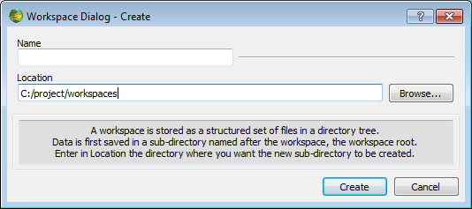

Figure 1: 'Create a new workspace' window. You can choose to save it wherever you want on your hard drive or local network, and name it as you prefer (preferably in such a way you will remember what's in it).

### Create a dataset

The first tab opened if you have never used BRAT is ‘**Datasets**’ (otherwise, the default tab is the one that was opened when you left BRAT GUI the last time you used it). This 'Datasets' tab is dedicated to the definition and selection of the data you want to use. You must define **at least one** dataset to be able to further use BRAT.

To create a dataset, click on the '**new**' button in the Datasets tab.

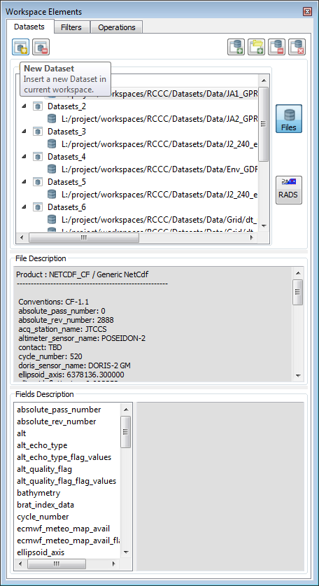

Figure 2: The Dataset tab as it appears when opening a new Workspace. The “New” button enables to create a new dataset

Default name for a new dataset is 'Dataset_1', with the number incrementing each time you create a dataset. You are strongly encouraged to re-name it, so that you'll remember what's in it when using it later on. To rename it, simply select the name, type in another one and press the Enter key.

When you have created your dataset and named it, you then have to add one or more data file(s), chosen from your hard drive, CD/DVD driver, local network or other medium. You can do so:

by using the '**Add Files**' button. **At least one file is necessary**.

If you wish to add a long list of files, the ‘**Add Dir**’ button allows you to choose all of the files within a folder by simply choosing the folder in which they are stored. Be careful that some data have header files in their data folders (you can remove them after selecting the whole folder) that won't be considered as homogeneous with the data files by BRAT.

**Dragging and dropping on datasets is currently not implemented, however it will be present in future BRAT releases.**

**Only coherent datasets are possible** (i.e. same format, same data product). BRAT netCDF outputs can be used, even several of them, provided they have exactly the same variables, with the same names. In the current BRAT release homogeneity of the Dataset files is performed automatically as the files are added.

Once you have added at least one data file, if you click on one file name in the list, you can see, bottom, information about the available fields within the data product, and (for netCDF files) about the file description below.

You can pre-select files relevant for your work by using the available ‘**Filters’** tab where you can define selection criteria for your datasets, in order not to uselessly process files out of desired area and period (date or cycle and pass). This new ‘Filters’ feature replaces the old ‘**Define selection criteria’** feature. Note that, besides selecting relevant files, ‘Filters’ also allow extracting/selecting data from files

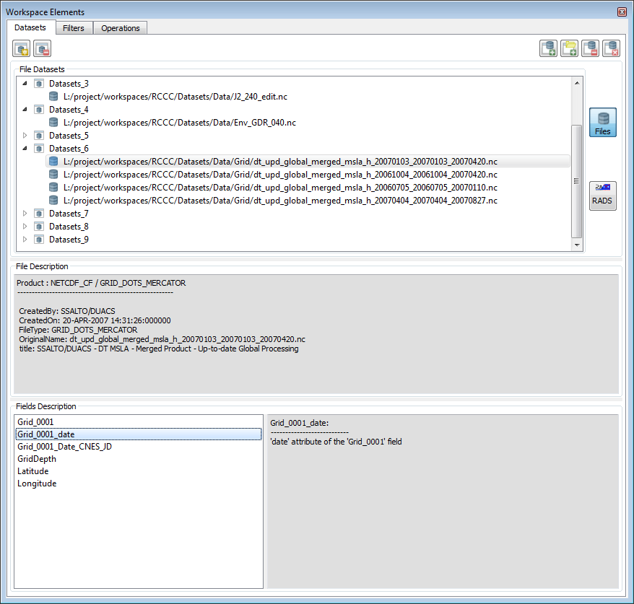

Figure 3: Several datasets. On the top, the list of files; on the centre, the description of the netCDF data file, bottom (left) enumeration of the available fields inside the netCDF file, bottom (right) field description.

### Create an operation

When you have defined which data you want to work on, you have to define what you want to do with them. This is done in the ‘Operations’ tab.

If none exist, you **have to create an Operation**. Click on the '**new**' button.

Default name for a new Operation is 'Operations_1', with the number incrementing each time you create an operation. You are strongly encouraged to re-name it, so that you'll remember what's in it when using it later on. To rename it, simply select the name, type in another one and press the Enter key.

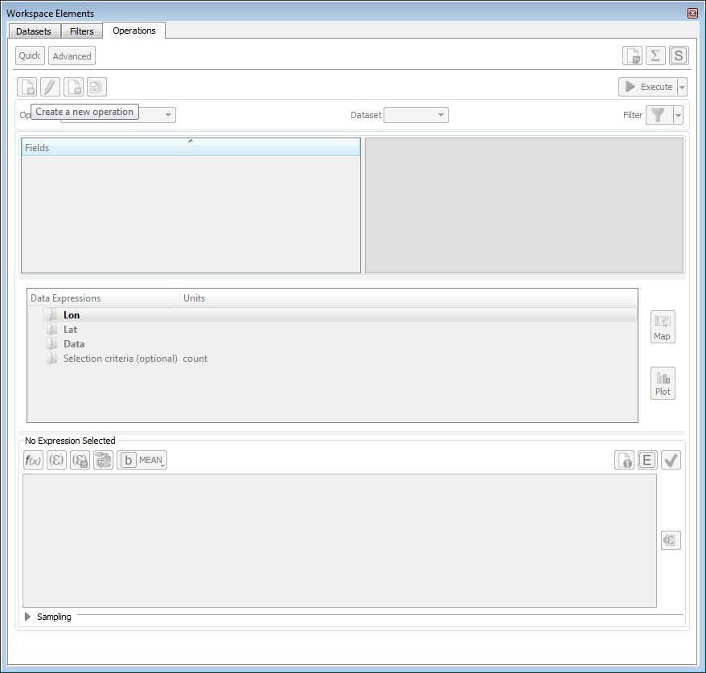Figure 4: An empty 'Operations' tab. The ‘Create new operation’ button enable to create a new 'Operation'.

Otherwise, you may work with a previously saved operation. The 'Operation' dropdown list contains all the already defined operations within the workspace, which can be selected, renamed, modified... Note that if you change the name of an operation within the ‘Operation’ box, it renames your operation.

#### Select source data

The information about the source data is in the topmost part of the Operations tab.

You first have to choose the dataset you want to work with from the ‘Dataset’ dropdown list. Then, within this dataset, the whole list of available fields is proposed, organised as a tree. If the data are split in different records, click on the '+' to expand the tree, '-' to flatten it.

The description of each field is given in the top (right) text box information available.

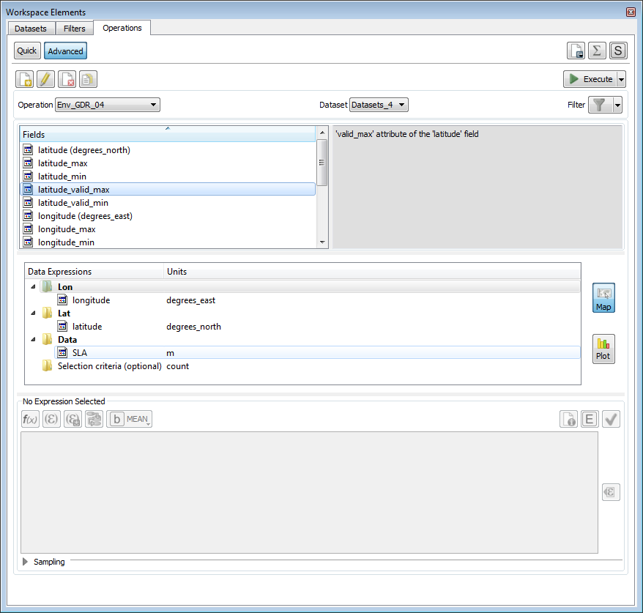

Figure 5: Choosing a dataset; below, the tree with records and data fields.

#### Define expressions

##### Generalities

An operation consists mainly in the definition of 'Expressions'.

An expression can be simple (one data field), or complex (with the use of arithmetic combinations, functions applied on several fields, etc.).

In the second row box of the 'Operations' tab ('Data expression'), you can see four categories of Expressions:

* ‘X’ or ‘Lon’ (case ‘Plot’ or ‘Map’ option is selected, respectively)
* ‘Y’ or ‘Lat’ (case ‘Plot’ or ‘Map’ option is selected, respectively)
* Data
* Selection criteria (optional)

**At least one expression as 'X', and one as 'Data' must be defined for an Operation to be valid**.

These expressions can be filled by several means, the quickest being by **drag & drop**: drag a field from the top (left) list and drop it in either one of those, or in the 'Expression' box (you can also use contextual menus by right-clicking either on the data fields or on the expressions, or use the 'Insert expression' and/or 'Insert field' button, or type in an empty expression the field names and functions you want to apply).

A 'brat_index_data' can be listed within the available data field. This is the index of the data (i.e. Measurement number in the file and/or record) **ordered along the time within a given file**. This means that it is not available for (e.g.) longitude-latitude grids, or for some data where the time is not provided explicitly.

If using this index with several different files in the same dataset, note that **the order of the files as appears within the dataset will be kept** (thus, if the files are not ordered chronologically, the net result will **not** be chronological either).

Note that only **one** expression can be defined as X, and (optionally) one as Y, whereas more than twenty can be defined as Data.

An Expression can be:

* only one field in a dataset (typically, for a map, longitude as X-axis, latitude as Y-axis, and e.g. significant wave height as Data, etc.)
* a combination of fields, either +,-,* and /, or by using the available Functions (see 4.3.3.4.2, Functions).
* a pre-set combination of fields among the ones you will find in the ‘Formulas’ (see 4.3.3.4.3, Formulas), e.g. SSH computation.

To check if your expression is well formulated, you can click on the '**Check syntax**' (green tick on the right) button (note, however, that this won't provide you with a validation of the relevance of your expression from the point of view of physics).

The '**Show Info**' button provides information about the original units (the ones defined in the data products) and the units used during computation or selection.

The '**Show Aliases**' button provides information about the aliases available for the chosen dataset. Aliases are equivalents that you can use instead of the fields' name.

E.g. a %{swh} alias exists, that works for all GDR data for the Ku-band significant wave height. Note, however, that since not all the fields exists for all the data, you may encounter warnings if you try some aliases on all the altimetry data.

If you want to go back on your work later on, or to save an expression as formula choose the “Save as” option and fill in the requested fields.

##### X, Y and data expressions

You can change the name of any X, Y or Data Expression, by double-clicking on their name, or by using the contextual menu available by right-click. This will then be the default name on the plots, on the axis or near to the scale if you have not given a title to your Expression (in the title/comment).

You can change the unit as it appears in the Expression tree area.

BRAT is able to understand all SI units and their sub-units as defined in the International System, i.e. **case sensitive** (e.g. “ms” means milliseconds, whereas “Ms” would mean megaseconds). There are also “count” for data without dimension, and “dB” (see section 4.3.3.4.1, Units). If you let “count” (which is the default) as unit, the resulting data will be in the basic SI unit (e.g. in metres, even if the field you used was defined in mm). **Note that you have to validate your change of unit by typing “enter” or clicking on the box below**.

If you choose a pre-saved formula, a default unit will appear as the unit. If you select one field in the dataset list and insert it, it will automatically be filled with the correct unit (but if you finally write your own formula, beware that the final unit might be different). If the unit you defined does not fit the unit of the data as defined, an error message will be generated (again, this does not work for complex expressions).

On any X, Y or Data Expression, you can apply 'data computation' (see 4.3.3.4.5, Data computation), to:

* compute statistics **at each point** (same X, optionally same Y): MEAN, STDDEV (standard deviation), COUNT.
* do some arithmetic operations **between files** within a dataset: adding, subtracting or multiplying: SUM, SUBTRACTION, PRODUCT)
* it can also be used for the display (MEAN, FIRST, LAST, MIN, MAX), if you prefer to visualise, for instance, the last value rather than the mean one.

Note that to compute the statistics for the Data Expressions as a whole (Number of valid data, Mean, Standard deviation, Minimum, Maximum), you can use the '**Compute Statistics**' (capital epsilon on the top right) button.

There are two main kinds of Operations:

* one – or several – Data expression(s) with respect to another one (X), leading to a “curve” plot
* or one – or more – Data expression(s) with respect to two others, leading to a “map” plot or 3D plot.

In the first case, you'll fill only the “X” expression; in the second, you'll fill both X and Y expressions. Note that X and Y can be Longitude and Latitude, but can also be any other two fields or combination of fields within the dataset.

If you fill both X and Y, you have to define a resolution (or sampling). For Longitude, Latitude a default resolution (1/3 of a degree for both axis), minimum and maximum are proposed. For other X and/or Y, a step of 1 is proposed, but no minimum and maximum. You can define a step, minimum and maximum values, or use the minimum and maximum value of your expression by clicking on the 'Get min/max expression values' button in the ‘Sampling’ section (on the bottom). The number of intervals is automatically computed from those elements, and cannot be directly changed.

Note that

* you cannot choose different resolutions for different data expressions within the same operation (they all share the same X and Y!).
* by choosing a step, you may sub-sample your source data.
* Changing the Min/Max can be used to extract a smaller X-Y area (as well as the selection criteria).
* And, of course, the smaller the steps, the higher the computation time! (and the heavier the output file)
* You can also choose to smooth and/or extrapolate the data by means of a Loess filter so as to obtain a fully coloured plot (and not individual tracks or points on a map). In that case, you will have to fill in the corresponding information for X and Y, too (see section 4.3.3.4.7, Smoothing).

##### Selection criteria expression

* The Selection criteria expression is used to select data e.g. by date and/or boundaries, etc. and/or for editing it using flag values, thresholds, etc. Logical, relational functions can be used, separated by && ('and'), || ('or') or with ! ('not'). Only the data fulfilling the whole set of conditions, and not equal to default values, are selected.
* The Selection criteria expression can be filled the same way than X, Y and Data expression. There can be only one Selection criteria expression. It is optional; when it is filled the 'Selection criteria' title is bold.

All the fields or combination of fields of the source data can be used. To use a combination of fields, it can be clearer to use a formula (see section 4.3.3.4.3, Formulas).

Note that the selection criteria expression is working only with the basic SI units (i.e. when defining thresholds, you have to put values in e.g. meters, even if the data source field is in mm).

#### Output

To process the defined operation on the whole selected dataset, you have to click on the ‘**Execute**’, button. The Logs tab then opens (see section 4.3.5, Logs tab), and you can see the current task(s) being executed (both operations and views), comments during execution (verbose mode) and errors.

The “Delay Execution” button enables to launch the Operation or an export (see next section) at a scheduled time. The “Launch scheduler” button launch the scheduler, which have to be running in order to have the task executed (NB. the Brat scheduler interface icon gives access to the same interface – see chapter 7 for more details).

Executing an operation builds an output netCDF. The name of this netCDF file is predefined using the name you gave to your operation, and cannot be changed within the GUI. It is stored in the Operation folder within your workspace.

BRAT output netCDF files can be used as source data in a new dataset, seen though the BRAT Display tool, or used with any other tool reading netCDF.

#### Export

You can choose to export the output data by clicking on the 'Export' button. Several formats are available:

* NetCDF (the same than the automatic one, but you can choose where you want it, and how it is named);
* Ascii - The Ascii export can also be seen (once saved) through a built-in text viewer ('Edit Ascii export' button);
* GeoTiff (if the axis of the operation are longitude and latitude), which also provides a Google Earth KML export format.

The KML/KMZ file contains the following information:

* The GeoTiff image overlaid,
* Along track points coloured as the GeoTiff. In the description of each point you will find:
  + Latitude and Longitude information
  + The Data variable chosen to be exported. In case the data exported is a distance measurement, the different along track points would be also placed with the elevation of the exported data. (Only one variable can be exported each time. If there are more variables placed on the Data folder, the export will not work).
  + Acquisition time, dataset/filetype information.
  + Colour bar relating the values of the variable exported and the corresponding color.
  + Brat logo overlaid.

### Create a view

When you have executed your operation, you may want to have a look at the results in a graphical way. This is usually automatic, after having computed a certain operation. If you want to view a certain operation you had previously computed, you can also do so by accessing “Window>Open” menu (this way you will not have to recompute every operation you may want to view).

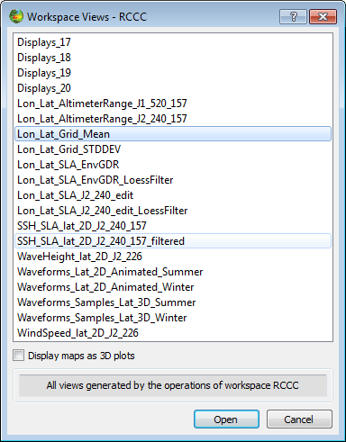

Figure 6: Dialog shown when “Window>Open” menu is triggered that allows the selection and visualization of a certain operations

In the current version of Brat you can only visualize data expression(s) from the same Operation previously computed. Therefore it will only make sense to visualize data from a given Operation. You can select the operation you want to visualize in the “**Operation”** drop-down menu.

The type of available display data has three main categories:

* Y=F(X), which are basically curve plots
* Z=F(X,Y), which are the representation of a value (in colors/contours) with respect to two others
* Z=F(Lon,Lat), i.e. maps

Different view types, will generate different view windows. However, there will be always a way to select the current “**Operation”** (via drop-down menu) and “**View**” (view “Operation Views” drop-down menu).

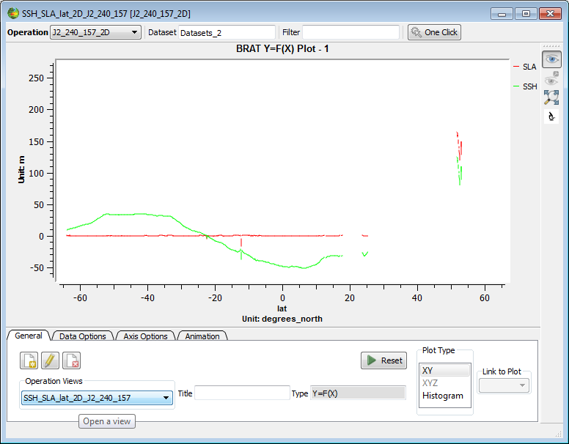

Figure 7: A 'Display’ window with one view created. Note the list of available views

Notice that all the data expressions are already made available for you to use under the “Data Options” tab. Here you can customize how to view your data or which data expressions to render.

You can select more than one data expression to be displayed. To handle animated plots configuration change the settings under “Animation” tab. All plot properties are to be changed within the visualisation window (see visualization interface) but, have to be re-defined each time you launch a plot.

## BRAT GUI tabs description

### Workspace menu

A 'workspace' is a way of saving your preferences, computations and generally the work done with BRAT.

A workspace contains definitions of:

* **Datasets**, that define the collections of files of the same kind you want to use,
* **Operations**, for reading and/or processing and/or selecting data within a dataset. An operation produces an intermediate file (netCDF) and a parameter file. Alternatively, data can be exported, in netCDF, Ascii or GeoTiff and KML.
* **Formulas**, to enable you to use pre-defined combinations of data fields or to define them yourself and re-use them later.
* **Views**, that plot results of one or more operations

A ‘view’ produces a parameter file and opens the visualisation tool

All these are stored within a folder named from the workspace, with a sub-folder for each part: Datasets, Displays, Formulas and Operations. Displays and Operations folders include parameter files (.par), which define the Views and Operations done, and the latter also include the netCDF intermediate files produced by the tool.

Workspace folders can be copied and exchanged. Results saved within a workspace can be accessed even if the source data are not available (but warning messages will be emitted when opening the workspace if some source data are not available).

Workspaces in BRAT GUI are managed by the menu the further to the left. It contains the following items:

* '**New**': creates a new workspace
* '**Open**': opens a previously saved workspace
* '**Save**': (or ctrl+s) saves the current workspace and all its datasets, operations, formulas and views
* '**Import**': imports a previously saved workspace within the current one (Datasets, Operations, Formulas and/or Views). Formulas can be imported separately, but otherwise, Views need the Operations and Operations need Datasets, so that you can't import Views without Operations and Datasets, nor Operations without Datasets.
* '**Rename**': renames the current workspace (note that it is not a copy, but a change of name)
* '**Delete**': deletes the current workspace
* '**Recent workspaces**': lists the 2 most recently used workspaces

### Datasets tab

This tab is dedicated to the choice of the source data product files.

In this tab window:

* The selected files’ names are on the left; as well as the tools to select them.
* The bottom display lists all fields defined for this kind of data and, in the middle there is a more detailed description of the selected field (extracted from the data dictionary).

You may define as many datasets as you wish.

Note that if you want the same operation to be applied to several files separately, you will have to define several datasets, or use the parameter files directly with a script (see section 8.3).

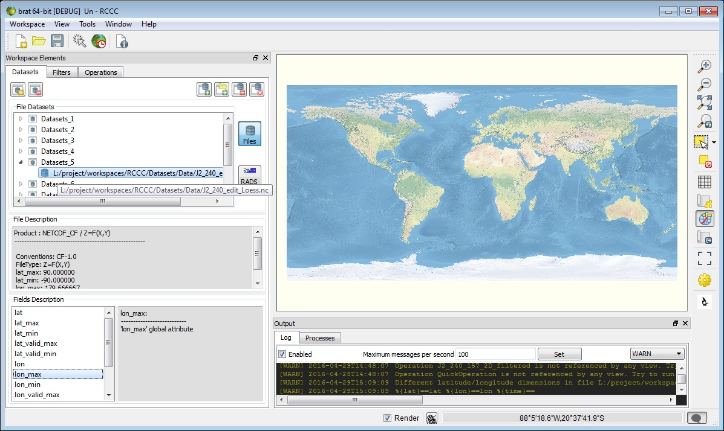

Figure 8: Example of dataset with netCDF data selected.

#### Creation of a dataset

The ‘Dataset Name’ is available in the “File Datasets” text box. This list contains all the defined dataset names and allows you to select and rename a dataset. You have to give the dataset a name (with no spaces or special characters in the name).

* If you change the name within “File Datasets” text box, and press the Enter key it renames your dataset.
* The 'New Dataset' button creates a new dataset, with a name like 'Datasets_2'
* The 'Delete...' button enables to delete an existing dataset, if your dataset is not used in an Operation.

#### Management of the data files list

The '**File Datasets**' textbox list is organized as a tree like structure that will list all the Datasets included in the current workspace and, when expanded, a certain dataset will list all the files of the dataset. Note that only coherent datasets are possible (i.e. same format, same data product).

* The ‘Clear’ button will remove the whole list included in selected dataset.
* You can delete the selected file by using the ‘Remove...’ button.

#### Selection of data files

Data can be selected in a quite long list of altimetry data (see 2, Data read and processed). File names don't have to be the original ones. However, files within a dataset have to be of the same data product (no mixing of e.g. Envisat and Jason-1 GDR data).

* The ‘Add files...’ button (at the top right of the window) enables you to select those data files you wish to work on.
* If there are a lot of files, you should preferably select a whole folder by clicking on ‘Add Dir...’, or proceed in several steps. Otherwise, some files names could be truncated, thus leading to an error.

For a more automatic selection of data files, you can use the Filters tab. When you apply a certain filter to a dataset (via Operations>filters) you will filter out all data files that do not match the filtering criteria. A filter is a set of Areas, time, cycle and pass constraints. The top four buttons allow you to perform basic Filters operations, namely:

* Create a new filter by pressing the “Create Filter” button.
* Rename an existing filter by pressing the “Rename Filter” button.
* Delete an existing filter by pressing the “Delete Filter” button.
* Saving a an existing filter by pressing the “Save Filter” button.

To define which areas this filter will contain, areas have been organised in regions – regions are mainly area containers and only exist to provide the user with better filtering interface (i.e. the lake region contains only lake areas). To edit the region settings, click under “**Region Settings**” button and a new dialog entitled “Region Settings...” should pop-up. There three buttons available for use:

* **“Create a Region”**  - creates a new region
* **“Rename a Region” –** renames the current region
* “**Delete a Region”** – deletes the current region

The purpose of this Dialog is simply to create a new region – the user can do this simply by selecting the areas to be included in the current (new) region and simply click “close” when the current region is defined.

The list of available regions are listed within the drop-down menu by the right of the “show all” button. By the right there is a display that shows the bounding area for each area within the selected region. Within each region there is also the possibility of excluding/including areas from being applied to the current filter – this is done by deselecting/selecting a checkbox within the area list available on the left side of the Filters tab. The “**Show All**”button simply lists all the available areas and the user should select only the ones he/she wants to include in the current filter. There are several ways to define a new area:

* One can simply select a new area by first using the “**Selection Tool**”by the right hand side of BRAT and then clicking on the “**Create Area**”button on the left side of the Filters tab, and the newly created area will represent the selected area created with the “**Selection Tool**”.
* From a KML file using the “**Add Area from KML file**”button .

The user can also rename a certain (selected) area by clicking on the “**Rename Area**”button. In a similar way, the user can also delete an area by clicking under the “**Delete Area**” button. Another filtering option is the Start Date/Stop Date – this will only keep the dataset files whose time range is contained within the range [Start Date, Stop Date]. Other filtering option is the Start Cycle/Stop Cycle that should only keep the dataset files whose Cycle is contained in the range [Start Cycle, Stop Cycle]. Start Pass/Stop Pass works in a similar manner.

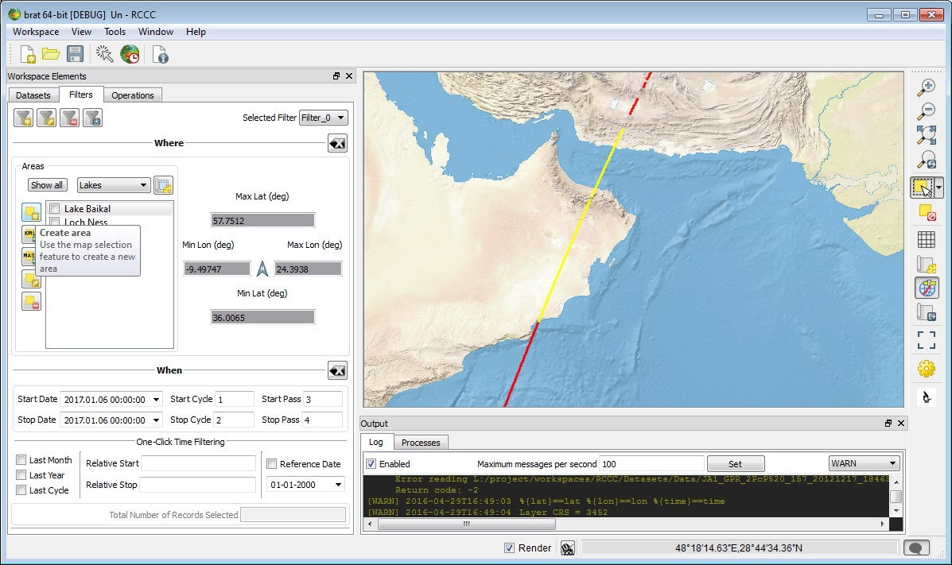

Figure 9: Filters tab showing applied filter

#### Data file information

On the middle left part of the Datasets tab, you can see information about the fields within the source data product.

Among the listed dataset properties, the following are available:

* 'Full name': the fully described name in the file structure hierarchy and related to the record.
* 'Name': the short field name
* 'Unit': the unit of the field
* 'Dim': Dimension of the field (number of values in arrays, if the data is stored in an array)

Under the list there is the '**Fields description**' box with a detailed description of the currently selected field (as extracted from the data dictionary)

Left, under the file list is a '**File description**' box, that give the information about the file for netCDF products.

### Operations tab

This tab is dedicated to the definition of what kind of computation(s) and/or selection(s) you want to apply on the data.

Building an operation in fact creates a 'parameter' files (.par), which keeps all the informations and which is stored in the Workspace Operations folder. Executing an operation use either the BRATCreateYFX or the BRATCreateZFXY programme on this parameter file to generate the output of the operation. The whole process can however be done completely through the GUI.

In this Operations tab window:

* The management of the operations is at the top.
* The data source (datasets and fields available within) are on the left.
* The middle part shows the different Expressions within the current Operation
* The bottom part shows the content of the selected Expression.

You may define as many Operations as you wish.

Note that an Operation must contains at least one X expression, and one Data expression.

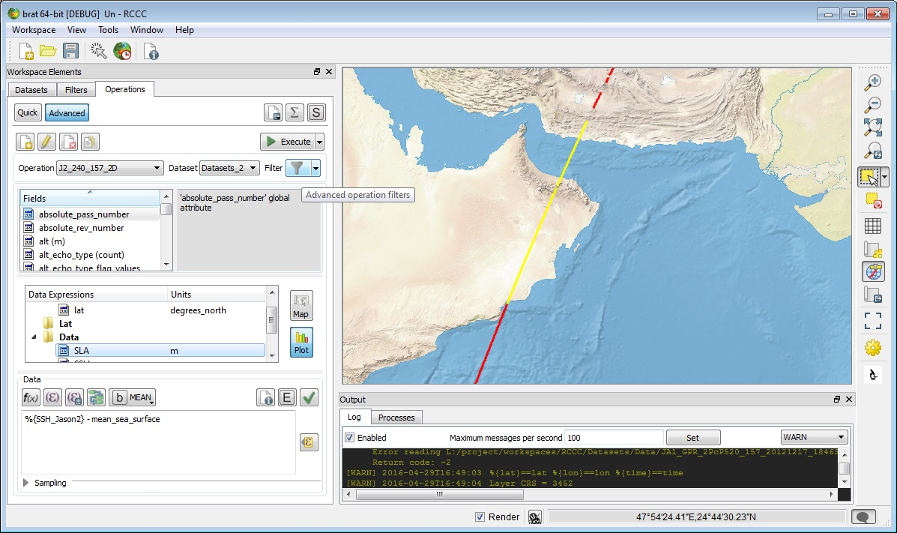

Figure 10: Operations tab, with an operation being built. Left the dataset chosen is called 'test_dataset', with Jason-2 data product; in the middle the list of fields within the J2 record being expanded. In the middle, only one Expression is defined yet ('lat' as X).

#### Manage Operations

Several functions are meant to 'manage' the operations.

* The ' operations' dropdown list contains all the defined operation names. To rename a certain operation you should use the “**Rename Operation**” button and allows you to select and rename an operation. When renaming an operation, take care that it does not copy it, but it replaces the old one.
* The **'Create a new operation'** button is used to create a new operation, with a name like 'Operations_2'
* The '**Duplicate selected operation**' button enables you to copy an existing operation, and modify it (e.g. change the dataset for another one with the same kind of data at another date, change the selection criteria, etc.).
* The **'Delete selected operation**' button enables to delete an existing operation, if none of your operation's expression is used in a View.
* The 'Execute' button executes the active operation.
* The 'Export' button enables to save the BRAT GUI output on either another format (Ascii, GeoTiff and KML) or in netCDF, and under another name wherever you prefer it.
* The 'Delay execution' feature is not implemented yet.
* The '**Launch scheduler**' button is not yet implemented in the current release.
* The '**Generate Statistics and save result in file**' button gives the global statistics for each Data expression. You can thus retrieve:
* Number of valid data,
* Mean,
* Standard deviation,
* Minimum,
* Maximum,

If you want to apply the same operation to different datasets, and be able to compare their outputs, you will have to re-create it as many times as needed, using the ‘**Duplicate selected operation**’ button. You can also use the parameter file directly with a script (see section 8.3, Using the parameter files to process many datasets). Or, you can export the data in netCDF for future use (otherwise, the output file will be replaced by the new one).

#### Define source data

* '**Datasets**' box lists the names of the datasets available within this workspace: you have to select one of them
* '**Fields**' box shows the list of all fields available within the selected dataset, organised as a tree.

Right-click provides a contextual menu, with 'sort ascending' and 'sort descending' at the bottom, to sort the data field names in alphabetical order (or reverse).

To know some information about one field, hover the mouse pointer over it, and a tooltip will appear.

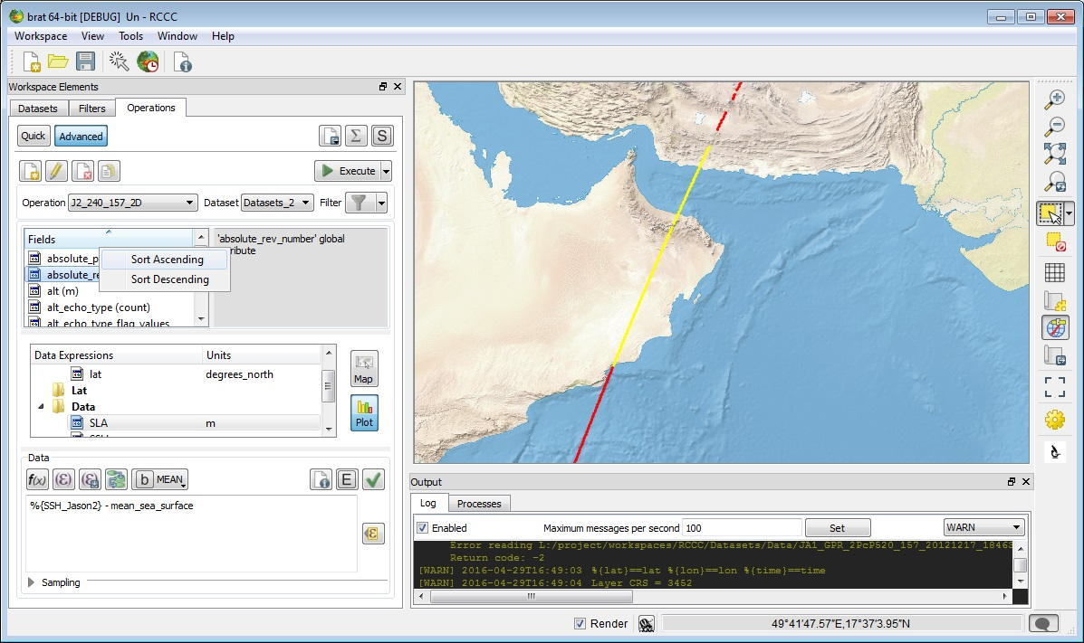

Figure 11: Operations tab.

#### Define expressions

In the middle of the Operations tab is the tree with the expressions, including the selection applied. You have four kinds of expressions:

* '**X**': as axis (the data will be organised relative to the values within this field); only one X expression is possible, and one is necessary.
* '**Y (optional)**': to be used as second axis (e.g. X=longitude, Y=latitude); only one Y expression is possible
* '**Data**': at least one Data expression is necessary, but you can add up to twenty of them.
* '**Selection criteria**' (optional; the title is bold when it is filled): it enables to select data e.g. by date and/or boundaries, etc. and/or for editing it using flag values, thresholds, etc. Logical, relational functions can be used, separated by && ('and'), || ('or') or with ! ('not'). All the fields, or combination of fields of the source data can be used. To use a combination of fields, it can be clearer to use a formula. Note that the selection criteria expression is working only with the basic SI units (i.e. when defining thresholds, you have to put values in e.g. meters, even if the data source field is in mm).

X an Y are used as axis: BRAT will read the source data and extract, for each X (optionally Y), the corresponding value of each Data expression fulfilling the conditions defined as 'selection criteria'.

All expressions can be filled the same ways.

The expressions can be filled by several means:

* The quickest is by **drag & drop**: drag a field from the leftmost list and drop it in either one of those, or in the 'Expression' box;

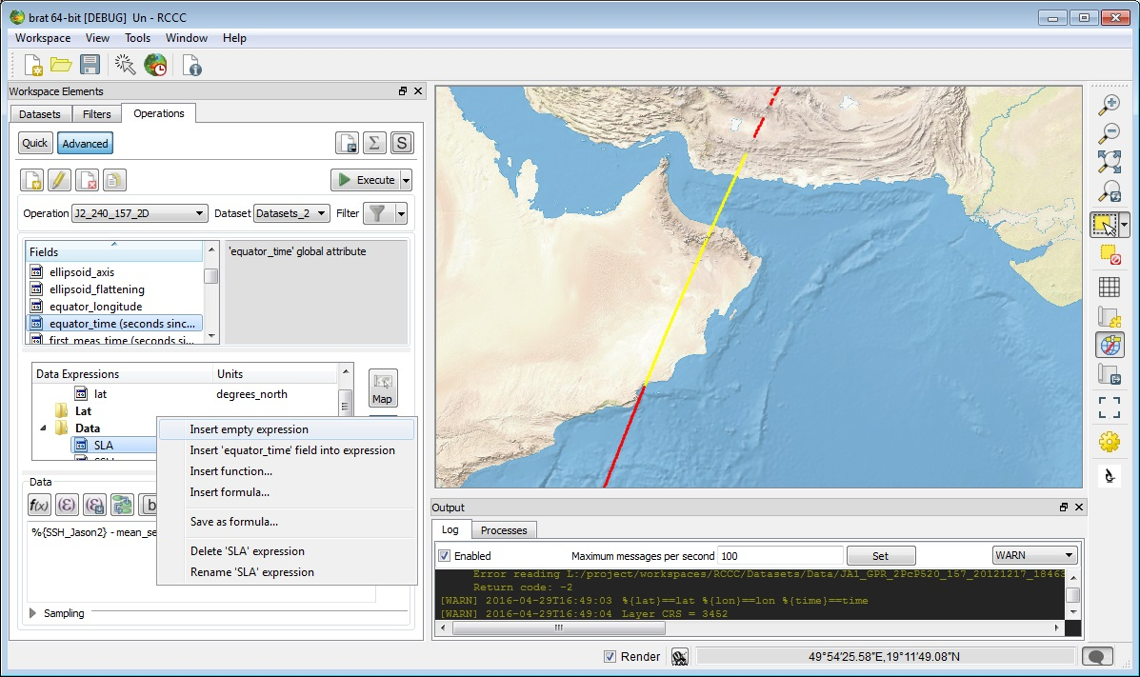

Figure 12: Example of menu that appears by right-click on a data expression (’SLA’). Note that here one data field ('equator_time') is selected (left-click); if no data field is selected, this item is inactive.

'Insert empty expression' will add a new expression (in 'Data'), or replace the active expression by an empty one (in X and Y). 'Insert (field) into expression' add the selected data field (if any) in the active expression. 'Insert function' enable to use the list of mathematical and logical functions, and 'Insert formula' insert one of the predefined expressions saved.

'Sort' enable to sort all the expressions (if there's more than one) by their name in either ascending or descending (alphabetical) order.

* or use the '**Insert field**' button (which will insert the selected data field in the active expression).
* or you can always use the '**Insert expression**' (which will insert an empty expression, to be filled by one or several combined fields) and type in an empty expression the field names and functions you want to apply, using your keyboard

Since you can do more than insert one field, a set of functions is available, as well as

* The '**Insert Function**' button opens the pop-up window with the list of available functions (see section 4.3.3.4.2, Functions) for the complete list and specifications)
* The '**Insert Formula**' button opens the pop-up window with the list of available formulas. A set of those is pre-defined (see section Formulas); more can be saved using '**Save as Formula**' button and re-used, in the same Workspace or imported in another one
* The '**Insert Algorithm**' button opens the pop-up window with the list of available algorithms (see section Algorithms) for the complete list and specifications)
* '**Delete expression**' button enables to delete an expression (the Delete key on your keyboard has also the same effect). Remember, however, that you have to have an X and a Data expression defined.

#### Expression information and parameters

When an expression is selected, several parameters can be filled/used.

* '**Unit**' of the expression: this text field is filled whenever you define a data field as expression, or use a predefined formula. Default is 'count' (meaning, without unit). See section 4.3.3.4.1, Units below for details about the units you can use. The unit of the Selection criteria expression is always 'count, by default', since it is a logical expression)
* The '**Type of the expression**' dropdown list is mainly of use for longitude, latitude and time as X and Y, and help manage specific needs for those type of data. Most of the time it should be automatically filled. If a discrepancy is detected, an error can be issued in the Logs tab.
* The '**Expression**' box: this where the expression itself is defined
* 'Data Computation' rolling list
* 'Check Syntax' button
* '**Show info**' button.
* 'Show aliases' button

Aliases have been added within BRAT to take into account the fact that the equivalent fields are not named similarly for all the datasets (names following the User documentation made by the data provider). The equivalent fields have been defined with the same alias(es) for all the altimetry data. If a given field is not available within the current dataset, a warning will be issued.

Note that there may be several aliases for a same field, in order to speed the typing (e.g. %{mss}), or be more self-explaining (e.g. %{mean_sea_surface}).

An alias can be a field or a combination of fields. They are stored in a “aliases.xml” file that can be edited (in brat program folder, data/ sub-folder). In the same folder, the aliases.xsd.html file gives the rules to define new aliases and/or modify the existing ones.

See section Aliases for more information.

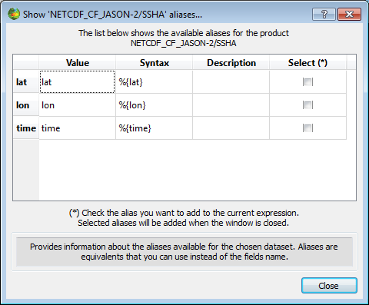

Figure 13: ''Show Aliases' pop-up window. Here for an Jason2 NetCDF file. Note the 'Syntax' column, where the alias syntax is given, while the 'Value' column gives the original field name (or combination).

If you are in an expression (X, Y or Data expression, or Selection criteria) you can insert one or several alias(es) in your expression by checking the box(es) in the 'Select' rightmost column. If no expression is selected, this column won't appear.

* 'Title/Comment' button

This feature is not available in current BRAT version.

* '**Resolution and filter information**' and '**Set Resolution / Filter**' feature from the older Brat is now available at ‘Sampling’ section and ‘Smoothing’ button, respectively.

##### Units

BRAT is able to understand all SI units and their sub-units, as defined in the International System, i.e. case sensitive: “ms” means milliseconds, whereas “Ms” would mean megaseconds), plus “count” for data without dimension, and “dB”.

Typically, the units you might use are:

* metres (m, mm, cm, km,...)
* seconds (s, ms, etc., but also hours, h, days)
* m/s (km/s,...)
* degrees East (longitude)
* degrees North (latitude)
* degrees
* count
* dB

Note that all data fields are converted in SI units in the data dictionary.

Thus practical units such as “TECU” are converted (1 TECU (Total Electron Content Unit) = 1 × 1016 electrons/m²).

If you let “count” (which is the default) as unit, the resulting data will be in the basic SI unit (e.g. in metres, even if the field(s) you used was defined in mm)

Every Operation is computed using SI units even if a sub-unit is defined for the data source and for the Expression (e.g. metres instead of cm, mm or km). Thus you can put ‘km’ as unit even if the data source field is defined in mm and still end up with correct values.

##### Functions

The **'insert function**' button provides a simple way of including (and knowing) the available functions and constants which can be used in expressions. The functions are organised by categories, but you can have a look at all of them. For each function, if selected, you will see a short explanation of what it does.

You can use those functions for, among others:

* compute geostrophic velocities modulus : sqrt(sqr(U) + sqr(V))
* a test on a flag: Surface_type == 0 will return only the ‘open ocean’ flagged Jason-1 GDR data
* boundaries: is_bounded(-130, alt_cog_ellip-ku_band_ocean_range ,100) (or: (alt_cog_ellip-ku_band_ocean_range >= -130) && (alt_cog_ellip-ku_band_ocean_range <= 100)) select only the data for which the uncorrected altimetric distance is between -130 and +100 metres

They are available for processing or selecting a data expression.

Basics functions (not listed below) are +, -, *, /, and ( and ); you can also use '^' to indicate a number to the power of another number (or data field or data expression) e.g. '10^-6' means '10-6'. Use the keyboard to insert them.

Table 3: BRAT functions

| Name | Description | Syntax | Type |
| --- | --- | --- | --- |
| ! | logical negation operator NOT  The logical negation operator (!) reverses the meaning of its operand.  The result is *true* if the converted operand is false; the result is *false* if the converted operand is true. | ! expr1 | Logical |
| != | not-equal-to operator  The not-equal-to operator (!=) returns *true* if the operands do not have the same value; otherwise, it returns *false*  A != B is true (when no default in A or B) if abs(A-B) >= epsilon | expr1 != expr2 | Relational |
| && | **logical AND operator**  The logical AND operator (&&) returns the boolean value *true* if both operands are *true* and returns *false* otherwise. Logical AND has left associativity. | expr1 && expr2 | Logical |
| || | logical OR operator  The logical OR operator (||) returns the boolean value *true* if either one operand is true or both operands are true and returns *false* otherwise. Logical OR has left associativity | expr1 || expr2 | Logical |
| < | **less than** It yields values of the Boolean type. The value returned is false (0) if the relationship in the expression is false; otherwise, the value returned is *true* (1). | arithmetic expr1 < arithmetic expr2 | Logical |
| <= | **less than or equal to** It yields values of the Boolean type. The value returned is false (0) if the relationship in the expression is false; otherwise, the value returned is *true* (1). | arithmetic expr1 <= arithmetic expr2 | Logical |
| == | equal-to operator  A == B is true (when there is no default in A or B) if abs(A-B) < epsilon  The equal-to operator returns true (1) if both operands have the same value; otherwise, it returns *false* (0). | == | Relational |
| > | **greater than** It yields values of the Boolean type. The value returned is false (0) if the relationship in the expression is false; otherwise, the value returned is true (1). | arithmetic expr1 > arithmetic expr2 | Relational |
| >= | **greater than or equal to** It yields values of the Boolean type. The value returned is false (0) if the relationship in the expression is false; otherwise, the value returned is true (1). | arithmetic expr1 >= arithmetic expr2 | Relational |
| ~ | bitwise not operator  Takes the value as an integer (a default value if the floating point one is outside the integer range) and reverses each bit. | ~ expr1 | Bitwise operator |
| & | **bitwise and operator** Takes the value of each operand as an integer (a default value if the floating point one is outside the integer range) and does an *and* operation on each corresponding bit *And* operation: 0011 & 0101 = 0001 | expr1 & expr2 | Bitwise operator |
| | | bitwise or operator  Takes the value of each operand as an integer (a default value if the floating point one is outside the integer range) and does an *or* operation on each corresponding bit *Or* operation: 0011 & 0101 = 0111 | expr1 | expr2 | Bitwise operator |
| () | parenthesis operator  Isolates an expression (or a sub expression) in order to take it as a whole. Exemple: A * (B + C) multiplies (B + C) by A. without parentheses, B would by multiplied by A and then C added | (expr1) |  |
| DV | Default value | DV | Constant |
| PI | **PI** value | PI | Constant |
| PI2 | **PI/2** value | PI2 | Constant |
| PI4 | **PI/4** value | PI4 | Constant |
| abs | absolute value  Calculates the absolute value. | abs(param1) | Math&Trigo |
| ceil | **ceiling of a value**  Calculates the ceiling of a value. | ceil(param1) | Math&Trigo |
| cos | cosine (radian)  Calculates the cosine (radian) of a value. | cos(param1) | Math&Trigo |
| cosd | cosine (degree)  Calculates the cosine (degree) of a value. | cosd(param1) | Math&Trigo |
| deg2rad | Translates Degree to Radian. | deg2rad(param1) | Math&Trigo |
| deg_normalize | **Normalizes longitude** (degree)  Z = deg_normalize(X, Y) returns a value which makes the following expressions true: Z = Y + n*360, X <= Z < X+360 | deg_normalize(param1, param2) | geographical |
| dv (DV) | Default value | DV | Constant |
| exp | **exponential**  Calculates the exponential. | exp(param1) | Math&Trigo |
| floor | **floor of a value**  Calculates the floor of a value | floor(param1) | Math&Trigo |
| frac | fractional parts  Calculates the fractional parts of a value. | frac(param1) | Math&Trigo |
| iif | Inline if  If the first parameter is true (not 0 and not default value),  the second parameter is returned, otherwise the third one is returned.  Logically equivalent to:  if (param1 is true)  return param2  else  return param3  end if | iif(param1, param2, param3) | Logical |
| iif3 | Inline if with default value case  If the first parameter is true (not 0 and not default value),  the second parameter is returned. If is is 0, the third one is  returned, otherwise (it is a default value) the fourth one is  returned.  Logically equivalent to:  if (param1 is default value)  return param4  else  if (param1 is true)  return param2  else  return param3  end if  end if | iif3(param1, param2, param3, param4) | Logical |
| int | integer parts  Calculates the integer parts of a value. | int(param1) | Math&Trigo |
| is_bounded | **Checks whether a value x is included between two values** (min/max).  is_bounded(min, x, max) | is_bounded(param1,param2,param3) | Relational |
| is_bounded_strict | **Checks whether a value x is stricly included between two values** (min/max).  is_bounded_strict(min, x, max) | is_bounded_strict(param1,param2,param3) | Relational |
| is_default | **Checks whether a value is a default value** (1: yes, 0: no) | is_default(param1) | Logical |
| log | logarithm  Calculates the logarithm of a value | log(param1) | Math&Trigo |
| log10 | base-10 logarithm  Calculates the base-10 logarithm of a value | log10(param1) | Math&Trigo |
| max | Maximum  Calculates the larger of two values | max(param1,param2) |  |
| min | Minimum  Calculates the smaller of two values | min(param1,param2) |  |
| mod | **floating-point remainder**  Calculates the floating-point remainder | mod(param1,param2) | Math&Trigo |
| rad2deg | Translates Radian to Degree | rad2deg(param1) | Math&Trigo |
| round | rounded value  Calculates the rounded value | round(param1) | Math&Trigo |
| rnd | **rounded value**  Calculates the rounded value of a number x with a decimal precision of n figures after decimal point. rnd(x,decimal precision) | Rnd(param1,param2) | Math&Trigo |
| sign | **Checks the sign** of a value (-1: negative, 1: positive or zero) | sign(param1) | Math&Trigo |
| sin | sine (radian)  Calculates the sine (radian) of a value. | sin(param1) | Math&Trigo |
| sind | sine (degreee)  Calculates the sine (degreee) of a value. | sind(param1) | Math&Trigo |
| sqr | square  Calculates the square of a value. | sqr(param1) | Math&Trigo |
| sqrt | square root  Calculates the square root of a value. | sqrt(param1) | Math&Trigo |
| tan | tangent (radian)  Calculates the tangent (radian) of a value. | tan(param1) | Math&Trigo |
| tand | tangent (degree)  Calculates the tangent (degree) of a value. | tand(param1) | Math&Trigo |
| to_date | Date formats conversion  Translates a string value into a date value  Allowed formats are:   YYYY-MM-DD HH:MN:SS.MS string.   For instance:   '1995-12-05 12:02:10.1230'   '1995-12-05 12:02:10'   '1995-12-05'   a Julian string: format:positive 'Days Seconds Microseconds'   Seconds must be stricty less 86400 and Microseconds must be stricty less than 1000000   For instance:   '2530 230 4569'   a Julian string: format:positive decimal Julian day   For instance:   '850.2536985'  For Julian string, it can contain its reference date at the end by specifying @YYYY where YYYY is the reference year that's must be one of 1950, 1958, 1985, 1990, 2000  The reference year YYYY stands for YYYY-01-01 00:00:00.0  If no reference date is specified the default reference date (1950) is used.   For instance:   '2530 230 4569@2000'   '850.2536985@1990'   '850.2536985@1950' is equal to '850.2536985'  Dates prior to 1950-01-01 00:00:00.0 are invalid | to_date(param1) | Date&Time |

NOTE: except when explicitly stated (as with iif3, is_default) every expression involving a default value (also called missing value) is a default value. A true expression is an expression which is not 0 and not a default value. The descriptions below are for expressions which do not contain default values (to simplify their writing). For example the result of ‘A || B’ (A or B) is a default value if B is one even if A is true. 0 and default values are considered as false values (! X is a default value if X is also one, so X is false and ! X too).

##### Formulas

In the **“insert formula”**button, you will find pre-defined formulas (Sea Surface Height and Sea Level Anomaly formulas from the different satellites’ GDR fields, and also 'Ocean editing' formulas, to use as selection criteria to select only valid data over ocean). If you have saved as formula an expression in the current workspace (or imported one from another workspace), you will also find it here. Any expression, i.e. valid combination of data fields and functions can be saved as formula. You can insert a developed formula and modify it, or use a formula as part of an expression.

The formula will appear either by its name only (if you leave the ‘as alias’ checked), or complete (if you un-check ‘as alias’).

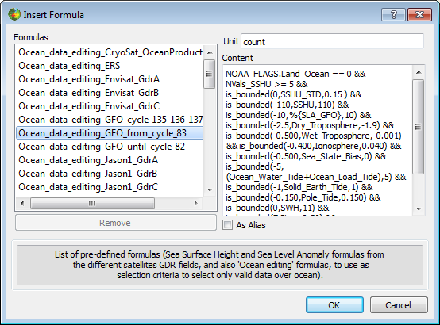

Figure 14: The 'Formulas' pop-up window, with the list of available formulas, top (sorted in alphabetical order).

Here, one of them (Ocean_data_editing_GFO_from_cycle_83) is selected, thus you can see the unit of the formula ('count', i.e. no unit, this is a selection formula), and the full formula in the box below. The check-box 'As alias' enables to insert the formula by its name only ('as alias') or, when unchecked, to insert in its full extent.

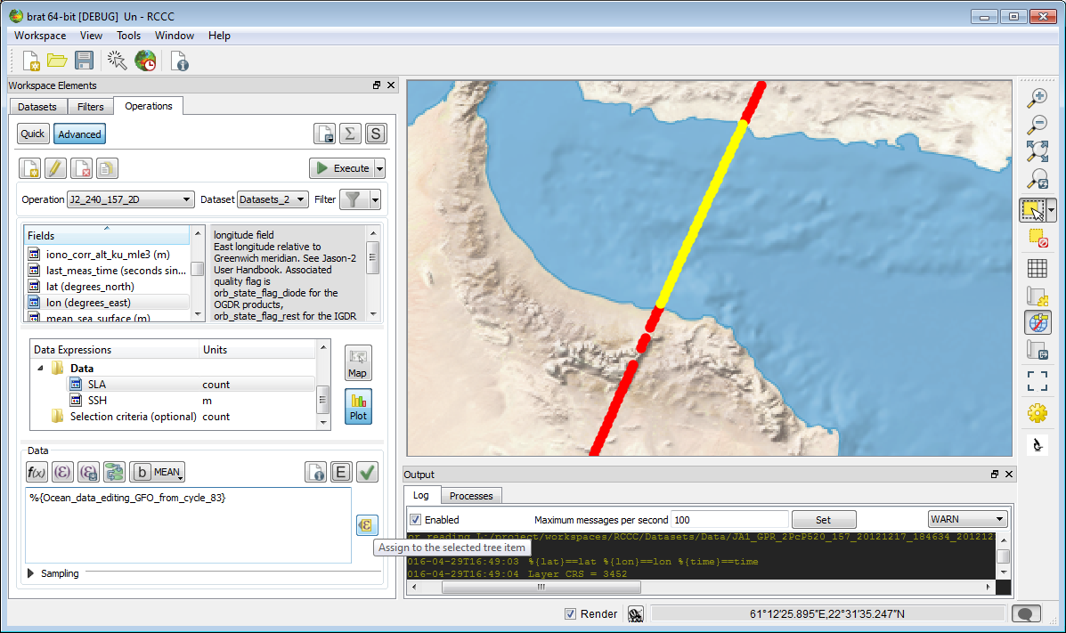

Figure 15: use of a pre-defined formula (Ocean_data_editing_GFO_from_cycle_83), by inserting its developed version Note the use in this particular formula of another formula as alias %{Ocean_data_editing_GFO_from_cycle_83} on the next to last line)

To apply the inserted formula to the selected Data Expression in the tree item, click the button “**Assign to the selected tree item**”.

##### Algorithms

Algorithms provide means of computing complex operations. They are pre-defined and compiled within BRAT. They include an algorithm name and a number of input parameters (depending on the algorithm) to be filled in by the user. The button “insert algorithm” enable to access the available algorithms with the relevant information provided.

Eleven algorithms are available at this time:

* computation of U (zonal) and of V (meridional) component of geostrophic velocities from gridded data
* computation of across-track geostrophic velocities from along-track data.
* Filters to apply on along-track data (Gaussian, Median, Lanczos or Loess)
* Filters to apply on gridded data (Gaussian, Median, Lanczos or Loess)

Note that, as in the all of BRAT, computations are done in SI units. If the field(s) you are using have a unit defined, BRAT will take care of the conversion. However, beware if there is no unit really defined (“count”). BRAT will then consider the data as in S.I.

Table 4: BRAT algorithms

| Name | Description | Input parameters |
| --- | --- | --- |
| BratAlgoGeosVelAtp | Geostrophic velocity computation for along-track data; result is the value of the geostrophic velocity component perpendicular to the track.  Input data must contain at least longitude, latitude and a field corresponding to an height information. | **Latitude**: to be replaced by the name of the latitude field within the data  **Longitude**: to be replaced by the name of the longitude field within the data  **Height**: to be replaced by the name of a field corresponding to an height (e.g. SLA, ADT...), or a formula enabling to compute it. |
| BratAlgoGeosVelGridU | Geostrophic velocity computation for gridded data; result is the value of the geostrophic velocity zonal (North) component, U.  Input data must contain at least longitude, latitude and a field corresponding to an height information. | **Latitude**: to be replaced by the name of the latitude field within the data  **Longitude**: to be replaced by the name of the longitude field within the data  **Height**: to be replaced by the name of a field corresponding to an height (e.g. SLA, ADT...), or a formula enabling to compute it.  **5**: latitude North and South below which the computation won't be done, to take into account the lack of Coriolis force at the Equator. |
| BratAlgoGeosVelGridV | Geostrophic velocity computation for gridded data;  result is the value of the geostrophic velocity meridional (East) component, V  Input data must contain at least longitude, latitude and a field corresponding to an height information. | **Latitude**: to be replaced by the name of the latitude field within the data  **Longitude**: to be replaced by the name of the longitude field within the data  **Height**: to be replaced by the name of a field corresponding to an height (e.g. SLA, ADT...), or a formula enabling to compute it.  **5**: latitude North and South below which the computation won't be done, to take into account the lack of Coriolis force at the Equator |
| BratAlgoFilterGaussianAtp | Gaussian Kernel filter for along-track data.  A gaussian filter is a linear weighted mean filter. Weights in the filter are calculated according to a gaussian distribution. | **Expr**: The input data (variable or Brat expression) on which the filter is applied **WindowLength**: Window/region size (N). The value must be odd.  **1**: The standard deviation (sigma) of the distribution. Set by default to 1. The parameter must be a constant value.  **3**: The coefficient of spreading to the left and right of the distribution." Set by default to 3. The parameter must be a strictly positive constant value. Usually in practice, the value used is 3 with sigma equals to 1. The part of Gaussian distribution utilized is the range [(-3 x sigma), (3 x sigma)], the Gaussian distribution is truncated at points +/- (3 x sigma). When the range is [(-3 x sigma), (3 x sigma)], the bell-shaped curve adjusts the corner values to 0.01.  **ValidPts**: The minimum number of valid points below which the algorithm is not applied.  **0**: A flag to specify if the algorithm is applied when the current data is 'defaut value' (no value). 0: not applied, 1: applied. |
| BratAlgoFilterGaussianGrid | Gaussian Kernel filter for gridded data.  A gaussian filter is a linear weighted mean filter. Weights in the filter are calculated according to a gaussian distribution. | **Expr**: The input data (variable or Brat expression) on which the filter is applied **WindowLength**: Window/region size (N x N). The value must be odd.  **1**: The standard deviation (sigma) of the distribution. Set by default to 1. The parameter must be a constant value.  **3**: The coefficient of spreading to the left and right of the distribution." Set by default to 3. The parameter must be a strictly positive constant value. Usually in practice, the value used is 3 with sigma equals to 1. The part of Gaussian distribution utilized is the range [(-3 x sigma), (3 x sigma)], the Gaussian distribution is truncated at points +/- (3 x sigma). When the range is [(-3 x sigma), (3 x sigma)], the bell-shaped curve adjusts the corner values to 0.01.  **ValidPts**: The minimum number of valid points below which the algorithm is not applied.  **0**: A flag to specify if the algorithm is applied when the current data is 'defaut value' (no value). 0: not applied, 1: applied. |
| BratAlgoFilterLanczosAtp | Lanczos kernel filter for along-track data.  A Lanczos filter is a weighted filter. Weights in the filter are calculated in the Frequency space, using Fourier transform. | **Expr**: The input data (variable or Brat expression) on which the filter is applied **WindowLength**: Window/region size (N). The value must be odd.  **CutOff**: The value of the cut-off period (number of data points). The frequency (1/CutOff) is the value at which the response passes from one to zero.  **ValidPts**: The minimum number of valid points below which the algorithm is not applied.  **0**: A flag to specify if the algorithm is applied when the current data is 'defaut value' (no value). 0: not applied, 1: applied. |
| BratAlgoFilterLanczosGrid | Lanczos kernel filter for gridded data.  A Lanczos filter is a weighted filter. Weights in the filter are calculated in the Frequency space, using Fourier transform. | **Expr**: The input data (variable or Brat expression) on which the filter is applied **WindowLength**: Window/region size (N x N). . The value must be odd.  **CutOff**: The value of the cut-off period (number of data points). The frequency (1/CutOff) is the value at which the response passes from one to zero.  **ValidPts**: The minimum number of valid points below which the algorithm is not applied.  **0**: A flag to specify if the algorithm is applied when the current data is 'defaut value' (no value). 0: not applied, 1: applied. |
| BratAlgoFilterLoessAtp | Loess kernel filter for along-track data.  A Loess filter is a low-pass filter mostly used for smoothing. It is based on a local regression using weighted linear least squares and a 2nd degree polynomial model | **Expr**: The input data (variable or Brat expression) on which the filter is applied  **X**: The input data (X values) used to compute weights.  **WindowLength**: Window/region size. The value must be odd.  **ValidPts**: The minimum number of valid points below which the algorithm is not applied.  **Extrapolate**: A flag to specify if the algorithm is applied when the current data is 'defaut value' (no value). 0: not applied, 1: applied. |
| BratAlgoFilterLoessGrid | Loess kernel filter for gridded data. When used with X=longitude, Y=latitude, it is equivalent to the filter available in the 'set resolution/filter' box (but it can be applied here on any and every X and Y)  A Loess filter is a low-pass filter mostly used for smoothing. It is based on a local regression using weighted linear least squares and a 2nd degree polynomial model | **Expr**: The input data (variable or Brat expression) on which the filter is applied **WindowWidth**: Window/region width (x). The parameter must be a constant odd value. **WindowHeight**: Window/region height (y). The parameter must be a constant odd value. **ValidPts**: The minimum number of valid points below which the algorithm is not applied.  **0**: A flag to specify if the algorithm is applied when the current data is 'defaut value' (no value). 0: not applied, 1: applied. |
| BratAlgoFilterMedianAtp | Median kernel filter for along-track data.  A Median filter is often used for speckle noise reduction. A median filter is a non-linear filter which orders the elements within a window and pick the middle one. | **Expr**: The input data (variable or Brat expression) on which the filter is applied **WindowLength**: Window/region size **ValidPts**: The minimum number of valid points below which the algorithm is not applied.  **0**: A flag to specify if the algorithm is applied when the current data is 'defaut value' (no value). 0: not applied, 1: applied. Expr:  WindowLength: |
| BratAlgoFilterMedianGrid | Median kernel filter for gridded data.  A Median filter is often used for speckle noise reduction. A median filter is a non-linear filter which orders the elements within a window and pick the middle one. | **Expr**: The input data (variable or Brat expression) on which the filter is applied **WindowWidth**: Window/region width (x) **WindowHeight**: Window/region height (y) **ValidPts**: The minimum number of valid points below which the algorithm is not applied.  **0**: A flag to specify if the algorithm is applied when the current data is 'defaut value' (no value). 0: not applied, 1: applied. |

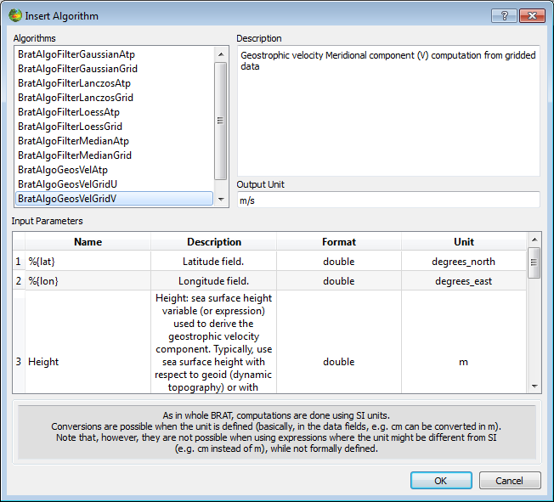

Figure 16: Insert Algorithm pop-up, with the BratAlgoGeosVelGridV selected.

A list of available algorithm is shown (top)

Description of the selected algorithm is available (just below) as well as the necessary input parameters (middle) and standard output unit (here m/s, bottom). Clicking on “OK” will insert the call to the algorithm within the current expression (it will appear as exec('”BratAlgoGeosVelGridV”,%{lat],%{lon],Height,5) in the expression box.

You then have to change the four input parameters (or not; most of the time, only “Height” will have to be changed; Latitude and Longitude aliases are used, so they will work for any dataset) to fit your dataset and your needs.

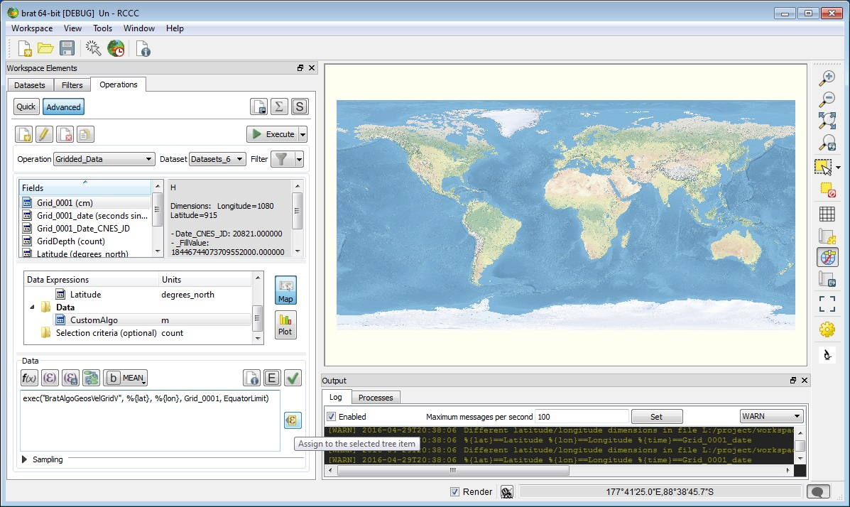

Figure 17: Operation resulting from the insertion of algorithms (here the “CustomAlgo” algorithm is visible). Latitude, Longitude and 5 have been left as default; Height is replaced by “Grid_0001”, which is the name of the Sea Level Anomaly height in the gridded dataset used.

##### Data computation

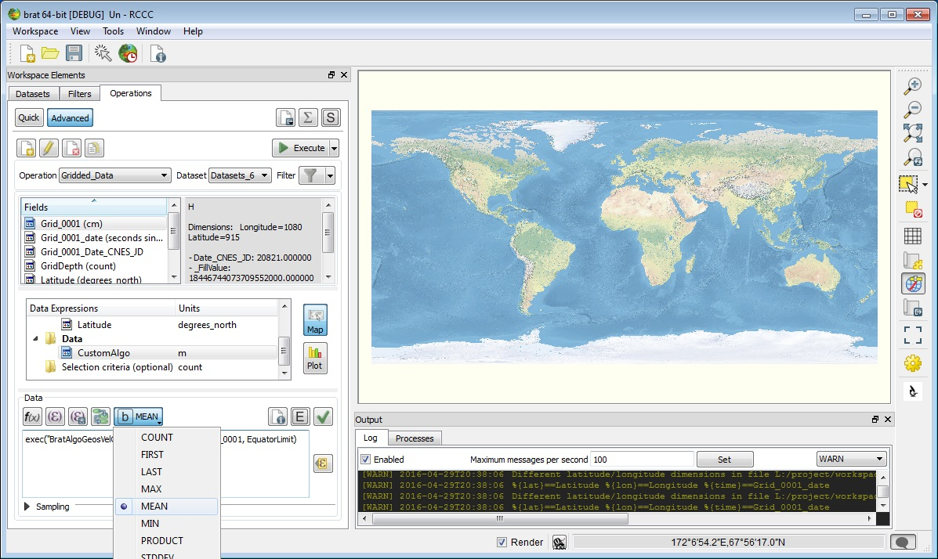

Figure 18: Choice of the data computation

The data computation is used whenever you have several values of a field for a given (X) or (X,Y). This is typically the case for:

* crossover points between tracks
* several files available for different dates
* sub-sample data

Possible computations are:

* '**MEAN**' (default): computes the mean for all values of the field within the dataset at each X (or (X,Y))
* '**COUNT**': returns the number of values of the field within the dataset at each X (or (X,Y))
* '**FIRST**': returns the first encountered value of the field within the dataset (in the order of the list of files as it appears in the ‘dataset’ tab)
* '**LAST**': returns the last encountered value of the field within the dataset (in the order of the list of files as it appears in the ‘dataset’ tab)
* '**MAX**': gives the maximum value of the field within the dataset
* '**MIN**': gives the minimum value of the field within the dataset
* '**PRODUCT**:' multiplies the selected field for each file within the dataset
* '**STDDEV**': computes the standard deviation for all values of the field within the dataset at each X (or (X,Y))
* '**SUBTRACTION**': subtracts the selected field for each file from the first of the list (file order dependent)
* '**SUM**': adds the selected field for each file

Take care, however, that for along-track data, on a given ground track, longitudes or latitudes are scarcely ever exactly the same from one cycle to the next. So if you want to (e.g.) average data over several cycles for a given track with respect to **only** longitude or latitude, you will have to round the data in the X expression (see round or rnd functions).

##### Sampling (previous ‘Resolution and filters’)

When you fill both X and Y, you 'grid' the data. You then have to define the grid parameters, i.e. **minimum, maximum and step, for the whole operation**. Note that by choosing a step, you may sub-sample your source data, and that by changing the Min/Max you can extract a smaller X-Y area.

* for longitude/latitude, Minimum and Maximum are set by default to 0 – 360°,-90° – 90° (whatever the data source). For any other type of X and Y, Minimum and maximum have to be defined. The 'Get min/max expression' button is here to help you: if you don't have an idea of what the values of your field could reasonably be, this will provide you with the absolute minimum and maximum of your expression (note that if your dataset include a long list of files, it can take some time to be computed). The unit in which the minimum and maximum have to be defined are those defined in the corresponding expressions, and are recalled, top of each sub-part of the window.
* Pre-defined steps are proposed (1/3° for longitude and latitude, 1 for any other data), but may not fit your need. The number of intervals is automatically computed from those elements, and cannot be directly changed.

However, note that the higher the step, the smaller the resolution, and the longer the execution time for the operation.

##### Smoothing

BRAT provides you with the possibility of “smoothing”, “binning”, or to extrapolate the data, using Loess filter

There are three different filters :

* '**Smooth**': smoothes the values of the data where there are already data (i.e. it will not fill in gaps between tracks)
* '**Extrapolate**': fills in the gaps between values (with some overlay on continents)
* '**Loess**': smoothes and fills in the gap values (with some overlay on continents)

The choice depend on the result you want. ‘Extrapolate tends’ to keep data ground tracks visible. ‘Smooth’ spreads out the data, but tends to level the maxima and minima and to generate ‘data’ on continents from ocean-only measurements. ‘Loess’ does both extrapolation and smoothing.

If you select one of them, you have set the ‘Loess cut-off’ value for each axis (both X and Y), i.e. the number of grid points before the Loess filter becomes equal to zero (odd number).

Typical Loess filter cut-off values depend on the Step you choose and on the kind of filter you have selected in your field (Smooth, Extrapolate or Loess). They are odd numbers (if you fill in an even number, the number used will be your number+1).

The general rule is that the higher the cut-off value, the more spread out the data will be, since the radius of action of the filter will be greatest.

For good results to render along-track data, values of 31 begins to gives rather correct results, even if they still show a hint of ground tracks.

### Logs tab

The ‘**Logs**’ tab displays the state of the programmes being run. Several operations and views can be executed at the same time. Errors can be detected using the messages from the Logs tab.

If things go well, you should have messages like:

'===> Task 'DisplayDisplays_17' (pid 284) SUCCESSFULLY ENDED <===

Currently the Log functionality of Brat only serves as a gateway to monitoring the behaviour of Brat internally.

# ALIASES

Aliases are short names or unified names for data fields. Aliases have been added within BRAT to take into account the fact that the equivalent fields are not named similarly for all the datasets (names always follow the User documentation made by the data provider, in order that the user can refer to this documentation for more information).

Some are already defined. The equivalent fields have been defined with the same alias(es) for all the relevant altimetry data. If a given field is not available within the current dataset, a warning will be issued. However, you can either modify them, or create your own ones.

A few aliases are “universal” (pre-defined for all known datasets read by BRAT) : %{lon}, %{lat}, %{time}

(NB. you may encounter NetCDF data read by BRAT but not pre-defined, for which this won't work, however, in this version we are currently developing ways to solve this problem)

Note that there may be several aliases for a same field, in order to either speed the typing (e.g. %{mss}), or be more self-explaining (e.g. %{mean_sea_surface}).

An alias can be a field or a combination of fields. They are stored in a “aliases.xml” file that can be edited (in brat program folder, data/ sub-folder). In the same folder, the aliases.xsd.html file gives the rules to define new aliases and/or modify the existing ones.

The following must be kept in mind:

* an alias always refer to a given data product.
* BRAT GUI call to aliases.xml for alias definition. If you modify this file, the aliases can change! (and, thus, if you used aliases previously, your Operations may not work anymore)

## Using aliases

Aliases can be used as any field or combination of field, by using “%” before the name, and encompassing it between “{“ and “}”

For example, a (nearly) universal SSH formula could be written as follow in the 'data expression' of an Operation:

%{alt} - %{range} - %{dry_tropo_corr} -%{dynamic_atmos_corr} - %{tides_all_corr} - %{ssb} - %{iono_corr} - %{wet_tropo_corr}

(**note that the fact that not all corrections are available for all satellites make it not absolutely universal!**)

or, in a “selection criteria” expression, you could write:

is_bounded(40,%{lat},60)

to select data between 40°N and 60°N.

## Structure

Here is an example of the structure of the xml file. For more information on this structure, please refer to aliases.xsd.html file.

<product class="ENVISAT_RA2MWR" description="ENVISAT RA2 and MWR products">

<defaultRecord name="ra2_mds"/>

<aliases>

….

<alias name="range">ku_band_ocean_range</alias>

….

</aliases>

</product>

Figure 19: example of the definition of an alias. This example is for Envisat RA2 and MWR products, by default for data within the “ra2_mds” record. “ku_band_ocean_range” is the name give by default in the documentation and thus in BRAT. To keep it simpler, we call it here “range”.

See Brat products format definitions in the doc/codadef/index.html file located in the Brat directory. Products are classified in 'class' (product class) and 'type' (product type)

## Modifying an alias

To modify an alias, edit the xml file in a text editor. And just change its name in <alias name="....">.

For example, you could replace:

alias name="range">ku_band_ocean_range</alias>

by

<alias name="THERANGE">ku_band_ocean_range</alias>

thus, afterwards, you would be using %{THERANGE} as alias. Note that, in this case, previous use of %{range} won't work anymore.

## Creating an alias

### For a field for which no alias exists

Find the product(s) for which you want the alias to work, and just add a line like:

<alias name="range">ku_band_ocean_range</alias>

defining the name you wish to use, and the given name of the field. You have to do it for any and every data product where you want to use this alias.

See Brat products format definitions in the doc/codadef/index.html file located in the Brat directory. Products are classified in 'class' (product class) and 'type' (product type)

You may have to specify a record within the default record.

You will put this in a ProductType tag, like

aliases productType="RA2_MWS_2P" record="avg_waveforms_mds" ref="RA2_GDR_2P">

You can use combination of fields to define an alias. E.g. an alias including all tide-related corrections can be:

“<alias name="tides_all_corr">(ocean_tide_sol1+ solid_earth_tide + pole_tide)</alias> “

### For a field for which an alias has already been defined

If you'd prefer something else than the predefined name, but do not want to erase it by modifying it, you can create alternate aliases.

For example, above we decided that when we will be using %{range}, it will be the field “ku_band_ocean_range“. However, it can be misunderstood (there's a 'C-Band' range in Envisat data). So you may want to specify at least in some cases that you are using the Ku-band range (e.g. if you're using C-Band data close-by).

To do this, you would define :

<alias name="range">ku_band_ocean_range</alias>*[as previously]*

<alias name="range_ku" ref="range"/>*[referring to the above alias]*

You can then use either %{range} or %{range_ku} in an expression with the same results.

# VISUALISATION INTERFACE

Within the “**Operations tab**” you also define which type of view you want to choose to display you data: you can choose between a Map type or a Plot type (simply by clicking on the button with the proper caption). However, to plot your data in a Map you need to have at least the field “Lon”, “Lat” and “Data” set. Otherwise (if you choose the “Plot” type) you are implicitly choosing 2D or 3D representation for your data. Once you do this you can view your data simply by clicking the “**Execute**” button.

The visualisation options are quite different for an ‘**Y=F(X)**’ (curve) than for a ‘**Z=F(lon,lat)**’ (map); the other plots ('**Z=F(X,Y)**') have functionalities from both types.

## ‘Plot2D’

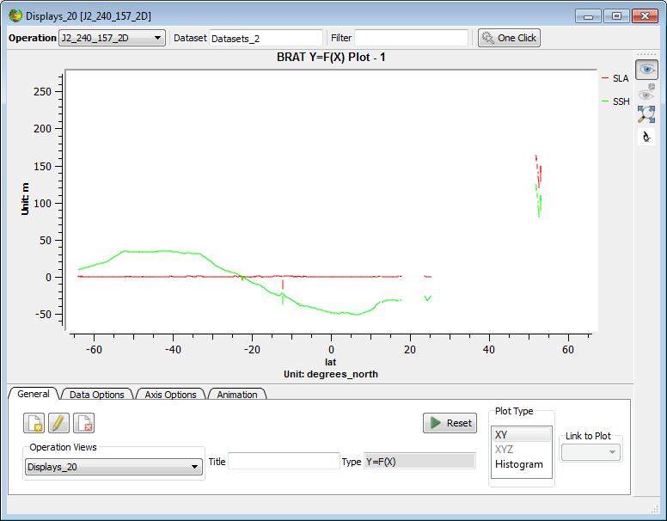

Figure 20: An example Y=F(X) visualisation with two curves

Usually this type of Plot is used upon displaying a y=f(x) curve type.

BRAT support saving the plots as an image format. The Plot2D dialog is organised in several tabs, each one with a different functionality.

|  |  |
| --- | --- |
| Figure 21: Data Options tab of the visualisation tool | The first tab ‘General’ holds information about the current Operation View associated with this Plot. You can change the current Operation View by changing the contents of the dropdown menu in “Operation Views”. Title should output the Plot title for the current plot however this is not currently implemented yet. The Plot type text box allows you to change the visualization type for the current data, but only certain types of Views are available depending on the contents of you current data.  When a field is selected in this ‘Data Options’ tab, you have some options to choose the colour and style (full, dots, etc.) of the line and of the points (none by default, circles, crosses, etc.). If there are several fields to plot, you can thus enhance the legibility of your plot.  Second tab (‘**Axis Options**’) enable to choose several options however, modifications done only in the visualisation window will not be saved as part of the workspace and thus cannot be recalled for future use. |

|  |  |
| --- | --- |
| Figure 22: Y-axis properties of a Y=F(X) plot, with only one field selected for view. Label (including the unit), number of ticks in the axis, min and max of the axis are shown. X-axis properties are similar. | The label of each axis includes by default the name of the plotted field and its unit, with \n for line break and \t for space.  ‘“2D Range” allows you to see the currently selected range. You can change the axis scale by changing the values in the 2D scale field. You can also change the number of axis ticks available for the current plot.  You can also zoom in on a portion of curve using middle button of your mouse. By pressing the wheel mouse button you can also move the Plot inside the view. |

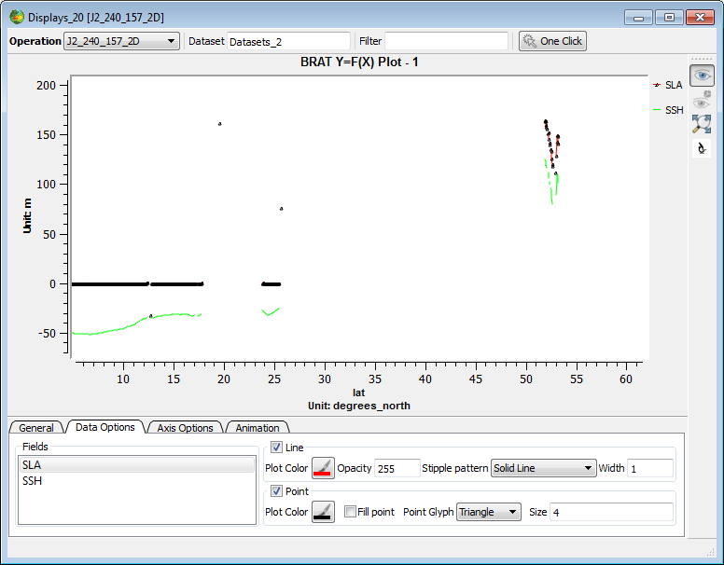

Figure 23: Two curves overlaid, with different point glyphs defined

## ‘Map Plot’

This type of plot is one of the three possibilities to display a plot of the type z=f(lon, lat) (The others are spectrograms and 3DPlots). The general tab view allows you to:

* Create a new view by pressing the “Create a new view” button
* Rename the current view by pressing the “Rename the selected view” button
* Delete the current view by pressing the “delete selected view” button

Similarly as before the operation views drop-down menu allows you to choose a view for the currently selected operation (the current operation can be changed in the drop-down menu “Operation”). The title text box should display the current plot title, but this is currently not implemented. The type view, shows you the current plot type.

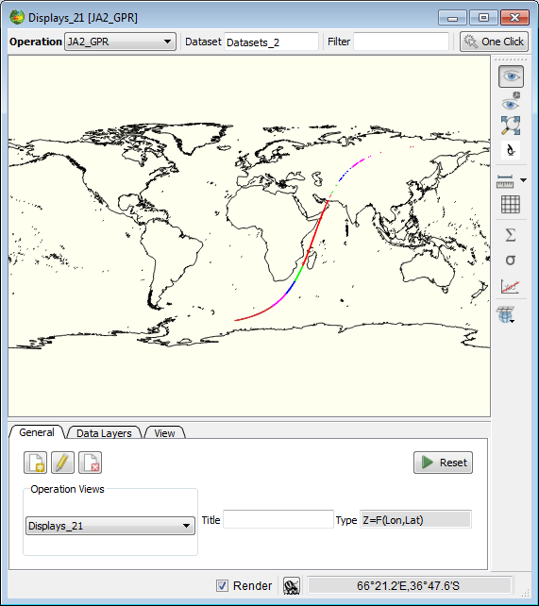

Figure 24: Map plot type to display a simple z=f(lon,lat) graph type..

Another tab available is the “Data Layers” that shows all the current available data layers for the current view, and in addition, should allow further visual details configuration, however this is not currently implemented.

The “View” tab contains other visual details configuration but are not currently available in this Brat release.

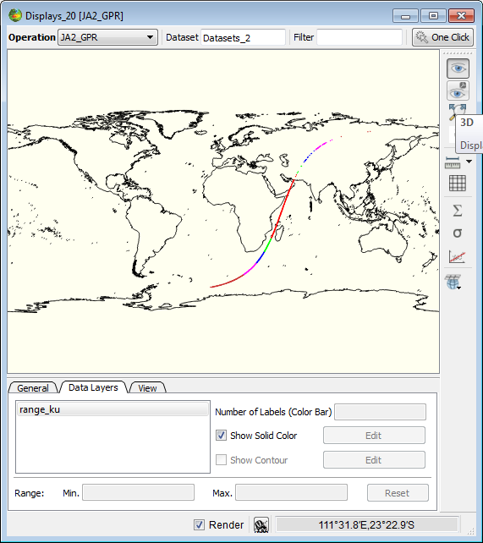

Figure 25: You can also trigger the Globe Plot for this type of data by clicking under the “3D” button

The following is a globe view example:

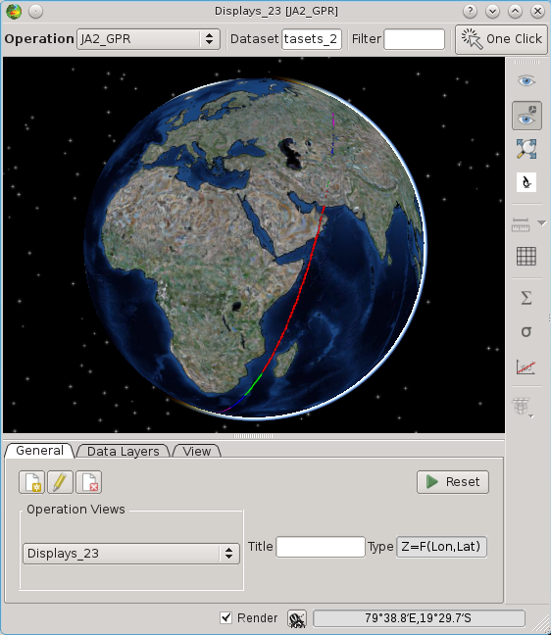

### Plot3D

The first tab ‘General’ holds information about the current Operation View associated with this Plot. You can change the current Operation View by changing the contents of the dropdown menu in “Operation Views”. Title should output the Plot title for the current plot however this is not currently implemented yet. The Plot type text box allows you to change the visualization type for the current data, but only certain types of Views are available depending on the contents of you current data. For 3D Plot types, one usually have two plotting possibilities: a spectrogram or a 3D graph. One can hide one or another when clicking under the “2D” or “3D” button.

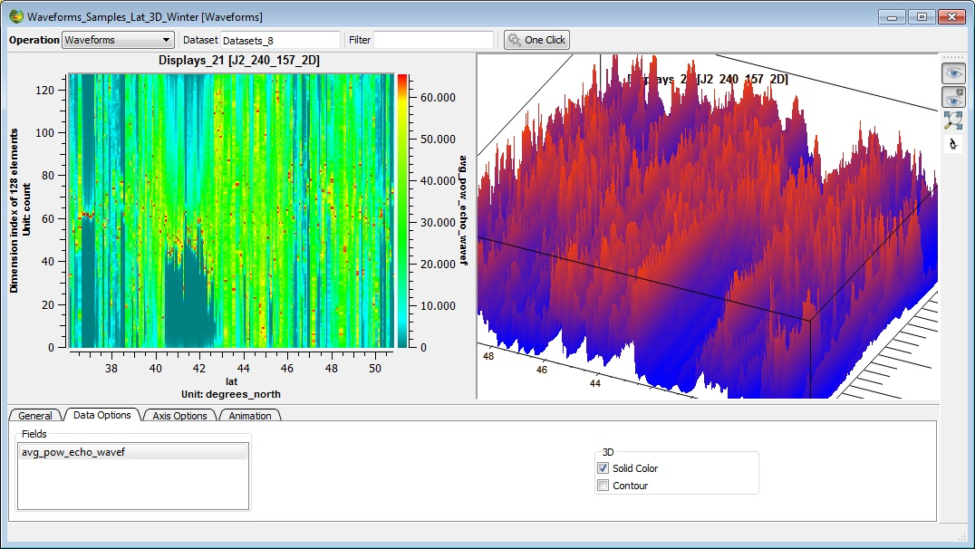

Figure 26 – Plotting a z=f(lon,lat) graph.

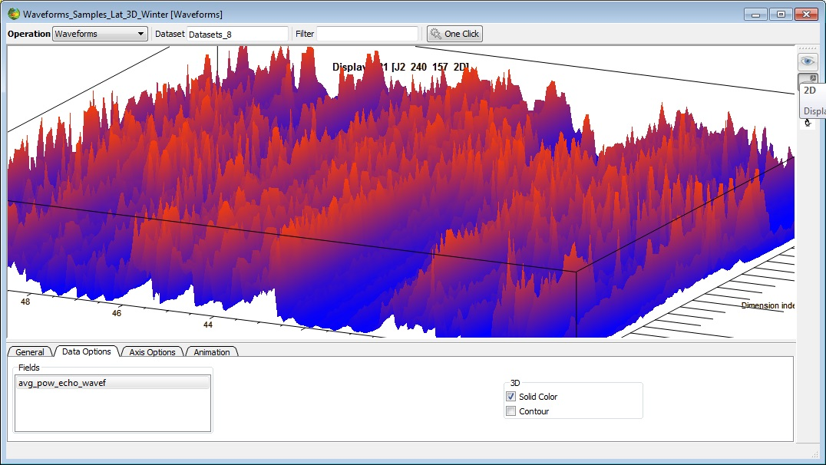

Figure 27 – Same plot but with a hidden spectrogram plot by clicking under the 2D button.

The “Axis Options” tab works in a similar manner as for the 2D case. The animation case should only address graphs that have animation, and implements features to stop and start the animation and define the number of frames to be used.

### Colour table editor

Several colour tables are available within BRAT. You can use any one of them.

## Vector Plots

Vector plots are displayed when fields from the visualization tab are selected as East and North vector components. Both components have to be present, otherwise an error message will be issued.

* East/North Component can be selected in ‘Map View proprieties’ button at ‘Operations’ tab. One expression has to be selected as north component and a different one for east component. Only one vector plot can be displayed at a time. Both expressions must be of the same data type.

Vectors are naturally visualized as arrows. The magnitude values available in the data are displayed when the user sets the mouse over an arrow.

# BRAT SCHEDULER INTERFACE

BRAT scheduler interface enable to postpone execution of operations. It has to be programmed through BRAT GUI (by clicking on the 'delay execution' button)

BRAT scheduler can be launched either from BRAT GUI or from the desktop icon. If it is not open and running, no scheduled task will be processed.

# USING BRAT IN ‘COMMAND LINES’ MODE WITH PARAMETERS FILE

The GUI is there to ease the use of BRAT. However, everything made with the GUI can be made directly by writing parameter files and execute them and more than what can be done with the GUI is possible with parameter files.

Dictionaries of key functions that can be called within parameter files are available in annex B (Y=F(X), annex C (Z=F(X,Y) and annex D (Display parameter file keys).

‘-h’ option offers help for launching the executable file

‘-k' offers help on parameter keys

BratCreateYFX.exe create an output netCDF with one or several data field(s) with respect to a single field

BratCreateZFXY.exe create an output netCDF with one or several data field(s) with respect to two different fields (e.g. longitude, latitude)

brat.exe can be used as the older “BratDisplay.exe” from the previous versions of Brat in order to just display a *.par file. In order to activate this mode one only needs to execute “brat.exe <par_path>” where <par_path> is a simple directory that points to your .par file. (i.e. brat.exe C:\projects\workspaces\UserJohn\Displays\DisplayDisplays_25.par ) .

BratExportAscii.exe export an output to Ascii

BratExportGeoTiff.exe export gridded data from a netCDF product to GeoTiff (with optional GoogleEarth wrapper)

BratListFieldNames.exe

BratShowInternalFile.exe

BratStats.exe

## Creating an output netCDF file

A ‘Create’ parameter file typically consist of:

* the definition of a dataset (a list of files that will be processed),
* the name of the record within the dataset in which the data you are interested in are stored,
* = the definition of an X axis and of one or several ‘Field(s)’; in the Z=F(X,Y) case, also the definition of an Y-axis,
* a selection expression, if need be
* the name and location of the netCDF output file.

The definition of the axis or of a field includes the name of an existing data field, or the expression that you wish to compute from several of them, a name (without any spaces or special characters), a unit, a title (that may include spaces or special characters), a min and a max and information about a possible filter.

#----- GENERAL PROPERTIES -----

DATA_MODE=MEAN

#----- DATASET -----

RECORD=ra2_mds

FILE=File1

FILE=File2

…

#----- FIELDS -----

Y=lat

Y_NAME=lat

Y_TYPE=Latitude

Y_UNIT=degrees_north

Y_TITLE=Latitude

Y_FILTER=DV

Y_MIN=DV

Y_MAX=DV

Y_INTERVALS=DV

Y_LOESS_CUTOFF=DV

X=lon

X_NAME=lon

X_TYPE=Longitude

X_UNIT=degrees_east

X_TITLE=Longitude

X_FILTER=DV

X_MIN=DV

X_MAX=DV

X_INTERVALS=DV

X_LOESS_CUTOFF=DV

FIELD=ra2_wind_sp

FIELD_NAME=my_first_field

FIELD_TYPE=Data

FIELD_UNIT=mm/s

FIELD_TITLE=Altimeter wind speed modulus

FIELD_FILTER=DV

FIELD_MIN=DV

FIELD_MAX=DV

FIELD_INTERVALS=DV

FIELD_LOESS_CUTOFF=DV

FIELD=alt_cog_ellip - ku_band_ocean_range - mod_dry_tropo_corr - inv_barom_corr - (tot_geocen_ocn_tide_ht_sol1 + tidal_load_ht + long_period_ocn_tide_ht) - solid_earth_tide_ht - geocen_pole_tide_ht - sea_bias_ku - ra2_ion_corr_ku - mwr_wet_tropo_corr

FIELD_NAME=SSH

FIELD_TYPE=Data

FIELD_UNIT=m

FIELD_TITLE=my second field

FIELD_FILTER=DV

FIELD_MIN=DV

FIELD_MAX=DV

FIELD_INTERVALS=DV

FIELD_LOESS_CUTOFF=DV

#----- SELECT -----

#----- OUTPUT -----

OUTPUT=output_file.nc

Figure 28: Example parameter file for creating a Z=F(X,Y) output

You create the netCDF file by typing

**‘BratCreateZFXY.exe command_file.par’**

**(or ‘BratCreateYFX.exe command_file.par’ )**

You will then have a netCDF file that you can either visualise through the tool provided within BRAT, or with some other tool capable of reading netCDF.

## Visualising an output netCDF file through BRAT

To visualise an output file, you have to write a second parameter file. This kind of file is simpler than the one needed to create a netCDF.

Basically, the commands needed are:

* the type of data to be displayed (Y=F(X) ==> 0 Z=F(Lat,Lon) ==> 2 Z=F(X,Y) ==> 1)
* the name of the file(s) to be displayed
* the title, projection
* the name of the field(s) to be displayed
* some information about the display (min, max, name, whether there is a contour or not, color table…)

#!/usr/bin/env BratCreateZFXY

#Type:Z=F(X,Y)

#----- DATASET -----

FILE=Createenvisat_cycle.nc

#----- GENERAL PROPERTIES -----

DISPLAY_TITLE=title of the plot

DISPLAY_PLOT_TYPE=1

DISPLAY_GROUPBY_FILE=Y

DISPLAY_PROJECTION=3D

#----- sigma_0_ku FIELD -----

FIELD=sigma_0_ku

#----- sigma_0_ku FIELDS PROPERTIES -----

DISPLAY_NAME=sigma_0_ku

FIELD_GROUP=1

DISPLAY_MINVALUE=0.00000

DISPLAY_MAXVALUE=50.000

DISPLAY_CONTOUR=N

DISPLAY_SOLID_COLOR =Y

DISPLAY_COLORTABLE=DV

Figure 29: Example ‘display’ parameter file

You open the visualisation tool by typing:

**‘BratDisplay.exe command_file.par’**

## Using the parameter files to process many datasets

A typical case in which using the parameter files will be much easier than using the GUI is when you want to process the same operation on all the altimetry satellite cycles or for a long series of them. Parameter files enable you to write a script that will process the same operation on a number of files.

You can either write the parameter file directly, or you can make the parameter file through the GUI, test it on one cycle and then modify it (right-click) by replacing the cycle number by a character that will be replaced consecutively by a list of cycle numbers through a script;

#!/usr/bin/env BratCreateZFXY

# SRC_DATA_DIR and CYCLE are environment variables that can be set in a shell # script

FILE=${SRC_DATA_DIR}/JA1_GDR_2PAP${CYCLE}_001.CNES

FILE=${SRC_DATA_DIR}/JA1_GDR_2PAP${CYCLE}_002.CNES

FILE=${SRC_DATA_DIR}/JA1_GDR_2PAP${CYCLE}_003.CNES

RECORD = data

VERBOSE = 2

ALIAS_NAME = SLA_JASON

ALIAS_VALUE = altitude - range_ku - model_dry_tropo_corr - inv_bar_corr - (ocean_tide_sol1 + ocean_tide_equil + load_tide_sol1) - solid_earth_tide - pole_tide - sea_state_bias_ku - iono_corr_alt_ku - rad_wet_tropo_corr - mss

X = longitude

X_TYPE = longitude

X_NAME = Longitude

X_UNIT = DV

X_TITLE = Longitude

X_MIN = DV

X_MAX = DV

X_INTERVALS = 1800

Y = latitude

Y_TYPE = latitude

Y_NAME = Latitude

Y_UNIT = DV

Y_TITLE = Latitude

Y_MIN = DV

Y_MAX = DV

Y_INTERVALS = 900

# SLA_JASON is an alias see ALIAS_NAME and ALIAS_VALUE above

FIELD = %{SLA_JASON}

FIELD_TYPE = data

FIELD_NAME = SLA

FIELD_UNIT = m

FIELD_TITLE = Sea Level Anomalies - Cycle ${CYCLE}

FIELD_FILTER = LOESS_EXTRAPOLATE

X_LOESS_CUTOFF = 5

Y_LOESS_CUTOFF = 5

SELECT = is_bounded(-1.0, %{SLA_JASON},1.0)

OUTPUT = ${BRATHL_DATA_DIR}/JasonSLA${CYCLE}.nc

OUTPUT_TITLE = Jason - Cycle ${CYCLE}

Figure 30: An example parameter file for creating output netCDF for several cycles (SLA from Jason-1 GDRs)

REM Set the cycle number

SET CYCLE=109

REM Set the data source path

SET SRC_DATA_DIR=D:\data\gdr_jason\cycle_%CYCLE%

REM Launch 'BRAT create Z=F(X,Y)' process

BratCreateZFXY C:\BRAT\MyCmdPath\BratCreateZFXYJasonSLASample.par

REM ------------------------------

REM Set another cycle number

SET CYCLE=110

REM Set the data source path

SET SRC_DATA_DIR=D:\data\gdr_jason\cycle_%CYCLE%

REM Launch 'BRAT create Z=F(X,Y)' process

BratCreateZFXY C:\BRAT\MyCmdPath\BratCreateZFXYJasonSLASample.par

Figure 31: An example script for DOS (to be inserted in a .bat file) to launch a parameter file over several cycles

#!/bin/bash

# BratCreateZFXYJasonSLASample.sh

# Set the cycle number

export CYCLE=109

# Set the data source path

export SRC_DATA_DIR=/data/gdr_jason/cycle_%CYCLE%

# Launch 'BRAT create Z=F(X,Y)' process

BratCreateZFXY BRAT/MyCmdPath/BratCreateZFXYJasonSLASample.par

# ------------------------------

# Set the cycle number

export CYCLE=110

# Set the data source path

export SRC_DATA_DIR=/data/gdr_jason/cycle_%CYCLE%

# Launch 'BRAT create Z=F(X,Y)' process

BratCreateZFXY BRAT/MyCmdPath/BratCreateZFXYJasonSLASample.par

Figure 32: An example Shell script for Linux for launching a parameter file over several cycles

# BRATHL APPLICATION PROGRAMMING INTERFACES (APIS)

Some functions of BRAT are not available through the GUI, but through C, Fortran, Python, IDL and MATLAB APIs. Note that for IDL and MATLAB under Linux and Mac OS you need to compile the API before being able to use them – they are not included in the binary distributions of BRAT.

## Data reading function

BRATHL_READDATA reads data from a set of files; each measurement for a data is a scalar value (a single number). It also gives statistics (e.g. a mean over a geographical area)

Possible arguments of this function are:

**[in] fileNames**: file name string (one file) or file names array

**[in] recordName**: Name of the fields record (for netCDF files the recordName is 'data')

**[in] selection**: Expression involving data fields which has to be true to select returned data. (if the string is empty nothing is selected (in other words all of the data is taken)

**[in] dataExpressions**: Expression string (one expression) or expressions array applied to data fields to build the wanted value.

**[in] units**: Wanted unit for each expression (string (one unit) or units array).

(if empty string, no unit conversion is applied to the data of the corresponding expression. When a unit conversion has to be applied, the result of the expression is considered to be the base unit (SI). For example if the wanted unit is grammes/litre, the unit of the expression is supposed to be kilogrammes/m3 (internally all data are converted to the basic unit of the actual fields unit which is coherent with the above assumption).

**[in/out] results**: Data read. Must be an array (dim = number of dataExpressions) of values to read.

**[in] ignoreOutOfRange**: Skip excess data. 0=*false*, other = *true*

Must be *false* if ‘statistics’ is *true*.

**[in] statistics**: returns statistics on data instead of data themselves

0=*false*, other = *true*

If statistics is *true*, ignoreOutOfRange must be *false*.

The returned values (5 values) for each expression are:

* Count of valid data taken into account.

Invalid data are those which are equal to the default/missing value

* Mean of the valid data.
* Standard deviation of the valid data
* Minimum value of the valid data
* Maximum value of the valid data

**[in] defaultValue**: value to use for default/missing values

This is the value you want to indicate that a value is missing or invalid.

return 0 or error code.

Syntax: see annexes

* for IDL
* for MATLAB
* for Fortran
* for C
* for Python

## Cycle/date conversion functions

Two functions are available to convert between cycle/pass and date.

Syntax: see annexes

* for IDL
* for MATLAB
* for Fortran
* for C
* for Python

BRATHL_CYCLE2YMDHMSM Converts a cyle/pass into a date.

* Arguments of this function are:

**[in] mission**:

0 : Topex/Poseidon

1 : Jason-1

2 : ERS2

3 : Envisat

4 : ERS1-A

5 : ERS1-B

6 : GFO

**[in] cycle**: number of cycles

**[in] pass**: number of passes in the cycle

* Outputs are:

[out] dateYMDHMSM: date to convert

BRATHL_YMDHMSM2CYCLE Converts a date into a cycle/pass

* Arguments of this function are:

**[in] mission**: mission type :

0 : Topex/Poseidon

1 : Jason-1

2 : ERS2

3 : Envisat

4 : ERS1-A

5 : ERS1-B

6 : GFO

**[in] dateYMDHMSM**: date to convert

* Outputs are:

[out] cycle: number of cycles

[out] pass: number of passes in the cycle

## Date conversion/computation function

A set of functions is available to convert between the different kinds of date formats:

* days-seconds-microseconds dates:
* Julian decimal dates:
* year, month, day, hour, minute, second, microsecond dates:

Syntax: see annexes

* for IDL
* for MATLAB
* for Fortran
* for C
* for Python

BRATHL_DAYOFYEAR

Retrieves the day of year of a date

BRATHL_NOWYMDHMSM

Gets the current date/time

BRATHL_SETREFUSER1

Set user-defined reference dates

BRATHL_SETREFUSER2

Set user-defined reference dates

BRATHL_DIFFDSM

Computes the difference between two days-seconds-microseconds dates (date1 - date2)

the result is expressed in a decimal number of seconds

BRATHL_DIFFJULIAN

Computes the difference between two decimal Julian dates (date1 - date2)

the result is expressed in a decimal number of seconds

BRATHL_DIFFYMDHMSM

Computes the difference between two year, month, day, hour, minute, second, microsecond dates (date1 - date2)

the result is expressed in a decimal number of seconds

BRATHL_DSM2JULIAN

Converts a days-seconds-microseconds date into a decimal Julian date, according to refDate parameter

BRATHL_DSM2SECONDS

Converts a days-seconds-microseconds date into seconds, according to refDate parameter

BRATHL_DSM2YMDHMSM

Converts a days-seconds-microseconds date into a year, month, day, hour, minute, second, microsecond date

BRATHL_JULIAN2DSM

Converts a decimal Julian date into a days-seconds-microseconds date, according to refDate parameter

BRATHL_JULIAN2SECONDS

Converts a decimal Julian date into seconds, according to refDate parameter

BRATHL_JULIAN2YMDHMSM

Converts a decimal Julian date into a year, month, day, hour, minute, second, microsecond date

BRATHL_SECONDS2DSM

Converts seconds into a days-seconds-microseconds date, according to refDate parameter

BRATHL_SECONDS2JULIAN

Converts seconds into a decimal Julian date, according to refDate parameter

BRATHL_SECONDS2YMDHMSM

Converts seconds into a a decimal Julian date, according to refDate parameter

BRATHL_YMDHMSM2DSM

Converts a year, month, day, hour, minute, second, microsecond date into a days-seconds-microseconds date, according to refDate parameter

BRATHL_YMDHMSM2JULIAN

Converts a year, month, day, hour, minute, second, microsecond date into a decimal Julian date, according to refDate parameter

BRATHL_YMDHMSM2SECONDS

Converts a year, month, day, hour, minute, second, microsecond date into seconds, according to refDate parameter

## Named structures

Several structures are also available, to represent the different kinds of date formats.

Syntax: see annexes

* for IDL
* for MATLAB
* for Fortran
* for C
* for Python

BRATHL_DATEYMDHMSM

YYYY-MM-DD HH:MN:SS:MS date structure

YEAR

MONTH

DAY

HOUR

MINUTE

SECOND

MUSECOND

BRATHL_DATEDSM

day/seconds/microseconds date structure

REFDATE reference date

DAYS numbers of days

SECONDS numbers of seconds

MUSECONDS numbers of microseconds

REFDATE is the reference date i.e :

0: 1950-01-01 00:00:00.0

1: 1958-01-01 00:00:00.0

2: 1985-01-01 00:00:00.0

3: 1990-01-01 00:00:00.0

4: 2000-01-01 00:00:00.0

5: user reference 1

6: user reference 2

values of 5 and 6 allow users to set two specific reference dates of their choice (see BRATHL_SETREFUSER1 and BRATHL_SETREFUSER2 functions)

BRATHL_DATESECOND

decimal seconds date structure

REFDATE reference date - see :BRATHL_DATEDSM

NBSECONDS decimal numbers of seconds (seconds.microseconds)

BRATHL_DATEJULIAN

decimal Julian date structure

REFDATE reference date - see :BRATHL_DATEDSM

JULIAN decimal Julian day

# ANNEX A: list of datasets read by BRAT

## Cryosat product overview

Table 5: 10.1. Cryosat product overview

|  |  |
| --- | --- |
| product type | description |
| SIR_LRM_1B | SIRAL L1B LRM product |
| SIR_SAR_1B | SIRAL L1B SAR mode product |
| SIR_SIN_1B | SIRAL L1B SARin mode product |
| SIR1LRM_0M | SIRAL MON-LRM/TRK product (Rx1 channel) |
| SIR2LRM_0M | SIRAL MON-LRM/TRK product (Rx2 channel) |
| SIR1SAR_0M | SIRAL MON-SAR product (Rx1 channel) |
| SIR2SAR_0M | SIRAL MON-SAR product (Rx2 channel) |
| SIR_SIN_0M | SIRAL MON-SARin product |
| SIR_SIC40M | SIRAL MON-CAL4 product |
| SIR1LRC11B | SIRAL CAL1-LRM product (Rx1 channel) |
| SIR2LRC11B | SIRAL CAL1-LRM product (Rx2 channel) |
| SIR1SAC11B | SIRAL CAL1-SAR product (Rx1 channel) |
| SIR2SAC11B | SIRAL CAL1-SAR product (Rx2 channel) |
| SIR_SIC11B | SIRAL CAL1-SARin product |
| SIR_SICC1B | SIRAL complex CAL1-SARin product |
| SIR1SAC21B | SIRAL CAL2-SAR product (Rx1 channel) |
| SIR2SAC21B | SIRAL CAL2-SAR product (Rx2 channel) |
| SIR1SIC21B | SIRAL CAL2-SARin product (Rx1 channel) |
| SIR2SIC21B | SIRAL CAL2-SARin product (Rx2 channel) |
| SIR_LRM_2_ | SIRAL L2 product from LRM processing |
| SIR_FDM_2_ | SIRAL L2 product from fast delivery ocean processing |
| SIR_SIN_2_ | SIRAL L2 product from SARin processing |
| SIR_SID_2_ | SIRAL L2 product from SARin degraded processing |
| SIR_SAR_2A | SIRAL L2 product from SAR step 1 processing |
| SIR_SAR_2B | SIRAL L2 product from SAR step 2 processing |
| SIR_GDR_2A | SIRAL L2 consolidated product including SAR step 1 data (SIR_SAR_2A) |
| SIR_GDR_2B | SIRAL L2 consolidated product including SAR step 2 data (SIR_SAR_2B) |
| SIR_LRMI2_ | SIRAL intermediate L2 product from LRM processing |
| SIR_FDMI2_ | SIRAL intermediate L2 product from fast delivery ocean processing |
| SIR_SINI2_ | SIRAL intermediate L2 product from SARin processing |
| SIR_SIDI2_ | SIRAL intermediate L2 product from SARin degraded processing |
| SIR_SARI2A | SIRAL intermediate L2 product from SAR step 1 processing |
| SIR_SARI2B | SIRAL intermediate L2 product from SAR step 2 processing |

## Cryosat Ocean products overview

Table 6: Cryosat Ocean products overview

| product type | description |
| --- | --- |
| SIR_IOP_1B | Interim L1B Ocean Product |
| SIR_GOP_1B | Geophysical L1B Ocean Product |
| SIR_IOP_2_ | Interim L2 Ocean Product |
| SIR_GOP_2_ | Geophysical L2 Ocean Product |

## Jason-2 product overview

Table 7: Jason-2 product overview

|  |  |
| --- | --- |
| product type | description |
| JA2_OPN_2P | The Operational Geophysical Data Record (OGDR), produced on a NRT basis |
| JA2_OPR_2P | The reduced Operational Geophysical Data Record(SSHA-OGDR), produced on a NRT basis |
| JA2_IPN_2P | The Interim Geophysical Data Record (IGDR) |
| JA2_IPR_2P | The reduced Interim Geophysical Data Record (SSHA-IGDR), produced on a NRT basis |
| JA2_IPS_2P | The Sensor Interim Geophysical Data Record (SIGDR) |
| JA2_GPN_2P | The Geophysical Data Record (GDR) |
| JA2_GPR_2P | The reduced Geophysical Data Record (SSHA-GDR), produced on a NRT basis |
| JA2_GPS_2P | The Sensor Geophysical Data Record (SGDR) |

## Envisat product overview

Table 8: Envisat product overview

|  |  |
| --- | --- |
| product type | description |
| RA2_FGD_2P | RA-2 Fast Delivery Geophysical Data Record |
| RA2_GDR_2P | RA-2 Geophysical Data Record |
| RA2_IGD_2P | RA-2 Intermediate Geophysical Data Record |
| RA2_MWS_2P | RA-2 Sensor Data Record |
| RA2_WWV_2P | RA-2 wind/wave product for Meteo Users |

## Jason-1 product overview

Table 9: Jason-1 product overview

| product type | description |
| --- | --- |
| JA1_OSD_2P | The Operational Sensor Data Record (OSDR), produced on a NRT basis |
| JA1_IGD_2P | The Interim Geophysical Data Record (IGDR) |
| JA1_GDR_2P | The Geophysical Data Record (GDR) |
| JA1_SDR_2P | The Sensor Geophysical Data Record (SGDR) |

## Topex/Poseidon product overview

Table 10: Topex/Poseidon radar altimetry products

|  |  |
| --- | --- |
| product type | description |
| MGDR_cycle_header_File | Merged GDR Topex/Poseidon cycle header file |
| MGDR_pass_file | Merged GDR Topex/Poseidon pass file |
| MGDR_crossover_point_file | Merged GDR Topex/Poseidon crossover point file (XNG) |
| SDR_pass_file | SDR Topex/Poseidon pass file |

## ERS-1 and 2 product overview

Table 11: ERS-1 and ERS-2 radar altimetry products

|  |  |
| --- | --- |
| product type | description |
| OPR_pass_file | Same as the off-line intermediate product but enhanced with all geophysical corrections and precise orbit altitude. |
| URA | Radar Altimeter Fast delivery |
| WAP | Radar Altimeter Waveform product |

## GFO product overview

Table 12: GFO product overview

|  |  |
| --- | --- |
| product type | description |
| GDR | The GDR is generated from GFO Sensor Data Records (SDRs), precise laser orbit ephemerides provided by NASA Goddard Space Flight Center and Raytheon ITSS, environmental corrections, and ancillary geophysical variables. |

## PODAAC product overview

Table 13: Physical Oceanography Distributed Active Archive Center radar altimetry products for Jason-1 and Topex/Poseidon

|  |  |
| --- | --- |
| product type | description |
| J1SSHA_CYCLE_HEADER_FILE | The PODAAC JASON-1 SSHA cycle header file |
| TPSSHA_CYCLE_HEADER_FILE | The PODAAC TOPEX/POSEIDON SSHA cycle header file |
| J1SSHA_PASS_FILE | The PODAAC JASON-1 SSHA pass file |
| TPSSHA_PASS_FILE | The PODAAC TOPEX/POSEIDON SSHA pass file |
| J1SSHA_ATG_FILE | The PODAAC JASON-1 Along Track Gridded SSHA file |
| TPSSHA_ATG_FILE | The PODAAC TOPEX/POSEIDON Along Track Gridded SSHA file |

## River and Lake product overview

Table 14: ENVISAT-ERS Exploitation River and Lake Products

|  |  |
| --- | --- |
| product type | description |
| RLH | River/Lake Hydrology Product |
| RLA | River/Lake Altimetry Product |

## NetCDF products

NetCDF products are self describing products.

This means that when ana netCDF file is opened one can retrieve the product structure from the file itself. For this reason, BRAT will not store fixed product format descriptions for HDF files in the Data Dictionary (you will therefore also not find netCDF product format descriptions in this documentation). What BRAT will do is use the underlying netCDF library to retrieve the product format dynamically once an netCDF file is opened. Based on this format BRAT will create, on the fly, a mapping of the HDF product structure to one that is based on the Data Dictionary data types

However, to be properly interpreted in the toolbox, a HDF product needs a description module to be added.

For example, in order to (really) read a netCDF files we need to:

1. Access to netCDF attributes
2. Identify default/missing values (see _FillValue standard attribute)
3. Convert data to its actual value (not the value stored in file): see scale_factor and add_offset standard attributes.
4. Interpret the structure of file to compute actual values of data (and not solely returning the netCDF variables values 'as is').
5. Avoid making available variables belonging to data structure (which are not the data themselves)

### Aviso Altimetry data in netCDF

Table 15: Aviso Altimetry data in netCDF

| product type | description |
| --- | --- |
| NRT- or DT-MSLA (h) | Ssalto/Duacs multimission Near real-time or Delayed time Maps of sea level anomalies (gridded) |
| NRT- or DT-MSLA (uv) | Ssalto/Duacs multimission Near real-time or Delayed time Geostrophic velocities associated to the Maps of sea level anomalies (gridded) |
| NRT- or DT-MSLA (err) | Ssalto/Duacs multimission Near real-time or Delayed time Maps of sea level anomalies Formal mapping error (gridded) |
| NRT- or DT-SLA | Ssalto/Duacs multimission Near real-time or Delayed time Sea level anomalies (along-track) |
| NRT- or DT-NRT- or DT-MADT (h) | Ssalto/Duacs multimission Near real-time or Delayed time Maps of absolute dynamic topography (gridded) |
| NRT- or DT-MADT (uv) | Ssalto/Duacs multimission Near real-time or Delayed time Geostrophic velocities associated to the Maps of absolute dynamic topography (gridded) |
| NRT- or DT-ADT | Ssalto/Duacs multimission Near real-time or Delayed time Absolute dynamic topography (along-track) |
| Monomission DT-SLA | Delayed time Sea level anomalies (along-track) |
| Monomission DT-CorSSH | Delayed time Corrected sea surface height (along-track) |
| NRT-MSWH | Near real-time Maps of Significant wave height (gridded) |
| NRT-MWind | Near real-time Maps of Wind speed modulus (gridded) |

### ERS REAPER data in netCDF

Table 16: ERS REAPER data in netCDF

|  |  |
| --- | --- |
| product type | description |
| ERS_ALT_2_ | REAPER L2 GDR Product |
| ERS_ALT_2S | REAPER L2 SGDR Product (GDR with echo waveforms) |
| ERS_ALT_2M | REAPER L2 Meteo Product (reduced 1Hz meteo product) |

### Sentinel 3 data in netCDF

Table 17: Sentinel 3 data in netCDF

|  |  |
| --- | --- |
| product type | description |
| SR_1_SRA___ | Echos parameters for LRM, PLRM and SAR mode (resolution 20Hz) |
| SR_1_CAL___ | Calibration parameters for LRM and SAR mode |
| SR_2_LAN___ | 1-Hz and 20-Hz Ku and C bands parameters (LRM/SAR/PLRM), waveforms. Over Land |
| SR_2_WAT___ | 1-Hz and 20-Hz Ku and C bands parameters (LRM/SAR/PLRM), waveforms. Over Water |

# ANNEX B: Y=F(X) parameter file keys

NOTE: The following table of parameter file keyword help can be always be obtained by calling: “BratCreateYFX -k”.

**FILE**

Type : Str Count : [1-n]

Input file name.

**RECORD**

Type : Str Count : 1

Record set name to take into account for a file.

**OUTPUT**

Type : Str Count : 1

Name of created/modified file.

**OUTPUT_TITLE**

Type : Str Count : [0-1]

Title of created/modified file (string describing the content and which should appear as a graphic title, for example).

(Default="")

**SELECT**

Type : Expr Count : [0-n]

True for record values selected.

(Default=1)

**FIELD**

Type : Expr Count : [1-20]=X

Expression of fields of *RECORD* to take into account.

**FIELD_NAME**

Type : Name Count : X

Name of the *FIELD* data

**FIELD_TYPE**

Type : KW1 Count : X

Type of *FIELD* data.

**FIELD_UNIT**

Type : Unit Count : X

Unit of *FIELD* expression.

**FIELD_TITLE**

Type : Str Count : X

Long name describing *FIELD*. The one which should appear in graphics on axis or legends, for example.

**DATA_MODE**

Type : KW2 Count : [0-1]

Keyword to indicate how data are stored/computed.

(Default=MEAN)

**X**

Type : Expr Count : 1

Expression of fields of *RECORD* to take into account.

**X_NAME**

Type : Name Count : 1

Name of the *X* data

**X_TYPE**

Type : KW1 Count : 1

Type of *X* data (normally X, T or longitude).

**X_UNIT**

Type : Unit Count : 1

Unit of *X* expression

**X_TITLE**

Type : Str Count : 1

Long name describing *X*. The one which should appearin graphics on axis or legends, for example.

**ALIAS_NAME**

Type : Name Count : [0-n]=N

Name of an alias. An alias is a value which can be used anywhere in another value of field by mean of %{NAME} construct. Names are case sensitive.If a name reference (%{XXX}) does not correspond to an actually defined alias, the expansion is an empty string.

(Default=None)

**ALIAS_VALUE**

Type : Str Count : N

The value of the alias. ALIAS_VALUE keyword must have at least as many occurences as the ALIAS_NAME one.

**VERBOSE**

Type : Int Count : [0-1]

Amount of output: 0=None...5=Debug.

(Default=0)

=====================

Description of types:

**Name**

String beginning with a letter and containing only letters, digits and '_'

**Int**

Integer

**Expr**

Combination of fields of the current record.

An expression which can contain function calls like trigonometric, conversion, test...

**Str**

String. Leading and trailing blanks are ignored.

**Unit**

Unit string conforming to Udunits package and the special keyword 'DATE' which means that the data is a date.

**KW1**

Keywords: X/Y/Z/T/Latitude/Longitude/Data

**KW2**

Keywords: FIRST/LAST/MIN/MAX/MEAN/STDDEV/COUNT

# ANNEX C: Z=F(X,Y) parameter file keys

NOTE: The following table of parameter file keyword help can be always be obtained by calling: “BratCreateZFXY -k”

**FILE**

Type : Str Count : [1-n]

Input file name.

**OUTPUT**

Type : Str Count : 1

Name of created/modified file.

**OUTPUT_TITLE**

Type : Str Count : [0-1]

Title of created/modified file (string describing the content and which should appear as a graphic title, for example).

(Default="")

**SELECT**

Type : Expr Count : [0-n]

True for record values selected.

(Default=1)

**RECORD**

Type : Str Count : 1

Record set name to take into account for a file.

**DATA_MODE**

Type : KW2 Count : [0-1]

Keyword to indicate how data are stored/computed.

(Default=MEAN)

**POSITION_MODE**

Type : KW3 Count : [0-1]

How position is computed.

(Default=NEAREST)

**OUTSIDE_MODE**

Type : KW4 Count : [0-1]

How data outside limits are managed.

(Default=STRICT)

**X**

Type : Expr Count : 1

Expression of fields of *RECORD* to take into account.

**X_NAME**

Type : Name Count : 1

Name of the *X* data

**X_TYPE**

Type : KW1 Count : 1

Type of *X* data (normally X, T or longitude).

**X_UNIT**

Type : Unit Count : 1

Unit of *X* expression

**X_TITLE**

Type : Str Count : 1

Long name describing *X*. The one which should appear in graphics on axis or legends, for example.

**X_INTERVALS**

Type : Int Count : 1

Number of intervals between Min and Max for *X*.

(Default=180 for lat 360 for lon)

**X_MIN**

Type : Flt Count : 1

Min value for *X* expression storage.

(Default=-90 for lat, -180 for lon)

**X_MAX**

Type : Flt Count : 1

Max value for *X* expression storage.

(Default=90 for lat, 180 for lon)

**X_LOESS_CUTOFF**

Type : Int Count : 1

Distance (in dots) where LOESS filter reaches 0 along X axis. Must be an odd integer. If 1 or 0, Distance computation is disabled. Needed only if at least one filter is asked.

(Default=0)

**Y**

Type : Expr Count : 1

Expression of fields of *RECORD* to take into account.

**Y_INTERVALS**

Type : Int Count : 1

Number of intervals between Min and Max for *Y*.

(Default=180 for lat 360 for lon)

**Y_NAME**

Type : Name Count : 1

Name of the *Y* data.

**Y_TYPE**

Type : KW1 Count : 1

Type of *Y* data (normally X, T or longitude).

**Y_UNIT**

Type : Unit Count : 1

Unit of *Y* expression.

**Y_TITLE**

Type : Str Count : 1

Long name describing *Y*. The one which should appearin graphics on axis or legends, for example.

**Y_MIN**

Type : Flt Count : 1

Min value for *Y* expression storage.

(Default=-90 for lat, -180 for lon)

**Y_MAX**

Type : Flt Count : 1

Max value for *Y* expression storage.

(Default=90 for lat, 180 for lon)

**Y_LOESS_CUTOFF**

Type : Int Count : 1

Distance (in dots) where LOESS filter reaches 0 along Y axis. Must be an odd integer. If 1 or 0, Distance computation is disabled. Needed only if at least one filter is asked.

(Default=0)

**FIELD**

Type : Expr Count : [1-20]=X

Expression of fields of *RECORD* to take into account.

**FIELD_NAME**

Type : Name Count : X

Name of the *FIELD* data

**FIELD_TYPE**

Type : KW1 Count : X

Type of *FIELD* data.

**FIELD_UNIT**

Type : Unit Count : X

Unit of *FIELD* expression.

**FIELD_TITLE**

Type : Str Count : X

Long name describing *FIELD*. The one which should appear in graphics on axis or legends, for example.

**FIELD_FILTER**

Type : KS1 Count : X

How to filter the data.

**ALIAS_NAME**

Type : Name Count : [0-n]=N

Name of an alias. An alias is a value which can be used anywhere in another value of field by mean of %{NAME} construct. Names are case sensitive. If a name reference (%{XXX}) does not correspond to an actually defined alias, the expansion is an empty string.

(Default=None)

**ALIAS_VALUE**

Type : Str Count : N

The value of the alias. ALIAS_VALUE keyword must have at least as many occurences as the ALIAS_NAME one.

**VERBOSE**

Type : Int Count : [0-1]

Amount of output: 0=None...5=Debug.

(Default=0)

=====================

Description of types:

**Name**

String beginning with a letter and containing only letters, digits and '_'

**Flt**

Floating point number

**Int**

Integer

**Expr**

Combination of fields of the current record.

An expression which can contain function calls like trigonometric, conversion, test...

**Str**

String. Leading and trailing blanks are ignored.

**Unit**

Unit string conforming to Udunits package and the specialkeyword 'DATE' which means that the data is a date.

**KW1**

Keywords: X/Y/Z/T/Latitude/Longitude/Data

**KW2**

Keywords: FIRST/LAST/MIN/MAX/MEAN/STDDEV/COUNT

**KW3**

Keywords: EXACT/NEAREST

EXACT: Measures which are exactly on boundaries (grid lines) are keeped others are ignored

NEAREST: Get the nearest boundary.

**KW4**

Keywords: STRICT/RELAXED/BLACK_HOLE

STRICT: Measure outside limits are ignored

RELAXED: Measure outside limits are ignored if they are farther than a half step from the limit.

BLACK_HOLE: Everything outside the limit is considered to be on the limit.

**KS1**

Set of keywords from: NONE, LOESS_SMOOTH, LOESS_EXTRAPOLATE, LOESS (LOESS means LOESS_SMOOTH and LOESS_EXTRAPOLATE)

# ANNEX D: Display parameter file keys

NOTE: The following table of parameter file keyword help can be always be obtained by calling: “BratDisplay –k”.

**FILE**

Type : Str Count : [1-n]

Input file name.

**FIELD**

Type : Expr Count : [1-23]=X

Expression of fields of *RECORD* to take into account.

**FIELD_GROUP**

Type : Int Count : X

Group id from where belongs *FIELD*. generally used to group many fields in one plot.

**DISPLAY_PROPERTIES**

Type : Bool Count : [0-1]

Indicates if property panel is shown.

(Default=No)

**DISPLAY_TITLE**

Type : Str Count : [0-1]

Title of the plot to be displayed.

(Default="")

**DISPLAY_ANIMATIONBAR**

Type : Bool Count : [0-1]

Keyword to indicate if property panel is shown.

(Default=No)

**DISPLAY_COLORBAR**

Type : Bool Count : [0-1]

Keyword to indicate if color bar (legend) is shown.

(Default=Yes)

**DISPLAY_CENTERLAT**

Type : Flt Count : [0-1]

Latitude of the projection's center point.

(Default=0)

**DISPLAY_CENTERLON**

Type : Flt Count : [0-1]

Longitude of the projection's center point.

(Default=0)

**DISPLAY_PROJECTION**

Type : KW9 Count : [0-1]

Projection to use for mapping the world globe.

(Default=3D)

**DISPLAY_COASTRESOLUTION**

Type : KW6 Count : [0-1]

Resolution of the coast line drawm on the map.

Recommended value: low.

(Default=low)

**DISPLAY_ZOOM_LON1**

Type : Flt Count : [0-1]

Zoom area west side.

(Default=-180)

**DISPLAY_ZOOM_LON2**

Type : Flt Count : [0-1]

Zoom area east side.

(Default=180)

**DISPLAY_ZOOM_LAT1**

Type : Flt Count : [0-1]

Zoom area south side.

(Default=-90)

**DISPLAY_ZOOM_LAT2**

Type : Flt Count : [0-1]

Zoom area north side.

(Default=90)

**DISPLAY_GROUPBY_FILE**

Type : Bool Count : [0-1]

For world plot. When several files are in input, this parameter indicates if fields are displayed in the same plot (group field by file) or in different plots (one plot by file).

(Default=Yes)

**DISPLAY_XMINVALUE**

Type : Flt Count : [0-1]

Minimum X coordinate value to use in XY plot.

(Default=min of data values for X axis)

**DISPLAY_XMAXVALUE**

Type : Flt Count : [0-1]

Maximum X coordinate value to use in XY plot.

(Default=max of data values for X axis)

**DISPLAY_YMINVALUE**

Type : Flt Count : [0-1]

Minimum Y coordinate value to use in XY plot.

(Default=min of data values for Y axis)

**DISPLAY_YMAXVALUE**

Type : Flt Count : [0-1]

Maximum Y coordinate value to use in XY plot.

(Default=max of data values for Y axis)

**DISPLAY_XLABEL**

Type : Str Count : [0-1]

X axis label to be displayed.

(Default=field title or field name)

**DISPLAY_YLABEL**

Type : Str Count : [0-1]

Y axis label to be displayed.

(Default=field title or field name)

**DISPLAY_XTICKS**

Type : Int Count : [0-1]

Number of ticks for the X axis.

(Default=6)

**DISPLAY_YTICKS**

Type : Int Count : [0-1]

Number of ticks for the Y axis.

(Default=6)

**DISPLAY_NAME**

Type : Str Count : [0-n]=W

Field name to be displayed.

**DISPLAY_OPACITY**

Type : Flt Count : 0 or W

Opacity of the color value map image:

1.0 color is totally opaque

0.0 is completely transparent.

(Default=0.7)

**DISPLAY_MINVALUE**

Type : Flt Count : 0 or W

Minimum color table value to use in plot.

(Default=min of data values)

**DISPLAY_MAXVALUE**

Type : Flt Count : 0 or W

Maximum color table value to use in plot.

(Default=max of data values)

**DISPLAY_NUMCOLORLABELS**

Type : Int Count : 0 or W

Number of labels shown on the plot's color bar.

(Default=2)

**DISPLAY_COLORTABLE**

Type : Str Count : 0 or W

Name of a predefined color table:

Aerosol

Blackbody

BlackToWhite

Cloud

Ozone

GreenToRed

Rainbow

RedToGreen

WhiteToBlack

or name of a file containing the color table definition

(absolute or relative path).

(Default=Aerosol)

**DISPLAY_COLORCURVE**

Type : KW5 Count : 0 or W

Set the color table on a specific curve.

(Default=Linear)

**DISPLAY_CONTOUR**

Type : Bool Count : 0 or W

Indicates if the contour layer of the field is shown or not.

(Default=No)

**DISPLAY_CONTOUR_NUMBER**

Type : Int Count : 0 or W

Number of contour lines to generate

(equally spaced contour values between specified range

See DISPLAY_CONTOUR_MINVALUE and DISPLAY_CONTOUR_MAXVALUE).

(Default=5)

**DISPLAY_CONTOUR_LABEL**

Type : Bool Count : 0 or W

Indicate if the contour labels (value) are shown or not.

(Default=No)

**DISPLAY_CONTOUR_LABEL_NUMBER**

Type : Int Count : 0 or W

Number of labels on each contour.

(Default=1)

**DISPLAY_CONTOUR_MINVALUE**

Type : Flt Count : 0 or W

Minimum value to use to contour calculation.

Default values are the same as the color scale one.

(Default=min of data values)

**DISPLAY_CONTOUR_MAXVALUE**

Type : Flt Count : 0 or W

Maximum value to use to contour calculation.

Default values are the same as the color scale one.

(Default=max of data values)

**DISPLAY_SOLID_COLOR**

Type : Bool Count : 0 or W

Indicates if color layer of the field is shown or not.

(Default=Yes)

**DISPLAY_EAST_COMPONENT**

Type : Bool Count : 0 or W

Indicates if this field is the East component of a vector plot.

(Default=No)

**DISPLAY_NORTH_COMPONENT**

Type : Bool Count : 0 or W

Indicates if this field is the North component of a vector plot.

(Default=No)

**DISPLAY_COLOR**

Type : KW7 Count : 0 or W

Color name of the XY plot field.

(Default=randow color)

**DISPLAY_POINTS**

Type : Bool Count : 0 or W

Indicates if points are displayed in a XY plot(for the field).

(Default=No)

**DISPLAY_LINES**

Type : Bool Count : 0 or W

Indicates if line is displayed in a XY plot (for the field).

(Default=Yes)

**DISPLAY_POINTSIZE**

Type : Flt Count : 0 or W

Size of the points (XY plot, for the field).

(Default=1.0)

**DISPLAY_LINEWIDTH**

Type : Flt Count : 0 or W

Width of the line (XY plot, for the field).

(Default=0.8)

**DISPLAY_STIPPLEPATTERN**

Type : KW10 Count : 0 or W

Stipple pattern for the line (field) (XY plot).

(Default=Full)

**DISPLAY_POINTGLYPH**

Type : KW8 Count : 0 or W

Glyph of the points (field) (XY plot).

(Default=Circle)

**DISPLAY_POINTFILLED**

Type : Bool Count : 0 or W

Indicates if points are filled or not.

(Default=Yes)

**ALIAS_NAME**

Type : Name Count : [0-n]=N

Name of an alias. An alias is a value which can be usedanywhere in another value of field by mean of%{NAME} construct. Names are case sensitive.If a name reference (%{XXX}) does not correspond toan actually defined alias, the expansion is an emptystring.

(Default=None)

**ALIAS_VALUE**

Type : Str Count : N

The value of the alias. ALIAS_VALUE keyword must have atleast as many occurences as the ALIAS_NAME one.

**VERBOSE**

Type : Int Count : [0-1]

Amount of output: 0=None...5=Debug.

(Default=0)

=====================

Description of types:

**Name**

String beginning with a letter and containing only letters,digits and '_'

**Bool**

Boolean

true if : YES/Y/TRUE/T/OUI/O/VRAI/V/1

false if : NO/N/FALSE/F/NON/N/FAUX/0

**Flt**

Floating point number

**Int**

Integer

**Expr**

Combination of fields of the current record.

An expression which can contain function calls like trigonometric, conversion, test...

**Str**

String. Leading and trailing blanks are ignored.

**KW5**

Keywords: cosine, linear, sqrt (square root)

**KW6**

Keywords: In incresing resolution: crude, low, intermediate, full

**KW7**

Keywords: AQUAMARINE, BLACK, BLUE, BLUE VIOLET, BROWN,

CADET BLUE, CORAL, CORNFLOWER BLUE, CYAN, DARK GREY,

DARK GREEN, DARK OLIVE GREEN, DARK ORCHID,

DARK SLATE BLUE, DARK SLATE GREY, DARK TURQUOISE,

DIM GREY, FIREBRICK, FOREST GREEN, GOLD, GOLDENROD,

GREY, GREEN, GREEN YELLOW, INDIAN RED, KHAKI,

LIGHT BLUE, LIGHT GREY, LIGHT STEEL BLUE, LIME GREEN,

MAGENTA, MAROON, MEDIUM AQUAMARINE, MEDIUM BLUE,

MEDIUM FOREST GREEN, MEDIUM GOLDENROD, MEDIUM ORCHID,

MEDIUM SEA GREEN, MEDIUM SLATE BLUE,

MEDIUM SPRING GREEN, MEDIUM TURQUOISE,

MEDIUM VIOLET RED, MIDNIGHT BLUE, NAVY, ORANGE,

ORANGE RED, ORCHID, PALE GREEN, PINK, PLUM, PURPLE,

RED, SALMON, SEA GREEN, SIENNA, SKY BLUE, SLATE BLUE,

SPRING GREEN, STEEL BLUE, TAN, THISTLE, TURQUOISE,

VIOLET, VIOLET RED, WHEAT, WHITE, YELLOW,

YELLOW GREEN.

**KW8**

Keywords: ARROW, CIRCLE, CROSS, DASH, DIAMOND, HOOKEDARROW, SQUARE, THICKARROW, THICKCROSS, TRIANGLE

**KW9**

Keywords: 3D, Azimuthal Equidistant, Lambert Cylindrical, Lambert Azimuthal, Mercator, Mollweide, Plate Caree,Robinson

**KW10**

Keywords: DASHTINY, DASH, DASHDOT, DOT, FULL

# ANNEX E: BRATHL-MATLAB API

The BRATHL-MATLAB API consists of just a handful of MATLAB structures and functions.

==================

structures

==================

BRATHL_DATEYMDHMSM = 0

BRATHL_DATEDSM = 1

BRATHL_DATESECOND = 2

BRATHL_DATEJULIAN = 3

To create a structure, use BRATHL_CREATESTRUCT (see description below)

BRATHL_DATEYMDHMSM structure

------------------------------------

This structure represents a YYYY-MM-DD HH:MN:SS:MS date structure :

YEAR

MONTH

DAY

HOUR

MINUTE

SECOND

MUSECOND

Example :

MyDate=BRATHL_CREATESTRUCT(0)

MyDate.YEAR=2003

MyDate.MONTH=12

MyDate.DAY=5

MyDate.HOUR=18

MyDate.MINUTE=0

MyDate.SECOND=21

MyDate.MUSECOND=1069

BRATHL_DATEDSM structure

------------------------------------

This structure represents a day/seconds/microseconds date structure:

REFDATE reference date

DAYS numbers of days

SECONDS numbers of seconds

MUSECONDS numbers of microseconds

REFDATE is the reference date i.e :

0: 1950-01-01 00:00:00.0

1: 1958-01-01 00:00:00.0

2: 1985-01-01 00:00:00.0

3: 1990-01-01 00:00:00.0

4: 2000-01-01 00:00:00.0

5: user reference 1

6: user reference 2

values of 5 and 6 allow the user to set two specifics reference date of his choice

(see BRATHL_SETREFUSER1 and BRATHL_SETREFUSER2 functions)

Example:

MyDate=BRATHL_CREATESTRUCT(1)

MyDate.REFDATE=3

MyDate.DAYS=423

MyDate.SECONDS=5

MyDate.MUSECONDS=0

BRATHL_DATESECONDS structure

------------------------------------

This structure represents a decimal seconds date structure:

REFDATE reference date - see :BRATHL_DATEDSM

NBSECONDS decimal numbers of seconds (seconds.microseconds)

Example:

MyDate=BRATHL_CREATESTRUCT(2)

MyDate.REFDATE=0

MyDate.NBSECONDS=56236.0253

BRATHL_DATEJULIAN structure

------------------------------------

This structure represents a decimal julian date structure:

REFDATE reference date - see :BRATHL_DATEDSM

JULIAN decimal julian day

Example:

MyDate=BRATHL_CREATESTRUCT(3)

MyDate.REFDATE=0

MyDate.JULIAN=123.569

==================

Functions

==================

==================

structure creation functions

==================

BRATHL_CREATESTRUCT

==================

Date conversion/computation functions

==================

BRATHL_DAYOFYEAR

BRATHL_DIFFDSM

BRATHL_DIFFJULIAN

BRATHL_DIFFYMDHMSM

BRATHL_DSM2JULIAN

BRATHL_DSM2SECONDS

BRATHL_DSM2YMDHMSM

BRATHL_JULIAN2DSM

BRATHL_JULIAN2SECONDS

BRATHL_JULIAN2YMDHMSM

BRATHL_SECONDS2DSM

BRATHL_SECONDS2JULIAN

BRATHL_SECONDS2YMDHMSM

BRATHL_NOWYMDHMSM

BRATHL_YMDHMSM2DSM

BRATHL_YMDHMSM2JULIAN

BRATHL_YMDHMSM2SECONDS

BRATHL_SETREFUSER1

BRATHL_SETREFUSER2

==================

Cycle/date conversion functions

==================

To convert cycle <-> date, these functions use an asci parameter file (ascii file) with records :

field 1 : Name of the mission

field 2 : Cycle reference

field 3 : Pass reference

field 4 : Reference date in decimal julian day

Each field has to be separated by, at least, a non-numeric character

The file can contained several records for a same mission.

Only the field with the greatest date is taken into account

You can add records.

You can add comments, commented lines start by '#' character.

If the file doesn't exist, default values are:

Name Cycle Pass Reference date

Jason-1 99 230 19987.9081795

Topex/Poseidon 442 230 19987.9127535

ERS2 66 598 18831.768334

ERS1-A 15 1 15636.938955

ERS1-B 42 108 16538.6732895

ENVISAT 30 579 19986.106016

BRATHL_CYCLE2YMDHMSM

BRATHL_YMDHMSM2CYCLE

BRATHL_DAYOFYEAR

------------------------------------

Retrieves the day of year of a date

dayOfYear = BRATHL_DAYOFYEAR(BRATHL_DATEYMDHMSM dateYMDHMSM)

[in] dateYMDHMSM : date

[out] dayOfYear : day of year of the date parameter

Example:

MyDate={BRATHL_DATEYMDHMSM}

MyDate.YEAR=2003

MyDate.MONTH=12

MyDate.DAY=5

MyDate.HOUR=18

MyDate.MINUTE=0

MyDate.SECOND=21

MyDate.MUSECOND=1069

dayOfYear=0L

r = BRATHL_DAYOFYEAR(MyDate, dayOfYear)

print, r, dayOfYear

BRATHL_DIFFDSM

------------------------------------

Computes the difference between two dates (date1 - date2)

the result is expressed in a decimal number of seconds

BRATHL_DIFFDSM(BRATHL_DATEDSM date1, BRATHL_DATEDSM date2, DOUBLE diff)

[in] date1

[in] date2

[out] diff : difference in seconds (date1 - date2)

return 0 or error code (see Date error codes in brathl general documentation)

Example:

d1={BRATHL_DATEDSM}

d1.REFDATE=3

d1.DAYS=423

d1.SECONDS=5

d1.MUSECONDS=0

d2={BRATHL_DATEDSM}

d2.REFDATE=2

d2.DAYS=36

d2.SECONDS=54

d2.MUSECONDS=2536

diff = 0.0D

r = BRATHL_DIFFYMDHMSM(d1, d2, diff)

print, r, diff

BRATHL_DIFFJULIAN

------------------------------------

Computes the difference between two dates (date1 - date2)

the result is expressed in a decimal number of seconds

BRATHL_DIFFJULIAN(BRATHL_DIFFJULIAN date1, BRATHL_DIFFJULIAN date2, DOUBLE diff)

[in] date1

[in] date2

[out] diff : difference in seconds (date1 - date2)

return 0 or error code (see Date error codes in brathl general documentation)

Example: see BRATHL_DIFFDSM

BRATHL_DIFFYMDHMSM

------------------------------------

Computes the difference between two dates (date1 - date2)

the result is expressed in a decimal number of seconds

BRATHL_DIFFYMDHMSM(BRATHL_DIFFYMDHMSM date1, BRATHL_DIFFYMDHMSM date2, DOUBLE diff)

[in] date1

[in] date2

[out] diff : difference in seconds (date1 - date2)

return 0 or error code (see Date error codes in brathl general documentation)

Example: see BRATHL_DIFFDSM

BRATHL_DSM2JULIAN

------------------------------------

Converts a days-seconds-microseconds date into a decimal julian date, according to refDate parameter

BRATHL_DSM2JULIAN(BRATHL_DATEDSM dateDSM, INT refDate, BRATHL_DATEJULIAN dateJulian);

[in] dateDSM : date to convert

[in] refDate : date reference conversion

[out] dateJulian : result of the conversion

return 0 or error code (see Date error codes in brathl general documentation)

Example :

dIn={BRATHL_DATEDSM}

dIn.REFDATE=3

dIn.DAYS=423

dIn.SECONDS=5

dIn.MUSECONDS=0

dOut={BRATHL_DATEJULIAN}

refDateDestination = 0

r = BRATHL_DSM2JULIAN(dIn, refDateDestination, dOut)

print, r, dOut.REFDATE, dOut.JULIAN

BRATHL_DSM2SECONDS

------------------------------------

Converts a days-seconds-microseconds date into secnods, according to refDate parameter

BRATHL_DSM2SECONDS(BRATHL_DATEDSM dateDSM, INT refDate, BRATHL_DATESECOND dateSeconds);

[in] dateDSM : date to convert

[in] refDate : date reference conversion

[out] dateSeconds : result of the conversion

return 0 or error code (see Date error codes in brathl general documentation)

Example: see BRATHL_DSM2JULIAN

BRATHL_DSM2YMDHMSM

------------------------------------

Converts a days-seconds-microseconds date into a year, month, day, hour, minute, second, microsecond date

BRATHL_DSM2YMDHMSM(BRATHL_DATEDSM dateDSM, BRATHL_DATEYMDHMSM dateYMDHMSM);

[in] dateDSM : date to convert

[in] refDate : date reference conversion

[out] dateYMDHMSM : result of the conversion

return 0 or error code (see Date error codes in brathl general documentation)

Example:

dIn={BRATHL_DATEDSM}

dIn.REFDATE=3

dIn.DAYS=423

dIn.SECONDS=5

dIn.MUSECONDS=0

dOut={BRATHL_DATEYMDHMSM}

refDateDestination = 0

r = BRATHL_DSM2YMDHMSM(dIn, dOut)

print, r, dOut.YEAR, dOut.JULIAN, dOut.MONTH, dOut.DAY, dOut.HOUR, dOut.MINUTE, dOut.SECOND, dOut.MUSECOND

BRATHL_JULIAN2DSM

------------------------------------

Converts a decimal julian date into a days-seconds-microseconds date, according to refDate parameter

BRATHL_JULIAN2DSM(BRATHL_DATEJULIAN dateJulian, INT refDate, BRATHL_DATEDSM dateDSM);

[in] dateJulian : date to convert

[in] refDate : date reference conversion

[out] dateDSM : result of conversion

return 0 or error code (see Date error codes in brathl general documentation)

BRATHL_DSM2YMDHMSM(BRATHL_DATEDSM dateDSM, BRATHL_DATEYMDHMSM dateYMDHMSM);

[in] dateDSM : date to convert

[in] refDate : date reference conversion

[out] dateYMDHMSM : result of the conversion

return 0 or error code (see Date error codes in brathl general documentation)

Example: see BRATHL_DSM2JULIAN

BRATHL_JULIAN2SECONDS

------------------------------------

Converts a decimal julian date into seconds, according to refDate parameter

BRATHL_JULIAN2SECONDS(BRATHL_DATEJULIAN dateJulian, INT refDate, BRATHL_DATESECOND dateSeconds)

[in] dateJulian : date to convert

[in] refDate : date reference conversion

[out] dateSeconds : result of conversion

return 0 or error code (see Date error codes in brathl general documentation)

Example: see BRATHL_DSM2JULIAN

BRATHL_JULIAN2YMDHMSM

------------------------------------

Converts a decimal julian date into a year, month, day, hour, minute, second, microsecond date

BRATHL_JULIAN2YMDHMSM(BRATHL_DATEJULIAN dateJulian, BRATHL_DATEYMDHMSM dateYMDHMSM);

[in] dateJulian : date to convert

[in] refDate : date reference conversion

[out] dateYMDHMSM : result of conversion

return 0 or error code (see Date error codes in brathl general documentation)

Example: see BRATHL_DSM2YMDHMSM

BRATHL_SECONDS2DSM

------------------------------------

Converts seconds into a days-seconds-microseconds date, according to refDate parameter

BRATHL_SECONDS2DSM(BRATHL_DATESECOND dateSeconds, INT refDate, BRATHL_DATEDSM dateDSM);

[in] dateSeconds : date to convert

[in] refDate : date reference conversion

[out] dateDSM : result of the conversion

return 0 or error code (see Date error codes in brathl general documentation)

Example: see BRATHL_DSM2JULIAN

BRATHL_SECONDS2JULIAN

------------------------------------

Converts seconds into a decimal julian date, according to refDate parameter

BRATHL_SECONDS2JULIAN(BRATHL_DATESECOND dateSeconds, INT refDate, BRATHL_DATEJULIAN dateJulian)

[in] dateSeconds : date to convert

[in] refDate : date reference conversion

[out] dateJulian : result of the conversion

return 0 or error code (see Date error codes in brathl general documentation)

Example: see BRATHL_DSM2JULIAN

BRATHL_SECONDS2YMDHMSM

------------------------------------

Converts seconds into a a decimal julian date, according to refDate parameter

BRATHL_SECONDS2YMDHMSM(BRATHL_DATESECOND dateSeconds, INT refDate, BRATHL_DATEJULIAN dateJulian)

[in] dateSeconds : date to convert

[in] refDate : date reference conversion

[out] dateJulian : result of the conversion

return 0 or error code (see Date error codes in brathl general documentation)

Example: see BRATHL_DSM2JULIAN

BRATHL_NOWYMDHMSM

------------------------------------

Gets the current date/time,

LIBRATHL_API int32_t brathl_NowYMDHMSM(brathl_DateYMDHMSM *dateYMDHMSM);

[out] dateYMDHMSM : current date/time

BRATHL_NOWYMDHMSM(BRATHL_DATEYMDHMSM dateYMDHMSM)

Example: see BRATHL_DSM2JULIAN

dOut={BRATHL_DATEYMDHMSM}

r = BRATHL_NOWYMDHMSM(dOut)

print, r, dOut.YEAR, dOut.JULIAN, dOut.MONTH, dOut.DAY, dOut.HOUR, dOut.MINUTE, dOut.SECOND, dOut.MUSECOND

BRATHL_YMDHMSM2DSM

------------------------------------

Converts a year, month, day, hour, minute, second, microsecond date into a days-seconds-microseconds date, according to refDate parameter

BRATHL_YMDHMSM2DSM(BRATHL_DATEYMDHMSM dateYMDHMSM, INT refDate, BRATHL_DATEDSM dateDSM)

[in] dateYMDHMSM : date to convert

[in] refDate : date reference conversion

[out] dateDSM : result of the conversion

return 0 or error code (see Date error codes in brathl general documentation)

Example: see BRATHL_DSM2JULIAN

BRATHL_YMDHMSM2JULIAN

------------------------------------

Converts a year, month, day, hour, minute, second, microsecond date into a decimal julian date, according to refDate parameter

BRATHL_YMDHMSM2JULIAN(BRATHL_DATEYMDHMSM dateYMDHMSM, INT refDate, BRATHL_DATEJULIAN dateJulian)

[in] dateYMDHMSM : date to convert

[in] refDate : date reference conversion

[out] dateJulian : result of the conversion

return 0 or error code (see Date error codes in brathl general documentation)

Example: see BRATHL_DSM2JULIAN

BRATHL_YMDHMSM2SECONDS

------------------------------------

Converts a year, month, day, hour, minute, second, microsecond date into a seconds, according to refDate parameter

BRATHL_YMDHMSM2SECONDS(BRATHL_DATEYMDHMSM dateYMDHMSM, INT refDate, BRATHL_DATESECOND dateSeconds)

[in] dateYMDHMSM : date to convert

[in] refDate : date reference conversion

[out] dateSeconds : result of the conversion

return 0 or error code (see Date error codes in brathl general documentation)

Example: see BRATHL_DSM2JULIAN

BRATHL_SETREFUSER1

BRATHL_SETREFUSER2

------------------------------------

Set user-defined reference dates

BRATHL_SETREFUSER1(STRING dateRef)

[in] dateRef : date to set - format: YYYY-MM-DD HH:MN:SS.MS

return 0 or error code (see Date error codes in brathl general documentation)

Example:

dateRefUser1 = '2001 01 12 14:57:23:1456'

dateRefUser2 = '2005 11 14'

brathl_setrefuser1(dateRefUser1)

brathl_setrefuser2(dateRefUser2)

MyDate={BRATHL_DATEDSM}

. Set user-defined ref. date 2001 01 12 14:57:23:1456

MyDate.REFDATE=5

MyDate.DAYS=423

MyDate.SECONDS=5

MyDate.MUSECONDS=0

AnotherDate={BRATHL_DATEDSM}

. Set user-defined ref. date 2005 11 14

AnotherDate.REFDATE=6

AnotherDate.DAYS=423

AnotherDate.SECONDS=5

AnotherDate.MUSECONDS=0

; ref. date for MyDate is now 2005 11 14

MyDate.REFDATE=6

brathl_setrefuser2('2005 05 18 13:08:00')

; ref. date for MyDate and AnotherDate is now 2005 05 18 13:08:00

BRATHL_CYCLE2YMDHMSM

------------------------------------

Converts a cyle/pass into a date

BRATHL_CYCLE2YMDHMSM(INT mission, ULONG cycle, ULONG pass, BRATHL_DATEYMDHMSM dateYMDHMSM)

[in] mission : mission type :

0 : Topex/Poseidon

1 : Jason-1

2 : ERS2

3 : Envisat

4 : ERS1-A

5 : ERS1-B

6 : GFO

[in] cycle : number of cycle to convert

[in] pass : number of pass in the cycle to cinvert

[out] dateYMDHMSM : date corresponding to the cycle/pass

return 0 or error code (see Cycle/date conversion error codes in brathl general documentation)

Example:

cycle=120L

pass=153L

mission=3

dOut={BRATHL_DATEYMDHMSM}

r = BRATHL_CYCLE2YMDHMSM(mission, cycle, pass, dOut)

print, "result ", r

print, "mission ", mission , " cycle ", cycle, " pass ", pass

print, "Y", dOut.year, " M ", dOut.month, " D ", dOut.day, " H ", dOut.hour, " MN ", dOut.minute, " S ", dOut.second, " MS ", dOut.muSecond

BRATHL_YMDHMSM2CYCLE

------------------------------------

Converts a date into a cycle/pass

BRATHL_YMDHMSM2CYCLE(INT mission, BRATHL_DATEYMDHMSM dateYMDHMSM, ULONG cycle, ULONG pass)

[in] mission : mission type :

0 : Topex/Poseidon

1 : Jason-1

2 : ERS2

3 : Envisat

4 : ERS1-A

5 : ERS1-B

6 : GFO

[in] dateYMDHMSM : date to convert

[out] cycle : number of cycle

[out] pass : number of pass in the cycle

return 0 or error code (see Cycle/date conversion error codes in brathl general documentation)

Example:

cycle=0L

pass=0L

mission=1

dIn={BRATHL_DATEYMDHMSM}

dIn.YEAR=2003

dIn.MONTH=12

dIn.DAY=5

dIn.HOUR=18

dIn.MINUTE=0

dIn.SECOND=21

dIn.MUSECOND=1069

r = BRATHL_YMDHMSM2CYCLE(mission, dIn, cycle, pass)

print, "result ", r

print, "Y", dOut.year, " M ", dOut.month, " D ", dOut.day, " H ", dOut.hour, " MN ", dOut.minute, " S ", dOut.second, " MS ", dOut.muSecond

print, "mission ", mission , " cycle ", cycle, " pass ", pass

# ANNEX F: BRATHL-Fortran API

The BRATHL-C API consists of just a handful of Fortran functions.

Below is the list of Fortran APIs functions.

A description of each function is detailed in the BRATHL documentation in html or latex format (search for refman-html or refman-latext sub-directories in your BRATHL directories installation). Note: When installing BRAT Toolbox, you have to selected 'Documentations' component.

==================

Date conversion/computation functions

==================

brathl_DayOfYear

brathl_DiffDSM

brathl_DiffJULIAN

brathl_DiffYMDHMSM

brathl_DSM2Julian

brathl_DSM2Seconds

brathl_DSM2YMDHMSM

brathl_JULIAN2DSM

brathl_JULIAN2Seconds

brathl_JULIAN2YMDHMSM

brathl_SECONDS2DSM

brathl_SECONDS2Julian

brathl_SECONDS2YMDHMSM

brathl_NowYMDHMSM

brathl_YMDHMSM2DSM

brathl_YMDHMSM2Julian

brathl_YMDHMSM2Seconds

Date conversion/computation example:

PROGRAM TESTDATE_F

IMPLICIT NONE

INCLUDE "brathlf.inc"

INTEGER IREFDATESRC

DOUBLE PRECISION ISECONDS

INTEGER IREFDATEDEST

INTEGER ODAYS

INTEGER OSECONDS

INTEGER OMUSECONDS

INTEGER Y

INTEGER M

INTEGER D

INTEGER H

INTEGER MN

INTEGER SEC

INTEGER MS

INTEGER RESULT

CHARACTER*128 ERRSTR

CHARACTER*28 REFUSER

INTEGER TMP

REFUSER = '1952 02 18'

CALL BRATHLF_SETREFUSER1(REFUSER)

IREFDATESRC = REF20000101

C IREFDATEDEST = REF19500101

IREFDATEDEST = REFUSER1

ISECONDS = 86460.16936D0

ODAYS = 0

OSECONDS = 0

OMUSECONDS = 0

RESULT = BRATHLF_SECONDS2DSM(IREFDATESRC, ISECONDS, IREFDATEDEST,

&ODAYS, OSECONDS, OMUSECONDS)

IF (RESULT .NE. BRATHL_SUCCESS) THEN

CALL BRATHLF_ERRNO2STRING(RESULT, ERRSTR)

WRITE(*,*) 'ERROR: ' // ERRSTR

STOP

END IF

WRITE(*,*) ' IREFDATESRC:', IREFDATESRC,' ISECONDS:', ISECONDS,

& ' IREFDATEDEST:', IREFDATEDEST, ' ODAYS:', ODAYS, ' OSECONDS:',

& OSECONDS, ' OMUSECONDS:', OMUSECONDS

C ------------------------------------------------------

RESULT = BRATHLF_DSM2SECONDS(IREFDATESRC, ODAYS, OSECONDS,

&OMUSECONDS, IREFDATEDEST, ISECONDS)

IF (RESULT .NE. BRATHL_SUCCESS) THEN

CALL BRATHLF_ERRNO2STRING(RESULT, ERRSTR)

WRITE(*,*) 'ERROR: ' // ERRSTR

STOP

END IF

WRITE(*,*) ' IREFDATESRC:', IREFDATESRC,' ISECONDS:', ISECONDS,

& ' IREFDATEDEST:', IREFDATEDEST, ' ODAYS:', ODAYS, ' OSECONDS:',

& OSECONDS, ' OMUSECONDS:', OMUSECONDS

C ------------------------------------------------------

RESULT = brathlf_DSM2YMDHMSM(IREFDATESRC, ODAYS, OSECONDS,

& OMUSECONDS, Y, M, D, H, MN, SEC, MS)

IF (RESULT .NE. BRATHL_SUCCESS) THEN

CALL BRATHLF_ERRNO2STRING(RESULT, ERRSTR)

WRITE(*,*) 'ERROR: ' // ERRSTR

STOP

END IF

WRITE(*,*) ' IREFDATESRC:', IREFDATESRC,' Y:', Y,

& ' M:', M, ' D:', D, ' H:', H,' MN:', MN,' SEC:', SEC,' MS:', MS,

& ' ODAYS:', ODAYS, ' OSECONDS:',

& OSECONDS, ' OMUSECONDS:', OMUSECONDS

C ------------------------------------------------------

RESULT = brathlf_YMDHMSM2DSM( Y, M, D, H, MN, SEC, MS,

& IREFDATEDEST, ODAYS, OSECONDS, OMUSECONDS,)

IF (RESULT .NE. BRATHL_SUCCESS) THEN

CALL BRATHLF_ERRNO2STRING(RESULT, ERRSTR)

WRITE(*,*) 'ERROR: ' // ERRSTR

STOP

END IF

WRITE(*,*) ' IREFDATESRC:', IREFDATESRC,' Y:', Y,

& ' M:', M, ' D:', D, ' H:', H,' MN:', MN,' SEC:', SEC,' MS:', MS,

& ' ODAYS:', ODAYS, ' OSECONDS:',

& OSECONDS, ' OMUSECONDS:', OMUSECONDS

C ------------------------------------------------------

END

==================

Cycle/date conversion functions

==================

To convert cycle <-> date, these functions use an asci parameter file (ascii file) with records:

field 1 : Name of the mission

field 2 : Cycle reference

field 3 : Pass reference

field 4 : Reference date in decimal julian day

Each field has to be separated by, at least, a non-numeric character

The file can contained several records for a same mission.

Only the field with the greatest date is taken into account

You can add records.

You can add comments, commented lines start by '#' character.

If the file doesn't exist, default values are :

Name Cycle Pass Reference date

Jason-1 99 230 19987.9081795

Topex/Poseidon 442 230 19987.9127535

ERS2 66 598 18831.768334

ERS1-A 15 1 15636.938955

ERS1-B 42 108 16538.6732895

ENVISAT 30 579 19986.106016

brathl_Cycle2YMDHMSM

brathl_YMDHMSM2Cycle

Cycle/date conversion example:

PROGRAM TESTCYCLE_F

IMPLICIT NONE

INCLUDE "brathlf.inc"

INTEGER C

INTEGER P

INTEGER MISSION

INTEGER Y

INTEGER M

INTEGER D

INTEGER H

INTEGER MN

INTEGER SEC

INTEGER MS

INTEGER RESULT

CHARACTER*128 ERRSTR

MISSION = ENVISAT

C = 120

P = 153

RESULT = BRATHLF_CYCLE2YMDHMSM(MISSION, C, P,

& Y, M, D, H, MN, SEC, MS)

IF (RESULT .NE. BRATHL_SUCCESS) THEN

CALL BRATHLF_ERRNO2STRING(RESULT, ERRSTR)

WRITE(*,*) 'ERROR: ' // ERRSTR

STOP

END IF

WRITE(*,*) ' MISSION:', MISSION,' CYCLE:', C,

& ' PASS:', P,

& ' Y:', Y,

& ' M:', M, ' D:', D, ' H:', H,' MN:', MN,' SEC:', SEC,' MS:', MS

C ------------------------------------------------------

RESULT = BRATHLF_YMDHMSM2CYCLE(MISSION,

& Y, M, D, H, MN, SEC, MS, C, P)

IF (RESULT .NE. BRATHL_SUCCESS) THEN

CALL BRATHLF_ERRNO2STRING(RESULT, ERRSTR)

WRITE(*,*) 'ERROR: ' // ERRSTR

STOP

END IF

WRITE(*,*) ' MISSION:', MISSION,' CYCLE:', C,

& ' PASS:', P,

& ' Y:', Y,

& ' M:', M, ' D:', D, ' H:', H,' MN:', MN,' SEC:', SEC,' MS:', MS

END

==================

Data reading function

==================

brathl_ReadData

Example:

PROGRAM P

IMPLICIT NONE

CHARACTER*(100) NAMES(10)

CHARACTER*(10) Record

CHARACTER*(120) Selection

CHARACTER*(200) Expressions(20)

CHARACTER*(20) Units(20)

REAL*8 Result(1000,20)

LOGICAL*4 Ignore

LOGICAL*4 Statistics

REAL*8 Default

INTEGER*4 NbValues

INTEGER*4 NbResults

INTEGER*4 ReturnCode

INCLUDE "brathlf.inc"

NAMES(1) = 'JA1_GDR_2PaP124_001.CNES'

NAMES(2) = 'JA1_GDR_2PaP124_002.CNES'

NAMES(3) = 'JA1_GDR_2PaP124_003.CNES'

Record = 'data'

Selection = 'latitude > 20'

Expressions(1) = 'latitude + longitude'

Units(1) = 'radians'

Expressions(2) = 'swh_ku'

Units(2) = 'm'

NbValues = 1000

NbResults = -1

Ignore = .false.

Statistics = .false.

Default = 1.0E100

ReturnCode = brathlf_ReadData(3,

$ NAMES,

$ Record,

$ Selection,

$ 2,

$ Expressions,

$ Units,

$ Result,

$ NbValues,

$ NbResults,

$ Ignore,

$ Statistics,

$ Default)

print *, NbResults

print *, ReturnCode

END

# ANNEX G: BRATHL-C API

The BRATHL-C API consists of just a handful of C structures and functions.

Below is the list of C APIs functions.

A description of each function is detailed in the BRATHL documentation in html or latex format (search for refman-html or refman-latext sub-directories in your BRATHL directories installation). Note: When installing BRAT Toolbox, you have to selected 'Documentations' component.

==================

Date conversion/computation functions

==================

brathl_DayOfYear

brathl_DiffDSM

brathl_DiffJULIAN

brathl_DiffYMDHMSM

brathl_DSM2Julian

brathl_DSM2Seconds

brathl_DSM2YMDHMSM

brathl_JULIAN2DSM

brathl_JULIAN2Seconds

brathl_JULIAN2YMDHMSM

brathl_SECONDS2DSM

brathl_SECONDS2Julian

brathl_SECONDS2YMDHMSM

brathl_NowYMDHMSM

brathl_YMDHMSM2DSM

brathl_YMDHMSM2Julian

brathl_YMDHMSM2Seconds

Date conversion/computation example:

#include <brathl.h>

#include <brathl_error.h>

void PrintfDateDSM(brathl_DateDSM *d);

void PrintfDateSecond(brathl_DateSecond *d);

void PrintfDateJulian(brathl_DateJulian *d);

void PrintfDateYMDHMSM(brathl_DateYMDHMSM *d);

int main (int argc, char *argv[])

{

double diff = 0;

brathl_DateSecond dateSeconds;

brathl_DateDSM dateDSM;

brathl_DateDSM dateDSM2;

brathl_DateJulian dateJulian;

brathl_DateJulian dateJulian2;

brathl_DateYMDHMSM dateYMDHMSM;

brathl_DateYMDHMSM dateYMDHMSM2;

brathl_refDate refDate = REF19500101;

brathl_refDate refDateDest = REF19500101;

char Buff[1024];

memset(brathl_refDateUser1, '\0', BRATHL_REF_DATE_USER_LEN - 1);

memset(&dateSeconds, '\0', sizeof(dateSeconds));

memset(&dateDSM, '\0', sizeof(dateDSM));

memset(&dateDSM2, '\0', sizeof(dateDSM2));

memset(&dateJulian, '\0', sizeof(dateJulian));

memset(&dateJulian2, '\0', sizeof(dateJulian2));

memset(&dateYMDHMSM, '\0', sizeof(dateYMDHMSM));

memset(&dateYMDHMSM2, '\0', sizeof(dateYMDHMSM2));

puts ("saisir Référentiel Source : \n"

"1 --> 1950\n"

"2 --> 1958\n"

"3 --> 1990\n"

"4 --> 2000\n"

"5 --> user 1\n"

"x Exit\n");

c = getchar();

getchar();

switch (c)

{

case 'X' :

case 'x' :

return 0;

case '1' : refDate = REF19500101; break;

case '2' : refDate = REF19580101; break;

case '3' : refDate = REF19900101; break;

case '4' : refDate = REF20000101; break;

case '5' :

refDate = REFUSER1;

puts ("saisir la date du réfétentiel au format YYYY MM DD hh:mn:s:ms ");

gets (Buff);

strncpy (brathl_refDateUser1, Buff, BRATHL_REF_DATE_USER_LEN - 1);

break;

default : refDate = REF19500101;

}

puts ("saisir Référentiel Destination : \n"

"1 --> 1950\n"

"2 --> 1958\n"

"3 --> 1990\n"

"4 --> 2000\n"

"5 --> user 1\n"

"x Exit\n");

c = getchar();

getchar();

switch (c)

{

case 'X' :

case 'x' :

return 0;

case '1' : refDateDest = REF19500101; break;

case '2' : refDateDest = REF19580101; break;

case '3' : refDateDest = REF19900101; break;

case '4' : refDateDest = REF20000101; break;

case '5' :

refDateDest = REFUSER1;

puts ("saisir la date du réfétentiel au format YYYY MM DD hh:mn:s:ms ");

//fgets (brathl_refDateUser1, strlen(refDateUser), stdin);

gets (Buff);

strncpy (brathl_refDateUser1, Buff, BRATHL_REF_DATE_USER_LEN - 1);

break;

default : refDateDest = REF19500101;

}

printf("ref. dest %d %s\n", refDateDest, brathl_refDateUser1 );

do

{

puts ("\nConversion : \n"

"1 - Seconds --> DSM\n"

"2 - DSM -->Seconds\n"

"3 - Julian --> DSM\n"

"4 - DSM -->Julian\n"

"5 - YMDHMSM --> DSM\n"

"6 - DSM -->YMDHMSM\n"

"7 - Seconds --> Julian\n"

"8 - Julian --> Seconds\n"

"9 - Seconds --> YMDHMSM\n"

"A - YMDHMSM --> Seconds\n"

"B - Julian --> YMDHMSM\n"

"C - YMDHMSM -->Julian\n"

"D - diff Date1 - Date2 (YMDHMSM)\n"

"E - diff Date1 (ref. src) - Date2 (ref. dest) (DSM)\n"

"F - diff Date1 (ref. src) - Date2 (ref. dest) (Julian)\n"

"N - Now --> YMDHMSM\n"

"Q - YMDHMSM --> Quantieme\n"

"x Exit\n");

c = getchar();

getchar();

switch (c)

{

case '1' : // Seconds --> DSM

memset(&dateSeconds, '\0', sizeof(dateSeconds));

memset(&dateDSM, '\0', sizeof(dateDSM));

dateSeconds.refDate = refDate;

puts ("nbSeconds :");

gets (Buff);

sscanf(Buff, "%lf", &dateSeconds.nbSeconds);

result = brathl_Seconds2DSM(&dateSeconds, refDateDest, &dateDSM);

printf("result %d %s\n", result, brathl_Errno2String(result));

PrintfDateSecond(&dateSeconds);

PrintfDateDSM(&dateDSM);

break;

case '2' : // DSM -->Seconds

memset(&dateSeconds, '\0', sizeof(dateSeconds));

memset(&dateDSM, '\0', sizeof(dateDSM));

dateDSM.refDate = refDate;

puts ("D S M :");

gets (Buff);

sscanf(Buff, "%ld%*c%ld%*c%ld ",

&dateDSM.days,

&dateDSM.seconds,

&dateDSM.muSeconds );

result = brathl_DSM2Seconds(&dateDSM, refDateDest, &dateSeconds);

printf("result %d %s\n", result, brathl_Errno2String(result));

PrintfDateSecond(&dateSeconds);

PrintfDateDSM(&dateDSM);

break;

case '3' : // Julian --> DSM

memset(&dateDSM, '\0', sizeof(dateDSM));

memset(&dateJulian, '\0', sizeof(dateJulian));

dateJulian.refDate = refDate;

puts ("julian :");

gets (Buff);

sscanf(Buff, "%lf", &dateJulian.julian);

result = brathl_Julian2DSM(&dateJulian, refDateDest, &dateDSM);

printf("result %d %s\n", result, brathl_Errno2String(result));

PrintfDateJulian(&dateJulian);

PrintfDateDSM(&dateDSM);

break;

case '4' : // DSM -->Julian

memset(&dateJulian, '\0', sizeof(dateJulian));

memset(&dateDSM, '\0', sizeof(dateDSM));

dateDSM.refDate = refDate;

puts ("D S M :");

gets (Buff);

sscanf(Buff, "%ld%*c%ld%*c%ld ",

&dateDSM.days,

&dateDSM.seconds,

&dateDSM.muSeconds );

result = brathl_DSM2Julian(&dateDSM, refDateDest, &dateJulian);

printf("result %d %s\n", result, brathl_Errno2String(result));

PrintfDateJulian(&dateJulian);

PrintfDateDSM(&dateDSM);

break;

case '5' : // YMDHMSM --> DSM

memset(&dateDSM, '\0', sizeof(dateDSM));

memset(&dateYMDHMSM, '\0', sizeof(dateYMDHMSM));

puts ("YYYY MM DD hh:mn:s:ms :");

gets (Buff);

sscanf(Buff, "%4d%*c%2d%*c%2d%*c"

"%2d%*c%2d%*c%2d%*c%6d",

&dateYMDHMSM.year, &dateYMDHMSM.month, &dateYMDHMSM.day,

&dateYMDHMSM.hour, &dateYMDHMSM.minute, &dateYMDHMSM.second, &dateYMDHMSM.muSecond);

result = brathl_YMDHMSM2DSM(&dateYMDHMSM, refDateDest, &dateDSM);

printf("result %d %s\n", result, brathl_Errno2String(result));

PrintfDateYMDHMSM(&dateYMDHMSM);

PrintfDateDSM(&dateDSM);

break;

case '6' : // DSM -->YMDHMSM

memset(&dateYMDHMSM, '\0', sizeof(dateYMDHMSM));

memset(&dateDSM, '\0', sizeof(dateDSM));

puts ("D S M :");

gets (Buff);

sscanf(Buff, "%ld%*c%ld%*c%ld ",

&dateDSM.days,

&dateDSM.seconds,

&dateDSM.muSeconds );

result = brathl_DSM2YMDHMSM(&dateDSM, &dateYMDHMSM);

printf("result %d %s\n", result, brathl_Errno2String(result));

PrintfDateYMDHMSM(&dateYMDHMSM);

PrintfDateDSM(&dateDSM);

break;

case '7' : // Seconds --> Julian

memset(&dateSeconds, '\0', sizeof(dateSeconds));

memset(&dateJulian, '\0', sizeof(dateJulian));

dateSeconds.refDate = refDate;

puts ("nbSeconds :");

gets (Buff);

sscanf(Buff, "%lf", &dateSeconds.nbSeconds);

result = brathl_Seconds2Julian(&dateSeconds, refDateDest, &dateJulian);

printf("result %d %s\n", result, brathl_Errno2String(result));

PrintfDateSecond(&dateSeconds);

PrintfDateJulian(&dateJulian);

break;

case '8' : // Julian --> Seconds

memset(&dateSeconds, '\0', sizeof(dateSeconds));

memset(&dateJulian, '\0', sizeof(dateJulian));

dateJulian.refDate = refDate;

puts ("julian :");

gets (Buff);

sscanf(Buff, "%lf", &dateJulian.julian);

result = brathl_Julian2Seconds(&dateJulian, refDateDest, &dateSeconds);

printf("result %d %s\n", result, brathl_Errno2String(result));

PrintfDateSecond(&dateSeconds);

PrintfDateJulian(&dateJulian);

break;

case '9' : // Seconds --> YMDHMSM

memset(&dateSeconds, '\0', sizeof(dateSeconds));

memset(&dateYMDHMSM, '\0', sizeof(dateYMDHMSM));

dateSeconds.refDate = refDate;

puts ("nbSeconds :");

gets (Buff);

sscanf(Buff, "%lf", &dateSeconds.nbSeconds);

result = brathl_Seconds2YMDHMSM(&dateSeconds, &dateYMDHMSM);

printf("result %d %s\n", result, brathl_Errno2String(result));

PrintfDateSecond(&dateSeconds);

PrintfDateYMDHMSM(&dateYMDHMSM);

break;

case 'A' : // YMDHMSM --> Seconds

case 'a' : // YMDHMSM --> Seconds

memset(&dateSeconds, '\0', sizeof(dateSeconds));

memset(&dateYMDHMSM, '\0', sizeof(dateYMDHMSM));

puts ("YYYY MM DD hh:mn:s:ms :");

gets (Buff);

sscanf(Buff, "%4d%*c%2d%*c%2d%*c"

"%2d%*c%2d%*c%2d%*c%6d",

&dateYMDHMSM.year, &dateYMDHMSM.month, &dateYMDHMSM.day,

&dateYMDHMSM.hour, &dateYMDHMSM.minute, &dateYMDHMSM.second, &dateYMDHMSM.muSecond);

result = brathl_YMDHMSM2Seconds(&dateYMDHMSM, refDateDest, &dateSeconds);

printf("result %d %s\n", result, brathl_Errno2String(result));

PrintfDateSecond(&dateSeconds);

PrintfDateYMDHMSM(&dateYMDHMSM);

break;

case 'B' : // Julian --> YMDHMSM

case 'b' : // Julian --> YMDHMSM

memset(&dateYMDHMSM, '\0', sizeof(dateYMDHMSM));

memset(&dateJulian, '\0', sizeof(dateJulian));

dateJulian.refDate = refDate;

puts ("julian :");

gets (Buff);

sscanf(Buff, "%lf", &dateJulian.julian);

result = brathl_Julian2YMDHMSM(&dateJulian, &dateYMDHMSM);

printf("result %d %s\n", result, brathl_Errno2String(result));

PrintfDateJulian(&dateJulian);

PrintfDateYMDHMSM(&dateYMDHMSM);

break;

case 'C' : // YMDHMSM --> Julian

case 'c' : // YMDHMSM --> Julian

memset(&dateJulian, '\0', sizeof(dateJulian));

memset(&dateYMDHMSM, '\0', sizeof(dateYMDHMSM));

puts ("YYYY MM DD hh:mn:s:ms :");

gets (Buff);

sscanf(Buff, "%4d%*c%2d%*c%2d%*c"

"%2d%*c%2d%*c%2d%*c%6d",

&dateYMDHMSM.year, &dateYMDHMSM.month, &dateYMDHMSM.day,

&dateYMDHMSM.hour, &dateYMDHMSM.minute, &dateYMDHMSM.second, &dateYMDHMSM.muSecond);

result = brathl_YMDHMSM2Julian(&dateYMDHMSM, refDateDest, &dateJulian);

printf("result %d %s\n", result, brathl_Errno2String(result));

PrintfDateJulian(&dateJulian);

PrintfDateYMDHMSM(&dateYMDHMSM);

break;

case 'D' : // diff Date1 (ref. src) - Date2 (ref. dest) (YMDHMSM)

case 'd' : // diff Date1 (ref. src) - Date2 (ref. dest) (YMDHMSM)

memset(&dateYMDHMSM, '\0', sizeof(dateYMDHMSM));

memset(&dateYMDHMSM2, '\0', sizeof(dateYMDHMSM2));

puts ("Date 1 YYYY MM DD hh:mn:s:ms :");

gets (Buff);

sscanf(Buff, "%4d%*c%2d%*c%2d%*c"

"%2d%*c%2d%*c%2d%*c%6d",

&dateYMDHMSM.year, &dateYMDHMSM.month, &dateYMDHMSM.day,

&dateYMDHMSM.hour, &dateYMDHMSM.minute, &dateYMDHMSM.second, &dateYMDHMSM.muSecond);

puts ("Date 2 YYYY MM DD hh:mn:s:ms :");

gets (Buff);

sscanf(Buff, "%4d%*c%2d%*c%2d%*c"

"%2d%*c%2d%*c%2d%*c%6d",

&dateYMDHMSM2.year, &dateYMDHMSM2.month, &dateYMDHMSM2.day,

&dateYMDHMSM2.hour, &dateYMDHMSM2.minute, &dateYMDHMSM2.second, &dateYMDHMSM2.muSecond);

diff = 0;

result = brathl_DiffYMDHMSM(&dateYMDHMSM, &dateYMDHMSM2, &diff);

printf("result %d %s\n", result, brathl_Errno2String(result));

PrintfDateYMDHMSM(&dateYMDHMSM);

PrintfDateYMDHMSM(&dateYMDHMSM2);

printf("\t----> Difference : %lf \n", diff);

break;

case 'E' : // diff Date1 (ref. src) - Date2 (ref. dest) (DSM)

case 'e' : // diff Date1 (ref. src) - Date2 (ref. dest) (DSM)

memset(&dateDSM, '\0', sizeof(dateDSM));

memset(&dateDSM2, '\0', sizeof(dateDSM2));

dateDSM.refDate = refDate;

dateDSM2.refDate = refDateDest;

puts (" Date 1 D S M :");

gets (Buff);

sscanf(Buff, "%ld%*c%ld%*c%ld ",

&dateDSM.days,

&dateDSM.seconds,

&dateDSM.muSeconds );

puts (" Date 2 D S M :");

gets (Buff);

sscanf(Buff, "%ld%*c%ld%*c%ld ",

&dateDSM2.days,

&dateDSM2.seconds,

&dateDSM2.muSeconds );

diff = 0;

result = brathl_DiffDSM(&dateDSM, &dateDSM2, &diff);

printf("result %d %s\n", result, brathl_Errno2String(result));

PrintfDateDSM(&dateDSM);

PrintfDateDSM(&dateDSM2);

printf("\t----> Difference : %lf \n", diff);

break;

case 'F' : // diff Date1 (ref. src) - Date2 (ref. dest) (Julian)

case 'f' : // diff Date1 (ref. src) - Date2 (ref. dest) (Julian)

memset(&dateDSM, '\0', sizeof(dateDSM));

memset(&dateDSM2, '\0', sizeof(dateDSM2));

dateJulian.refDate = refDate;

dateJulian2.refDate = refDateDest;

puts ("Date 1 julian :");

gets (Buff);

sscanf(Buff, "%lf", &dateJulian.julian);

puts ("Date 2 julian :");

gets (Buff);

sscanf(Buff, "%lf", &dateJulian2.julian);

diff = 0;

result = brathl_DiffJulian(&dateJulian, &dateJulian2, &diff);

printf("result %d %s\n", result, brathl_Errno2String(result));

PrintfDateJulian(&dateJulian);

PrintfDateJulian(&dateJulian2);

printf("\t----> Difference : %lf \n", diff);

break;

case 'N' : // Now --> YMDHMSM

case 'n' : // Now --> YMDHMSM

memset(&dateYMDHMSM, '\0', sizeof(dateYMDHMSM));

result = brathl_NowYMDHMSM(&dateYMDHMSM);

printf("result %d %s\n", result, brathl_Errno2String(result));

PrintfDateYMDHMSM(&dateYMDHMSM);

break;

case 'Q' : // YMDHMSM --> Quantième

case 'q' : // YMDHMSM --> Quantième

memset(&dateYMDHMSM, '\0', sizeof(dateYMDHMSM));

puts ("YYYY MM DD hh:mn:s:ms :");

gets (Buff);

sscanf(Buff, "%4d%*c%2d%*c%2d%*c"

"%2d%*c%2d%*c%2d%*c%6d",

&dateYMDHMSM.year, &dateYMDHMSM.month, &dateYMDHMSM.day,

&dateYMDHMSM.hour, &dateYMDHMSM.minute, &dateYMDHMSM.second, &dateYMDHMSM.muSecond);

uint32_t quantieme;

result = brathl_Quantieme(&dateYMDHMSM, &quantieme);

printf("result %d %s\n", result, brathl_Errno2String(result));

PrintfDateYMDHMSM(&dateYMDHMSM);

printf("\t----> Quantieme : %ld \n", quantieme);

break;

default : break;

}

if ((c != 'X') && (c != 'x'))

{

puts("Press enter key to continue");

getchar();

}

} while ((c != 'X') && (c != 'x'));

return 0;

}

//--------------------------------------

void PrintfDateDSM(brathl_DateDSM *d)

{

printf("\tbrathl_DateDSM days %ld seconds %ld museconds %ld ref. %d %s\n",

d->days, d->seconds, d->muSeconds, d->refDate, brathl_refDateUser1);

}

//--------------------------------------

void PrintfDateSecond(brathl_DateSecond *d)

{

printf("\tbrathl_DateSecond nbSeconds %lf ref. %d %s\n",

d->nbSeconds, d->refDate, brathl_refDateUser1);

}

//--------------------------------------

void PrintfDateJulian(brathl_DateJulian *d)

{

printf("\tbrathl_DateJulian julian %lf ref. %d %s\n",

d->julian, d->refDate, brathl_refDateUser1);

}

//--------------------------------------

void PrintfDateYMDHMSM(brathl_DateYMDHMSM *d)

{

printf("\tbrathl_DateYMDHMSM year %ld month %ld day %ld hour %ld minute %ld second %ld musecond %ld ref. %s\n",

d->year, d->month, d->day, d->hour, d->minute, d->second, d->muSecond, brathl_refDateUser1);

}

==================

Cycle/date conversion functions

==================

To convert cycle <-> date, these functions use an asci parameter file (ascii file) with records :

field 1 : Name of the mission

field 2 : Cycle reference

field 3 : Pass reference

field 4 : Reference date in decimal julian day

Each field has to be separated by, at least, a non-numeric character

The file can contained several records for a same mission.

Only the field with the greatest date is taken into account

You can add records.

You can add comments, commented lines start by '#' character.

If the file doesn't exist, default values are :

Name Cycle Pass Reference date

Jason-1 99 230 19987.9081795

Topex/Poseidon 442 230 19987.9127535

ERS2 66 598 18831.768334

ERS1-A 15 1 15636.938955

ERS1-B 42 108 16538.6732895

ENVISAT 30 579 19986.106016

brathl_Cycle2YMDHMSM

brathl_YMDHMSM2Cycle

Cycle/date conversion example

#include <brathl.h>

#include <brathl_error.h>

void PrintfDateDSM(brathl_DateDSM *d);

void PrintfDateSecond(brathl_DateSecond *d);

void PrintfDateJulian(brathl_DateJulian *d);

void PrintfDateYMDHMSM(brathl_DateYMDHMSM *d);

int main (int argc, char *argv[])

{

uint32_t cycle = 0;

uint32_t pass = 0;

int32_t result = BRATHL_SUCCESS;

char c;

double diff = 0;

brathl_mission mission;

brathl_DateYMDHMSM dateYMDHMSM;

char Buff[1024];

memset(&dateYMDHMSM, '\0', sizeof(dateYMDHMSM));

puts ("saisir la mission : \n"

"1 --> TOPEX\n"

"2 --> JASON1\n"

"3 --> ERS2\n"

"4 --> ENVISAT\n"

"5 --> ERS1_A\n"

"6 --> ERS1_B\n"

"7 --> GFO\n"

"x Exit\n");

c = getchar();

getchar();

switch (c)

{

case 'X' :

case 'x' :

return 0;

case '1' : mission = TOPEX; break;

case '2' : mission = JASON1; break;

case '3' : mission = ERS2; break;

case '4' : mission = ENVISAT; break;

case '5' : mission = ERS1_A; break;

case '6' : mission = ERS1_B; break;

case '7' : mission = GFO; break;

break;

default : mission = TOPEX;

}

do

{

puts ("\nConversion Cycle <--> Date: \n"

"1 - Cycle --> Date YMDHMSM\n"

"2 - Date YMDHMSM -->Cycle\n"

"x Exit\n");

c = getchar();

getchar();

switch (c)

{

case '1' : // Cycle --> Date YMDHMSM

memset(&dateYMDHMSM, '\0', sizeof(dateYMDHMSM));

cycle = pass = 0;

puts ("Cycle Pass:");

gets (Buff);

sscanf(Buff, "%ld%*c%ld ", &cycle, &pass);

result = brathl_Cycle2YMDHMSM(mission, cycle, pass, &dateYMDHMSM);

printf("result %d %s\n", result, brathl_Errno2String(result));

printf("\tcycle %d pass %d\n", cycle, pass);

PrintfDateYMDHMSM(&dateYMDHMSM);

break;

case '2' : // Date YMDHMSM -->Cycle

memset(&dateYMDHMSM, '\0', sizeof(dateYMDHMSM));

cycle = pass = 0;

puts ("YYYY MM DD hh:mn:s:ms :");

gets (Buff);

sscanf(Buff, "%4d%*c%2d%*c%2d%*c"

"%2d%*c%2d%*c%2d%*c%6d",

&dateYMDHMSM.year, &dateYMDHMSM.month, &dateYMDHMSM.day,

&dateYMDHMSM.hour, &dateYMDHMSM.minute, &dateYMDHMSM.second, &dateYMDHMSM.muSecond);

result = brathl_YMDHMSM2Cycle(mission, &dateYMDHMSM, &cycle, &pass);

printf("result %d %s\n", result, brathl_Errno2String(result));

printf("\tcycle %d pass %d\n", cycle, pass);

PrintfDateYMDHMSM(&dateYMDHMSM);

break;

default : break;

}

if ((c != 'X') && (c != 'x'))

{

puts("Press enter key to continue");

getchar();

}

} while ((c != 'X') && (c != 'x'));

return 0;

}

//--------------------------------------

void PrintfDateDSM(brathl_DateDSM *d)

{

printf("\tbrathl_DateDSM days %ld seconds %ld museconds %ld ref. %d %s\n",

d->days, d->seconds, d->muSeconds, d->refDate, brathl_refDateUser1);

}

//--------------------------------------

void PrintfDateSecond(brathl_DateSecond *d)

{

printf("\tbrathl_DateSecond nbSeconds %lf ref. %d %s\n",

d->nbSeconds, d->refDate, brathl_refDateUser1);

}

//--------------------------------------

void PrintfDateJulian(brathl_DateJulian *d)

{

printf("\tbrathl_DateJulian julian %lf ref. %d %s\n",

d->julian, d->refDate, brathl_refDateUser1);

}

//--------------------------------------

void PrintfDateYMDHMSM(brathl_DateYMDHMSM *d)

{

printf("\tbrathl_DateYMDHMSM year %ld month %ld day %ld hour %ld minute %ld second %ld musecond %ld ref. %s\n",

d->year, d->month, d->day, d->hour, d->minute, d->second, d->muSecond, brathl_refDateUser1);

}

==================

Data reading function

==================

brathl_ReadData

Example:

#include <stdio.h>

#include <stdlib.h>

#include "brathl.h"

#include "brathl_error.h"

int main(int argc, char **argv)

{

char *Names[10];

int32_t ReturnCode;

double *Data[2] = {NULL,NULL};

int32_t Sizes[2] = {-1, -1};

char *Expressions[2];

char *Units[2];

int32_t ActualSize;

Names[0] = "JA1_GDR_2PaP124_001.CNES";

Names[1] = "JA1_GDR_2PaP124_002.CNES";

Names[2] = "JA1_GDR_2PaP124_003.CNES";

Expressions[0] = "latitude + longitude";

Units[0] = "radians";

Expressions[1] = "swh_ku";

Units[1] = "m";

ReturnCode = brathl_ReadData(3, Names,

"data",

"latitude > 20",

2,

Expressions,

Units,

Data,

Sizes,

&ActualSize,

0,

0,

0);

printf("Return code : %d\n", ReturnCode);

printf("Acutal number of data: %d\n", ActualSize);

return 0;

}

# ANNEX H: BRATHL-PYTHON API

The BRATHL-Python API consists of a handful of Python structures and functions.

=======================================

BRATHL-Python API: Structures

=======================================

- brathl_DateYMDHMSM

- brathl_DateDSM

- brathl_DateSecond

- brathl_DateJulian

brathl_DateYMDHMSM data structure:

-----------------------------------

This structure represents a YYYY-MM-DD HH:MN:SS:MS date structure.

=> Example - Defining date 2000-01-01 12:25:20.1:

MyDate = brathl_DateYMDHMSM (2000, 1, 1, 12, 25, 20, 100000)

=> Example - Retrieving information:

MyDate.YEAR : numbers of years

MyDate.MONTH : numbers of months

MyDate.DAY : numbers of days

MyDate.HOUR : numbers of hours

MyDate.MINUTE : numbers of minutes

MyDate.SECOND : numbers of seconds

MyDate.MUSECOND : numbers of microseconds

brathl_DateDSM data structure:

-----------------------------------

This structure represents day/seconds/microseconds date structure.

=> Example - Defining date 1 day, 62 seconds and 100000 microseconds:

MyDate = brathl_DateDSM(brathl_refDate.REF19500101, 1, 62, 100000)

=> Example - Retrieving information:

MyDate.REFDATE : date reference number

MyDate.DAY : numbers of days

MyDate.SECOND : numbers of seconds

MyDate.MUSECOND : numbers of microseconds

REFDATE is the reference date i.e:

0: brathl_refDate.REF19500101 : reference to 1950-01-01 00:00:00.0

1: brathl_refDate.REF19580101 : reference to 1958-01-01 00:00:00.0

2: brathl_refDate.REF19850101 : reference to 1985-01-01 00:00:00.0

3: brathl_refDate.REF19900101 : reference to 1990-01-01 00:00:00.0

4: brathl_refDate.REF20000101 : reference to 2000-01-01 00:00:00.0

5: brathl_refDate.REFUSER1 : user reference 1

6: brathl_refDate.REFUSER2 : user reference 2

-> NOTE: REFUSER1 and REFUSER2 allow the user to set two specifics reference dates of his choice

(see brathl_SetRefDateUser1 and brathl_SetRefDateUser1 functions)

brathl_DateSecond data structure:

-----------------------------------

This structure represents a decimal seconds date structure.

=> Example - Defining 86401.01 seconds (starting reference date: 1950-01-01 00:00:00.0):

MyDate = brathl_DateSecond (brathl_refDate.REF19500101, 86401.01)

=> Example - Retrieving information:

MyDate.REFDATE : date reference number

MyDate.SECOND : numbers of seconds

brathl_DateJulian data structure:

-----------------------------------

This structure represents a decimal Julian date structure.

=> Example - Defining 1.5 days (starting reference date: 2000-01-01 00:00:00.0):

MyDate = brathl_DateJulian (brathl_refDate.REF20000101, 1.5)

=> Example - Retrieving information:

MyDate.REFDATE : date reference number

MyDate.JULIAN : decimal julian day

=======================================

BRATHL-Python API: Functions

=======================================

--------------------------------------

Date conversion/computation functions

--------------------------------------

- brathl_DayOfYear

- brathl_DiffDSM

- brathl_DiffJulian

- brathl_DiffYMDHMSM

- brathl_DSM2Julian

- brathl_DSM2Seconds

- brathl_DSM2YMDHMSM

- brathl_Julian2DSM

- brathl_Julian2Seconds

- brathl_Julian2YMDHMSM

- brathl_Seconds2DSM

- brathl_Seconds2Julian

- brathl_Seconds2YMDHMSM

- brathl_NowYMDHMSM

- brathl_YMDHMSM2DSM

- brathl_YMDHMSM2Julian

- brathl_YMDHMSM2Seconds

- brathl_SetRefDateUser1

- brathl_SetRefDateUser2

--------------------------------------

Cycle/Date Conversion functions

--------------------------------------

- brathl_Cycle2YMDHMSM

- brathl_YMDHMSM2Cycle

--------------------------------------

Data Reading functions

--------------------------------------

- brathl_ReadData

brathl_DayOfYear function:

--------------------------

Retrieves the day of the year of a date.

brathl_DayOfYear(date)

[in] date : date object (Type: brathl_DateYMDHMSM)

return dayOfYear : day of year (Type: Python integer)

brathl_DiffDSM function:

------------------------

Computes the difference between two dates (date1 - date2).

brathl_DiffDSM(dateDSM1, dateDSM2)

[in] dateDSM1 : date object (Type: brathl_DateDSM)

[in] dateDSM2 : date object (Type: brathl_DateDSM)

return diff : difference in seconds (Type: Python float)

brathl_DiffJulian function:

---------------------------

Computes the difference between two dates (date1 - date2).

brathl_DiffJulian(dateJulian1, dateJulian2)

[in] dateJulian1 : date object (Type: brathl_DateJulian)

[in] dateJulian2 : date object (Type: brathl_DateJulian)

return diff : difference in seconds (Type: Python float)

brathl_DiffYMDHMSM function:

---------------------------

Computes the difference, in seconds, between two dates (date1 - date2).

brathl_DiffYMDHMSM(date1, date2)

[in] dateYMDHMSM1 : date object (Type: brathl_DateYMDHMSM)

[in] dateYMDHMSM2 : date object (Type: brathl_DateYMDHMSM)

return diff : difference in seconds (Type: Python float)

brathl_DSM2Julian function:

---------------------------

Converts a days-seconds-microseconds date into a decimal julian date, according to refDate parameter.

brathl_DSM2Julian(dateDSM, refDate)

[in] dateDSM : date to convert (Type: brathl_DateDSM)

[in] refDate : date reference conversion (see REFDATE on brathl_DateDSM data structure example)

return dateJulian : result of the conversion (Type: brathl_DateJulian)

brathl_DSM2Seconds function:

---------------------------

Converts a days-seconds-microseconds date into seconds, according to refDate param-eter.

brathl_DSM2Seconds(dateDSM, refDate)

[in] dateDSM : date to convert (Type: brathl_DateDSM)

[in] refDate : date reference conversion (see REFDATE on brathl_DateDSM data structure example)

return dateSeconds : result of the conversion (Type: brathl_DateSecond)

brathl_DSM2YMDHMSM function:

---------------------------

Converts a days-seconds-microseconds date into a year, month, day, hour, minute, second, microsecond date.

brathl_DSM2YMDHMSM(dateDSM)

[in] dateDSM : date to convert (Type: brathl_DateDSM)

return dateYMDHMSM : result of the conversion (Type: brathl_DateYMDHMSM)

brathl_Julian2DSM function:

---------------------------

Converts a decimal julian date into a days-seconds-microseconds date, according to refDate parameter.

brathl_Julian2DSM(dateJulian, refDate)

[in] dateJulian : date to convert (Type: brathl_DateJulian)

[in] refDate : date reference conversion (see REFDATE on brathl_DateDSM data structure example)

return dateDSM : result of the conversion (Type: brathl_DateDSM)

brathl_Julian2Seconds function:

---------------------------

Converts a decimal julian date into seconds, according to refDate parameter.

brathl_Julian2Seconds(dateJulian, refDate)

[in] dateJulian : date to convert (Type: brathl_DateJulian)

[in] refDate : date reference conversion (see REFDATE on brathl_DateDSM data structure example)

return dateSeconds : result of the conversion (Type: brathl_DateSecond)

brathl_Julian2YMDHMSM function:

---------------------------

Converts a decimal julian date into a year, month, day, hour, minute, second, mi-crosecond date.

brathl_Julian2YMDHMSM(dateJulian)

[in] dateJulian : date to convert (Type: brathl_DateJulian)

return dateYMDHMSM : result of the conversion (Type: brathl_DateYMDHMSM)

brathl_Seconds2DSM function:

---------------------------

Converts seconds into a days-seconds-microseconds date, according to refDate param-eter.

brathl_Seconds2DSM(dateSeconds, refDate)

[in] dateSeconds : date to convert (Type: brathl_DateSecond)

[in] refDate : date reference conversion (see REFDATE on brathl_DateDSM data structure example)

return dateDSM : result of the conversion (Type: brathl_DateDSM)

brathl_Seconds2Julian function:

---------------------------

Converts seconds into a decimal julian date, according to refDate parameter.

brathl_Seconds2Julian(dateSeconds, refDate)

[in] dateSeconds : date to convert (Type: brathl_DateSecond)

[in] refDate : date reference conversion (see REFDATE on brathl_DateDSM data structure example)

return dateJulian : result of the conversion (Type: brathl_DateJulian)

brathl_Seconds2YMDHMSM function:

---------------------------

Converts seconds into a year, month, day, hour, minute, second, microsecond date.

brathl_Seconds2YMDHMSM(dateSeconds)

[in] dateSeconds : date to convert (Type: brathl_DateSecond)

return dateYMDHMSM : result of the conversion (Type: brathl_DateYMDHMSM)

brathl_NowYMDHMSM function:

---------------------------

Gets the current year, month, day, hour, minute, second, microsecond date.

brathl_NowYMDHMSM()

return dateYMDHMSM : current date/time (Type: brathl_DateYMDHMSM)

brathl_YMDHMSM2DSM function:

---------------------------

Converts a year, month, day, hour, minute, second, microsecond date into a days-seconds-microseconds date.

brathl_YMDHMSM2DSM(dateYMDHMSM, refDate)

[in] dateYMDHMSM : date to convert (Type: brathl_DateYMDHMSM)

[in] refDate : date reference conversion (see REFDATE on brathl_DateDSM data structure example)

return dateDSM : result of the conversion (Type: brathl_DateDSM)

brathl_YMDHMSM2Julian function:

---------------------------

Converts a year, month, day, hour, minute, second, microsecond date into a decimal julian date, according to refDate parameter.

brathl_YMDHMSM2Julian(dateYMDHMSM, refDate)

[in] dateYMDHMSM : date to convert (Type: brathl_DateYMDHMSM)

[in] refDate : date reference conversion (see REFDATE on brathl_DateDSM data structure example)

return dateJulian : result of the conversion (Type: brathl_DateJulian)

brathl_YMDHMSM2Seconds function:

---------------------------

Converts a year, month, day, hour, minute, second, microsecond date into seconds, according to refDate parameter.

brathl_YMDHMSM2Seconds(dateYMDHMSM, refDate)

[in] dateYMDHMSM : date to convert (Type: brathl_DateYMDHMSM)

[in] refDate : date reference conversion (see REFDATE on brathl_DateDSM data structure example)

return dateSeconds : result of the conversion (Type: brathl_DateSecond)

brathl_SetRefDateUser1 function:

---------------------------

Set first user defined reference date: REFUSER1.

brathl_SetRefDateUser1(dateRef)

[in] dateRef : date to set in format: YYYY MM DD HH:MN:SS.MS (Type: Python string).

brathl_SetRefDateUser2 function:

---------------------------

Set first user defined reference date: REFUSER2.

brathl_SetRefDateUser2(dateRef)

[in] dateRef : date to set in format: YYYY MM DD HH:MN:SS.MS (Type: Python string).

brathl_Cycle2YMDHMSM function:

---------------------------

Converts a cyle/pass into a date.

brathl_Cycle2YMDHMSM(mission, cycle, nbPass)

[in] mission : mission type (Type: brathl_mission)

[in] cycle : number of cycle to convert (Type: Python int/long)

[in] nbPass : number of pass in the cycle to convert (Type: Python int/long)

return dateYMDHMSM : date/time corresponding to the cycle/pass (Type: brathl_DateYMDHMSM)

'mission' is the Satellite/mission reference i.e:

0: brathl_mission.TOPEX : Topex/Poseidon mission

1: brathl_mission.JASON2 : Jason-2 mission

2: brathl_mission.JASON1 : Jason-1 mission

3: brathl_mission.ERS2 : ERS2 mission

4: brathl_mission.ENVISAT : Envisat mission

5: brathl_mission.ERS1_A : ERS1-A mission

6: brathl_mission.ERS1_B : ERS1-B mission

7: brathl_mission.GFO : GFO mission

=> Example:

cycle = 1

nbPass = 2

dateYMDHMSM = brathl_Cycle2YMDHMSM(brathl_mission.JASON1, cycle, nbPass)

brathl_YMDHMSM2Cycle function:

---------------------------

Converts a date into a cyle/pass.

brathl_YMDHMSM2Cycle(mission, dateYMDHMSM)

[in] mission : mission type (Type: brathl_mission)

[in] dateYMDHMSM : date/time to convert (Type: brathl_DateYMDHMSM)

return cycle : number of cycle (Type: Python int/long)

return nbPass : number of pass in the cycle (Type: Python int/long)

=> Example:

dateYMDHMSM = brathl_DateYMDHMSM (2002, 1, 15, 6, 35, 43, 261871)

cycle, nbPass = brathl_YMDHMSM2Cycle(brathl_mission.JASON1, dateYMDHMSM)

brathl_ReadData function:

---------------------------

Reads data from a set of files.

brathl_ReadData(fileNames, recordName, selection, expressions, units, ignore-OutOfRange, statistics, defaultValue):

[in] fileNames : File name list. Empty strings are ignored (Type: Python list of strings).

[in] recordName : Name of the fields record. For netCDF files is 'data' (Type: Python string).

[in] selection : Expression for selecting data fields. If empty string, all data are selected

(Type: Python string).

[in] expressions : Expressions applyed to data fields to build wanted value.

If empty string, the returned data are always default values

(Type: Python list of strings).

[in] units : Wanted unit for each expression. Must be None or of 'ex-pressions' size.

If None, no unit conversion is done. If an entry is None or an empty string,

no unit conversion is applied to the data of the corresponding expression

(Type: Python list of strings).

[in] ignoreOutOfRange : Skip excess data. If there are too much values to store they are ignored

(case is set True).

Must be False if statistics is True (Type: Python bool).

[in] statistics : Returns statistics on data instead of data themselves (Type: Python bool).

The returned values for each expression are:

- Count of valid data taken into account;

- Mean of the valid data;

- Standard deviation of the valid data;

- Minimum value of the valid data;

- Maximum value of the valid data.

[in] defaultValue : Value to use for default/missing values (Type: Python float or int).

return dataResults : Data read. Must contain a number of entries to values to read

equal to expressions size

(Type: Python list).

=> Example:

fileNames = ['example.nc']

recordName = 'data'

selection = ''

expressions = ['lat_mwr_l1b', 'lon_mwr_l1b']

units = ['radians', 'radians']

ignoreOutOfRange = False

statistics = False

defaultValue = 0

dataResults = brathl_ReadData(fileNames,

recordName,

selection,

expressions,

units,

ignoreOutOfRange,

statistics,

defaultValue)

print ("--------------- Printing data values ---------------")

for i in range(len(dataResults)):

print (expressions[i], "(", len(dataResults[i]), " values) =", dataRe-sults[i])

print ("----------------------------------------------------")

End of Document

1. Windows® is a registered trademark of Microsoft Corporation in the United States and other countries.
2. Linux® is the registered trademark of Linus Torvalds in the U.S. and other countries.
3. Mac OS X® is a registered trademark of Apple Inc. in the U.S. and other countries.
4. This is valid for 32 bit installers in 32 bit systems and 64 bit installers in 64 bit systems. 32 bit installers in 64 bit systems will install BRAT by default in C:/Program Files (x86)/ BRAT-4.0.0-beta /.